**BTEC Level 3 BUSINESS**

**Unit 3: Personal and Business Finance**

**Student Booklet: Learning Outcome E**

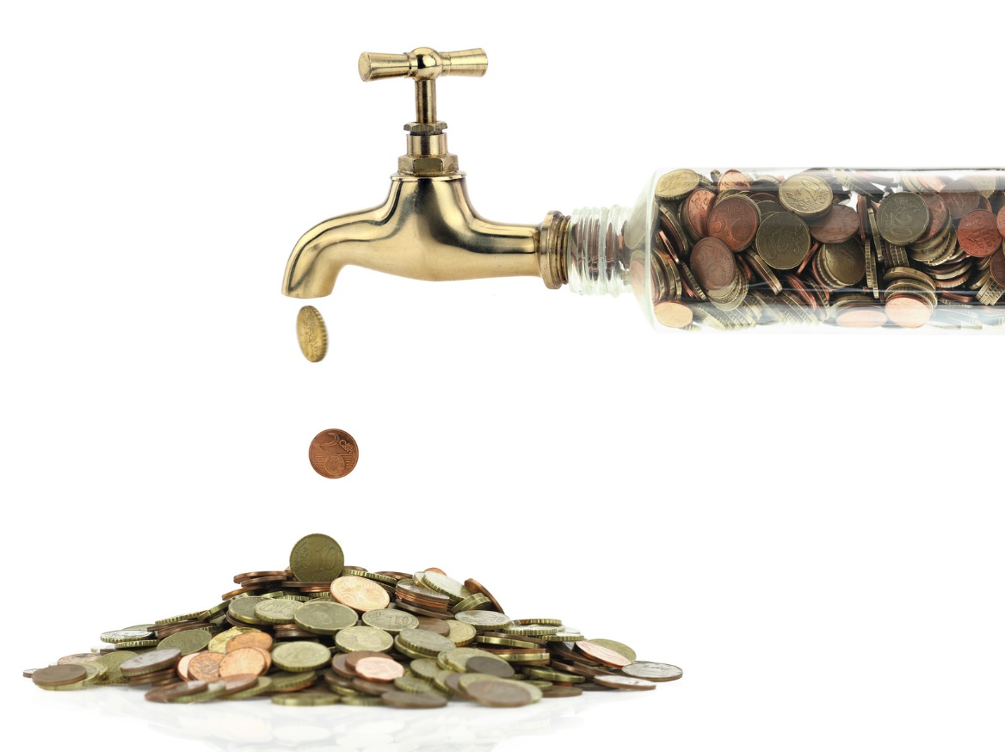

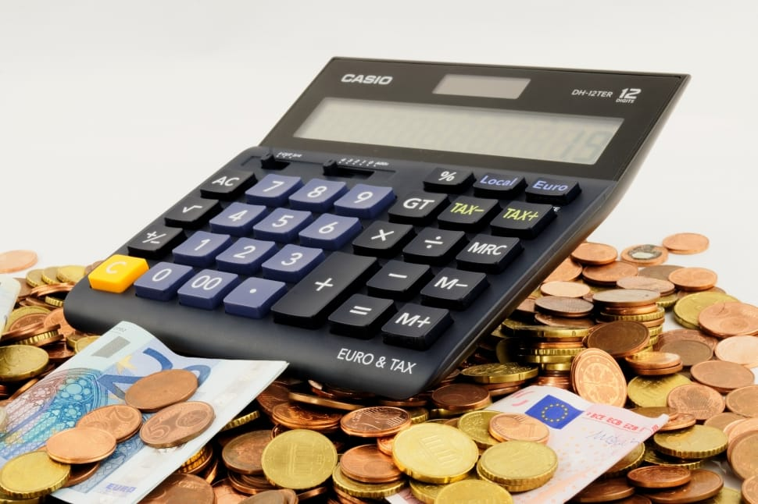

**Name**_____________________________________________________

Learning Outcome **E** – **Cash Flow forecasts and Break Even**

**Activity 1 – Types of Inflow**

As we go through each type of common inflow a business may have, provide an explanation of that inflow in the table below.

|  |  |
| --- | --- |
| **Inflow** | **Explanation** |
| Cash sales |  |
| Credit sales |  |
| Loans |  |
| Capital introduced |  |
| Sale of assets |  |
| Bank interest received |  |

**Activity 2 – Cash Flow Inflows**

Add the inflows that have been covered to the left-hand side of the cash flow forecast. Starting With the first one below opening balance.

|  |  |  |  |
| --- | --- | --- | --- |
|  | **January**  **(£)** | **February**  **(£)** | **March**  **(£)** |
| **OPENING BALANCE (b/f)** |  |  |  |
|  |  |  |  |
|  |  |  |  |
|  |  |  |  |
|  |  |  |  |
|  |  |  |  |
|  |  |  |  |
| **TOTAL INFLOWS** |  |  |  |
| **TOTAL CASH AVAILABLE** |  |  |  |
|  |  |  |  |
| **Expenses** |  |  |  |
|  |  |  |  |
|  |  |  |  |
|  |  |  |  |
|  |  |  |  |
|  |  |  |  |
|  |  |  |  |
|  |  |  |  |
|  |  |  |  |
|  |  |  |  |
| **TOTAL OUTFLOWS** |  |  |  |
| **CLOSING BALANCE (c/f)** |  |  |  |

**Activity 3 – Types of Outflows**

As we go through each type of common outflows a business may have, provide an explanation of that outflow in the table below.

|  |  |
| --- | --- |
| **Outflow** | **Explanation** |
|  |  |
|  |  |
|  |  |
|  |  |
|  |  |
|  |  |
|  |  |
|  |  |
|  |  |
|  |  |

**Activity 4 – Cash Flow Outflows**

**Go back to the cash flow in activity 2 and now fill in the outflows starting underneath the total cash available.**

**Activity 5 – Key Elements of a Cash Flow Forecast**

Fill in the boxes and explain key sections of the cash flow forecast below

|  |  |  |  |
| --- | --- | --- | --- |
|  | **January**  **(£)** | **February**  **(£)** | **March**  **(£)** |
| **OPENING BALANCE (b/f)** | 1000 | 9400 | 7500 |
| Cash Sales | 5000 | 4200 | 8000 |
| Credit Sales | 2000 | 1000 | 3000 |
| Loan | 5000 | 0 | 0 |
| **TOTAL INFLOWS** | 12000 | 5000 | 11000 |
| **TOTAL CASH AVAILABLE** | 13000 | 14600 | 18500 |
|  |  |  |  |
| **Expenses** |  |  |  |
| Rent | 1000 | 1000 | 1000 |
| Wages | 2000 | 4000 | 4000 |
| Loan Payment | 100 | 100 | 100 |
| Advertising | 500 | 2000 | 0 |
|  |  |  |  |
| **TOTAL OUTFLOWS** | 3600 | 7100 | 5100 |
| **CLOSING BALANCE (c/f)** | 9400 | 7500 | 13400 |

Opening balance:

Total inflows:

Total cash available:

Why is February’s opening balance £9,400?

Total outflows:

Closing balance:

**Activity 6 - Cash Flow Explained**

Watch the video named ‘Cash Flow Forecasting Explained | How to Complete a Cash Flow Forecast Example’ and answer the following questions.

[Video Link: Cash Flow Explained](https://www.youtube.com/watch?v=4SNWA_HbF6U&t=39s)

In your own words, define what a cash flow forecast is.

Explain what a cash inflow is with 3 supporting examples.

What is net cash flow and how is it calculated?

Why is cash flow forecasting important? Provide at least 3 benefits to a business.

What does the term insolvency mean? And how can a cash flow forecast help a business to avoid insolvency?

List at least 3 cash inflows and 3 cash outflows.

Explain the following key pieces of cash flow terminology and show how they are calculated:

**Opening Balance** =

**Total Inflow** =

**Total Outflow** =

**Net Cashflow** =

**Closing Balance** =

**Complete the cash flow forecast for Lauren after reading the scenario below:**

Lauren is a Business Studies student at University in her final year, alongside her course, she works part time at McDonalds and sells personalised t-shirts on Etsy. Lauren lives near university and splits the payment of rent and bills etc. with her housemates. Upon completion of her course, Lauren wants to open up a shop on her local high street. However, she currently does not have enough money to open a shop as this would cost £400 per month Therefore, she wants you to produce a cashflow forecast to see if she will be able to afford to open up a shop in August, which is 6 months away when she completes her course.

Use the following information to complete the cash flow forecast for Lauren:

* At the start of February, Lauren has just £500 in her bank account.
* Lauren gets paid £400 a month from her part time job at McDonalds.
* She pays £250 for rent each month
* She pays £50 per month for utility bills such as gas, electric and water.
* She pays a further £12 per month towards the houses broadband Netflix subscription.
* Lauren’s Etsy sales change every month and the predictions have been prefilled based on last year’s sales in the forecast below.
* She purchases materials every month to make the personalised t-shirts to sell on Etsy. The amount she buys is based on how much she is predicting to sell in the following month, and these have been prefilled below.
* In May, Lauren’s laptop breaks and she needs a new one to keep her Etsy shop running. This costs £400.
* In June, Lauren works extra hours at McDonalds to help pay for the laptop and earns an additional £370
* In July, Lauren sells £275 more than she predicted too as one of her t-shirts becomes very popular and sells out.

|  |  |  |  |  |  |  |
| --- | --- | --- | --- | --- | --- | --- |
|  | **FEB** | **MAR** | **APR** | **MAY** | **JUN** | **JUL** |
| **OPENING BALANCE (b/f)** |  |  |  |  |  |  |
| **CASH INFLOWS** |  |  |  |  |  |  |
| McDonalds Wage |  |  |  |  |  |  |
| Etsy Sales | 125 | 90 | 120 | 175 | 125 | 110 |
| **TOTAL INFLOWS** |  |  |  |  |  |  |
| **CASH OUTFLOWS** |  |  |  |  |  |  |
| Rent |  |  |  |  |  |  |
| Utility Bills |  |  |  |  |  |  |
| Broadband and Netflix |  |  |  |  |  |  |
| Materials | 45 | 60 | 90 | 60 | 60 | 90 |
| New Laptop |  |  |  |  |  |  |
| **TOTAL OUTFLOWS** |  |  |  |  |  |  |
| **NET CASH FLOW** |  |  |  |  |  |  |
| **CLOSING BALANCE (c/f)** |  |  |  |  |  |  |

**Activity 7 – The Use of Cash Flow Forecasts**

While we go through the uses of a cash flow forecast. Fill in the boxes provided by giving more detail regarding that particular use of a cash flow forecast.

|  |  |
| --- | --- |
| **Planning** | **Monitoring** |
| **Control** | **Target Setting** |

Explain what problems might occur on a cash flow forecast.

**Activity 8 – Cash Flow Practice (Ross’ ebay Business)**

Ross is an entrepreneur and has started his own ebay store flipping trainers. He currently works at Tesco part time so has two sources of income. He still lives at home and because it’s his parents’ home he has had to rent a small storage unit for his stock.

**Use the information below to create a cash flow forecast for Ross.**

* Ross starts May with £1,000 pounds in his account
* Ross receives £700 a month from his job at Tesco
* The storage facility costs £200 a month
* He pays £30 a month for super-fast broadband at his parents’ house.
* In May he spends £1,500 on 6 pairs of trainers to flip.
* He only sells one pair in May for £400.
* In June he buys another 12 pairs for £3,000
* Also, in June he sells all the other pairs for £2,300
* In July he sells none of the 12 pairs he purchased
* Despite this he buys two special edition pairs for £1,000
* He also decides to spend £300 on Facebook marketing in July and August
* His marketing works amazingly, and he sell all his stock for £9,000 in August
* He reinvests that in August and buys £5,000 of trainers to sell
* His business is doing that well he decides to quit his job and will not receive an income from Tesco in September and October
* He makes sales of £8,000 in September and buys £10,000 of stock
* In September he also decides to go for it with his Facebook marketing and spends £1,000.
* His gamble on Facebook marketing pays off and he sells £25,000 in October
* He buys £10,000 of stock and spends another £1000 in Facebook marketing in October

|  |  |  |  |  |  |  |
| --- | --- | --- | --- | --- | --- | --- |
|  | **MAY** | **JUNE** | **JULY** | **AUG** | **SEPT** | **OCT** |
| **OPENING BALANCE (b/f)** | **1000** |  |  |  |  |  |
|  |  |  |  |  |  |  |
| **INCOME / SALES** |  |  |  |  |  |  |
| Tesco |  |  |  |  |  |  |
| eBay |  |  |  |  |  |  |
|  |  |  |  |  |  |  |
| **TOTAL INFLOWS** |  |  |  |  |  |  |
| **TOTAL CASH AVAILABLE** |  |  |  |  |  |  |
|  |  |  |  |  |  |  |
| **EXPENSES** |  |  |  |  |  |  |
| Rent |  |  |  |  |  |  |
| Broadband |  |  |  |  |  |  |
| Purchases |  |  |  |  |  |  |
| Marketing |  |  |  |  |  |  |
|  |  |  |  |  |  |  |
| **TOTAL OUTFLOWS** |  |  |  |  |  |  |
| **CLOSING BALANCE (c/f)** |  |  |  |  |  |  |

Justify whether you think Ross has a healthy cash flow.

Assess the problems Ross may face due to his cash flow forecast.

Justify what actions Ross could take to improve his cash flow.

**Activity 9 – Cash Flow Practice (Holly’s Christmas Business)**

Holly loves Christmas and owns a business that sells predominantly Christmas decorations but also sells items for special occasions such as Valentine’s day. She has a little shop and a growing online presence. She has a pre-arranged overdraft with her bank as she is a seasonal business.

**Use the information below to create a cash flow forecast for Holly’s business.**

* Holly starts October with £2,500 pounds in the business account
* Her Mortgage is fixed at £400 a month and she also has just started an 18 month broadband deal at £20 a month
* In October she makes £420 in online sales and £500 in store and has one part time member of staff at a cost of £330. Also, in October she tries to ramp up sales in the run up to Christmas so spends £250 on marketing.
* In November, her online sales and store sales pick up. She makes £1,500 online and £3,000 in store. Due to her being busy this has meant that she has upped her part time worker to full time at a cost of £1000 for the month of November. Again, due to it being near Christmas she increases her marketing spend to £500 to help boost sales.
* December sees a massive increase in sales as this is her busiest time of year. Online she makes £4,000 and in store £12,000. She has two full time staff currently over Christmas at a cost of £2,000, however she reduces her marketing spend to £250 as the busy period is over.
* Sales in January are £500 online and £1,000 in store. Due to the reduction, she will only need one part time member of staff at a cost of £500 but decides to stick with a marketing spend of £250 to start drumming up sales for Valentine’s day.
* Due to Valentine’s day her sales increase in February to £3,000 online and £4,000 in store. Two part time staff are required over this period at a cost of £1,000. She sticks to a marketing spend of £250
* March sees sales reduce again to £500 online and £500 in store. This means only one member of staff is needed at an expense of £500. Due to the downturn she decides to reduce her marketing budget to £100 that month to save a little cash.

|  |  |  |  |  |  |  |
| --- | --- | --- | --- | --- | --- | --- |
|  | **OCT** | **NOV** | **DEC** | **JAN** | **FEB** | **MARCH** |
| **OPENING BALANCE (b/f)** |  |  |  |  |  |  |
|  |  |  |  |  |  |  |
| **INCOME / SALES** |  |  |  |  |  |  |
| Online Sales |  |  |  |  |  |  |
| Store Sales |  |  |  |  |  |  |
|  |  |  |  |  |  |  |
| **TOTAL INFLOWS** |  |  |  |  |  |  |
| **TOTAL CASH AVAILABLE** |  |  |  |  |  |  |
|  |  |  |  |  |  |  |
| **EXPENSES** |  |  |  |  |  |  |
| Mortgage |  |  |  |  |  |  |
| Utilities | **250** | **300** | **400** | **250** | **250** | **250** |
| Wages |  |  |  |  |  |  |
| Broadband |  |  |  |  |  |  |
| Purchases | **1500** | **3000** | **500** | **500** | **500** | **500** |
| Marketing |  |  |  |  |  |  |
|  |  |  |  |  |  |  |
| **TOTAL OUTFLOWS** |  |  |  |  |  |  |
| **CLOSING BALANCE (c/f)** |  |  |  |  |  |  |

Justify whether you think Holly has a healthy cash flow.

Assess the problems Holly may face due to his cash flow forecast.

Justify what actions Holly could take to improve his cash flow.

**Activity 10 – Benefits and Limitations of Cash Flow Forecasts**

Now you have looked at cash flow forecasting, fill in the table in your book with the benefits and drawbacks of cash flow forecasting.

|  |  |
| --- | --- |
| **Benefits** | **Limitations** |
|  |  |
|  |  |
|  |  |
|  |  |

Using the benefits and limitations above and your own knowledge, **evaluate** the usefulness of a cash flow forecast to a business.

**Activity 11 – Exam Question**

Fill in the grey boxes with your answer. This question is from a 2019 paper and is worth 6 marks.

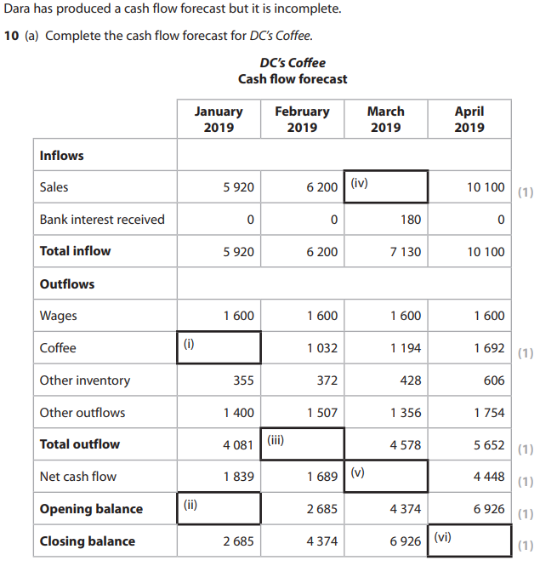

**Activity 12 – Knowledge Check E1 Cash Flow Forecast**

Describe what the word inflows means.

Provide 3 types of inflow.

1. 3.

2.

Describe what the word outflows means.

Provide 3 types of outflow.

1. 3.

2.

What are the 4 key uses for a cash flow forecast.

1. 3.

2. 4.

Assess the problems that can occur with cash flow and some possible solutions.

**Activity 13 – What is Break-even?**

Explain what break-even is.

As we cover the different types of costs involved in break-even write down an explanation of that cost along with examples.

|  |  |  |
| --- | --- | --- |
| **Costs** | **Explanation** | **Examples** |
| **Variable costs** |  |  |
| **Semi-variable costs** |  |  |
| **Fixed costs** |  |  |
| **Total costs** |  |  |

Just like we did for costs do the same for sales and the terminology used for the business generating revenue.

|  |  |  |
| --- | --- | --- |
| **Sales** | **Explanation** | **Examples** |
| **Total revenue** |  |  |
| **Selling price per unit** |  |  |
| **Sales in value** |  |  |
| **Sales in volume** |  |  |

**Activity 14 - Walk Through of Business Z**

For the following scenario we are going to calculate a variety of break-even calculations that will equip you to be able to calculate break-even for any scenario. Fill in the missing information as we go through the scenario.

You have the following information for Business Z:

* It has the following fixed costs:

£1,000 Rent

£500 Electricity

£500 Gas

* Variable cost per unit of £5 per t-shirt
* Selling price of £10 per t-shirt
* Maximum number of sales of 1200 t-shirts.

A business breaks-even when __________ = ____________

**Total Revenue**

Total revenue is the total amount of money a business receives from selling its

goods or services. It is calculated in the following way _________ x __________

What is the total revenue for Business Z if they sell 1200 t-shirts?

**Total Costs**

Total costs are the total amount of money a business spends on making the goods.

It is calculated using the following formula ____________ + ______________

What are the total costs for Business Z?

**Contribution Per Unit**

Contribution per unit is the amount by which an individual unit sold exceeds its variable costs. It is used to help calculate the break-even point of a business.

The calculation for contribution per unit is _______________ - ________________

Calculate the contribution per unit for Business Z.

**Break-even Point**

Now we have calculated the contribution per unit for Business Z we have all the information we need to calculate the break-even point. This is where the business is neither making a profit or a loss.

The calculation for the break-even point is ____________ divide by ____________

The break-even point for Business Z is

**Margin of Safety (Units)**

If a business is producing AND selling more than the break-even level of output, then it has a margin of safety.

This is effectively a “safety net” and can be calculated as:

______________ - _____________

Calculate the margin of safety in units for Business Z.

**Margin of Safety (Value)**

We have established that Business Z has a margin of safety of 800 units however, how much is this in value (£)?

Margin of safety in value can be calculated as ____________ x ______________

What is the margin of safety in value for Business Z?

**Calculating Profit**

It has been established that Business Z has a margin of safety of 800 units.

To calculate the profit from this amount you can do one of two things:

You can multiply the _____________ by _____________ which for Business Z is

£_____ x _____ = £____________ profit

OR

You can calculate the __________________ minus ____________ which for

Business Z is ________ x £______ = £________ minus fixed costs of £_________

= £_____________ profit

**Activity 15 – Break Even Video and Kenneth & Hilda Activity**

Watch the video link: [Break-even Video](https://www.youtube.com/watch?v=7RocdGhTd6Q&t=450s) and answer the questions below.

Kenneth and Hilda are planning to start a T-shirt business and they want to know how many they will have to sell to break even.

**Information:**

* Their fixed costs will be £200
* Their variable costs are £2 per T-shirt
* They are going to produce 80 T-shirts
* The selling price will be £10

Using the information above, complete table below.

|  |  |  |  |  |  |
| --- | --- | --- | --- | --- | --- |
| **No. sold** | **Sales Revenue (£)** | **Fixed**  **Costs (£)** | **Variable**  **Costs (£)** | **Total**  **Costs (£)** | **Profit/**  **Loss** |
| **0** | **0** |  |  |  | **(200)** |
| **10** |  |  |  | **220** |  |
| **20** |  |  | **40** |  |  |
| **30** |  |  |  |  | **40** |
| **40** | **400** | **200** |  |  |  |
| **50** |  |  |  |  |  |
| **60** |  | **200** |  |  |  |
| **70** | **700** |  |  |  |  |
| **80** |  |  |  |  |  |

**Activity 16 - How to Create a Break-even Chart**

As we go through drawing a break-even chart write down the steps involved and create a visual example.

**Step one:**

**Step two:**

**Step three:**

**Step four:**

**Step five:**

**Step six:**

**Activity 17 – Break-even Chart Kenneth & Hilda**

Draw a break-even chart below. Use the data in the table from Kenneth and Hilda’s business in activity 15. Make sure you label each element of the break-even chart.

|  |  |  |  |  |  |  |  |  |  |  |  |  |  |  |  |  |  |  |  |  |  |  |  |  |  |  |  |  |  |
| --- | --- | --- | --- | --- | --- | --- | --- | --- | --- | --- | --- | --- | --- | --- | --- | --- | --- | --- | --- | --- | --- | --- | --- | --- | --- | --- | --- | --- | --- |
|  |  |  |  |  |  |  |  |  |  |  |  |  |  |  |  |  |  |  |  |  |  |  |  |  |  |  |  |  |  |
|  |  |  |  |  |  |  |  |  |  |  |  |  |  |  |  |  |  |  |  |  |  |  |  |  |  |  |  |  |  |
|  |  |  |  |  |  |  |  |  |  |  |  |  |  |  |  |  |  |  |  |  |  |  |  |  |  |  |  |  |  |
|  |  |  |  |  |  |  |  |  |  |  |  |  |  |  |  |  |  |  |  |  |  |  |  |  |  |  |  |  |  |
|  |  |  |  |  |  |  |  |  |  |  |  |  |  |  |  |  |  |  |  |  |  |  |  |  |  |  |  |  |  |
|  |  |  |  |  |  |  |  |  |  |  |  |  |  |  |  |  |  |  |  |  |  |  |  |  |  |  |  |  |  |
|  |  |  |  |  |  |  |  |  |  |  |  |  |  |  |  |  |  |  |  |  |  |  |  |  |  |  |  |  |  |
|  |  |  |  |  |  |  |  |  |  |  |  |  |  |  |  |  |  |  |  |  |  |  |  |  |  |  |  |  |  |
|  |  |  |  |  |  |  |  |  |  |  |  |  |  |  |  |  |  |  |  |  |  |  |  |  |  |  |  |  |  |
|  |  |  |  |  |  |  |  |  |  |  |  |  |  |  |  |  |  |  |  |  |  |  |  |  |  |  |  |  |  |
|  |  |  |  |  |  |  |  |  |  |  |  |  |  |  |  |  |  |  |  |  |  |  |  |  |  |  |  |  |  |
|  |  |  |  |  |  |  |  |  |  |  |  |  |  |  |  |  |  |  |  |  |  |  |  |  |  |  |  |  |  |
|  |  |  |  |  |  |  |  |  |  |  |  |  |  |  |  |  |  |  |  |  |  |  |  |  |  |  |  |  |  |
|  |  |  |  |  |  |  |  |  |  |  |  |  |  |  |  |  |  |  |  |  |  |  |  |  |  |  |  |  |  |
|  |  |  |  |  |  |  |  |  |  |  |  |  |  |  |  |  |  |  |  |  |  |  |  |  |  |  |  |  |  |
|  |  |  |  |  |  |  |  |  |  |  |  |  |  |  |  |  |  |  |  |  |  |  |  |  |  |  |  |  |  |
|  |  |  |  |  |  |  |  |  |  |  |  |  |  |  |  |  |  |  |  |  |  |  |  |  |  |  |  |  |  |
|  |  |  |  |  |  |  |  |  |  |  |  |  |  |  |  |  |  |  |  |  |  |  |  |  |  |  |  |  |  |
|  |  |  |  |  |  |  |  |  |  |  |  |  |  |  |  |  |  |  |  |  |  |  |  |  |  |  |  |  |  |
|  |  |  |  |  |  |  |  |  |  |  |  |  |  |  |  |  |  |  |  |  |  |  |  |  |  |  |  |  |  |
|  |  |  |  |  |  |  |  |  |  |  |  |  |  |  |  |  |  |  |  |  |  |  |  |  |  |  |  |  |  |
|  |  |  |  |  |  |  |  |  |  |  |  |  |  |  |  |  |  |  |  |  |  |  |  |  |  |  |  |  |  |
|  |  |  |  |  |  |  |  |  |  |  |  |  |  |  |  |  |  |  |  |  |  |  |  |  |  |  |  |  |  |
|  |  |  |  |  |  |  |  |  |  |  |  |  |  |  |  |  |  |  |  |  |  |  |  |  |  |  |  |  |  |
|  |  |  |  |  |  |  |  |  |  |  |  |  |  |  |  |  |  |  |  |  |  |  |  |  |  |  |  |  |  |
|  |  |  |  |  |  |  |  |  |  |  |  |  |  |  |  |  |  |  |  |  |  |  |  |  |  |  |  |  |  |
|  |  |  |  |  |  |  |  |  |  |  |  |  |  |  |  |  |  |  |  |  |  |  |  |  |  |  |  |  |  |
|  |  |  |  |  |  |  |  |  |  |  |  |  |  |  |  |  |  |  |  |  |  |  |  |  |  |  |  |  |  |
|  |  |  |  |  |  |  |  |  |  |  |  |  |  |  |  |  |  |  |  |  |  |  |  |  |  |  |  |  |  |
|  |  |  |  |  |  |  |  |  |  |  |  |  |  |  |  |  |  |  |  |  |  |  |  |  |  |  |  |  |  |
|  |  |  |  |  |  |  |  |  |  |  |  |  |  |  |  |  |  |  |  |  |  |  |  |  |  |  |  |  |  |
|  |  |  |  |  |  |  |  |  |  |  |  |  |  |  |  |  |  |  |  |  |  |  |  |  |  |  |  |  |  |
|  |  |  |  |  |  |  |  |  |  |  |  |  |  |  |  |  |  |  |  |  |  |  |  |  |  |  |  |  |  |
|  |  |  |  |  |  |  |  |  |  |  |  |  |  |  |  |  |  |  |  |  |  |  |  |  |  |  |  |  |  |
|  |  |  |  |  |  |  |  |  |  |  |  |  |  |  |  |  |  |  |  |  |  |  |  |  |  |  |  |  |  |
|  |  |  |  |  |  |  |  |  |  |  |  |  |  |  |  |  |  |  |  |  |  |  |  |  |  |  |  |  |  |
|  |  |  |  |  |  |  |  |  |  |  |  |  |  |  |  |  |  |  |  |  |  |  |  |  |  |  |  |  |  |
|  |  |  |  |  |  |  |  |  |  |  |  |  |  |  |  |  |  |  |  |  |  |  |  |  |  |  |  |  |  |
|  |  |  |  |  |  |  |  |  |  |  |  |  |  |  |  |  |  |  |  |  |  |  |  |  |  |  |  |  |  |
|  |  |  |  |  |  |  |  |  |  |  |  |  |  |  |  |  |  |  |  |  |  |  |  |  |  |  |  |  |  |
|  |  |  |  |  |  |  |  |  |  |  |  |  |  |  |  |  |  |  |  |  |  |  |  |  |  |  |  |  |  |
|  |  |  |  |  |  |  |  |  |  |  |  |  |  |  |  |  |  |  |  |  |  |  |  |  |  |  |  |  |  |
|  |  |  |  |  |  |  |  |  |  |  |  |  |  |  |  |  |  |  |  |  |  |  |  |  |  |  |  |  |  |
|  |  |  |  |  |  |  |  |  |  |  |  |  |  |  |  |  |  |  |  |  |  |  |  |  |  |  |  |  |  |
|  |  |  |  |  |  |  |  |  |  |  |  |  |  |  |  |  |  |  |  |  |  |  |  |  |  |  |  |  |  |

Use the break-even calculation to work out the break-even point and check whether your break-even chart is accurate.

Calculate the margin of safety for Kenneth and Hilda’s business.

Based on everything you have worked out, evaluate whether Kenneth and Hilda’s t-shirt business is a worthwhile venture.

**Activity 18 – Prepare, Complete, Analyse, Revise and Evaluate Break-even**

Beth and Niyaz run a small business making picture frames and selling them on Etsy. They need some help producing a break-even chart and analysing their business situation.

Use the information below about their business to fill in in the table.

**Information:**

* Their fixed costs are £550
* Their variable costs are £6.50 per picture frame
* They produce 600 picture frames
* The selling price is £8.75

|  |  |  |  |  |  |
| --- | --- | --- | --- | --- | --- |
| **No. sold** | **Sales Revenue (£)** | **Fixed**  **Costs (£)** | **Variable**  **Costs (£)** | **Total**  **Costs (£)** | **Profit/**  **Loss** |
| **0** |  |  |  |  |  |
| **75** |  |  |  |  |  |
| **150** |  |  |  |  |  |
| **225** |  |  |  |  |  |
| **300** |  |  |  |  |  |
| **375** |  |  |  |  |  |
| **450** |  |  |  |  |  |
| **525** |  |  |  |  |  |
| **600** |  |  |  |  |  |

Draw a break-even chart on the graph paper below. Use the data in the table from Beth & Niyaz’s business. Make sure you label each element of the break-even chart.

|  |  |  |  |  |  |  |  |  |  |  |  |  |  |  |  |  |  |  |  |  |  |  |  |  |  |  |  |  |  |
| --- | --- | --- | --- | --- | --- | --- | --- | --- | --- | --- | --- | --- | --- | --- | --- | --- | --- | --- | --- | --- | --- | --- | --- | --- | --- | --- | --- | --- | --- |
|  |  |  |  |  |  |  |  |  |  |  |  |  |  |  |  |  |  |  |  |  |  |  |  |  |  |  |  |  |  |
|  |  |  |  |  |  |  |  |  |  |  |  |  |  |  |  |  |  |  |  |  |  |  |  |  |  |  |  |  |  |
|  |  |  |  |  |  |  |  |  |  |  |  |  |  |  |  |  |  |  |  |  |  |  |  |  |  |  |  |  |  |
|  |  |  |  |  |  |  |  |  |  |  |  |  |  |  |  |  |  |  |  |  |  |  |  |  |  |  |  |  |  |
|  |  |  |  |  |  |  |  |  |  |  |  |  |  |  |  |  |  |  |  |  |  |  |  |  |  |  |  |  |  |
|  |  |  |  |  |  |  |  |  |  |  |  |  |  |  |  |  |  |  |  |  |  |  |  |  |  |  |  |  |  |
|  |  |  |  |  |  |  |  |  |  |  |  |  |  |  |  |  |  |  |  |  |  |  |  |  |  |  |  |  |  |
|  |  |  |  |  |  |  |  |  |  |  |  |  |  |  |  |  |  |  |  |  |  |  |  |  |  |  |  |  |  |
|  |  |  |  |  |  |  |  |  |  |  |  |  |  |  |  |  |  |  |  |  |  |  |  |  |  |  |  |  |  |
|  |  |  |  |  |  |  |  |  |  |  |  |  |  |  |  |  |  |  |  |  |  |  |  |  |  |  |  |  |  |
|  |  |  |  |  |  |  |  |  |  |  |  |  |  |  |  |  |  |  |  |  |  |  |  |  |  |  |  |  |  |
|  |  |  |  |  |  |  |  |  |  |  |  |  |  |  |  |  |  |  |  |  |  |  |  |  |  |  |  |  |  |
|  |  |  |  |  |  |  |  |  |  |  |  |  |  |  |  |  |  |  |  |  |  |  |  |  |  |  |  |  |  |
|  |  |  |  |  |  |  |  |  |  |  |  |  |  |  |  |  |  |  |  |  |  |  |  |  |  |  |  |  |  |
|  |  |  |  |  |  |  |  |  |  |  |  |  |  |  |  |  |  |  |  |  |  |  |  |  |  |  |  |  |  |
|  |  |  |  |  |  |  |  |  |  |  |  |  |  |  |  |  |  |  |  |  |  |  |  |  |  |  |  |  |  |
|  |  |  |  |  |  |  |  |  |  |  |  |  |  |  |  |  |  |  |  |  |  |  |  |  |  |  |  |  |  |
|  |  |  |  |  |  |  |  |  |  |  |  |  |  |  |  |  |  |  |  |  |  |  |  |  |  |  |  |  |  |
|  |  |  |  |  |  |  |  |  |  |  |  |  |  |  |  |  |  |  |  |  |  |  |  |  |  |  |  |  |  |
|  |  |  |  |  |  |  |  |  |  |  |  |  |  |  |  |  |  |  |  |  |  |  |  |  |  |  |  |  |  |
|  |  |  |  |  |  |  |  |  |  |  |  |  |  |  |  |  |  |  |  |  |  |  |  |  |  |  |  |  |  |
|  |  |  |  |  |  |  |  |  |  |  |  |  |  |  |  |  |  |  |  |  |  |  |  |  |  |  |  |  |  |
|  |  |  |  |  |  |  |  |  |  |  |  |  |  |  |  |  |  |  |  |  |  |  |  |  |  |  |  |  |  |
|  |  |  |  |  |  |  |  |  |  |  |  |  |  |  |  |  |  |  |  |  |  |  |  |  |  |  |  |  |  |
|  |  |  |  |  |  |  |  |  |  |  |  |  |  |  |  |  |  |  |  |  |  |  |  |  |  |  |  |  |  |
|  |  |  |  |  |  |  |  |  |  |  |  |  |  |  |  |  |  |  |  |  |  |  |  |  |  |  |  |  |  |
|  |  |  |  |  |  |  |  |  |  |  |  |  |  |  |  |  |  |  |  |  |  |  |  |  |  |  |  |  |  |
|  |  |  |  |  |  |  |  |  |  |  |  |  |  |  |  |  |  |  |  |  |  |  |  |  |  |  |  |  |  |
|  |  |  |  |  |  |  |  |  |  |  |  |  |  |  |  |  |  |  |  |  |  |  |  |  |  |  |  |  |  |
|  |  |  |  |  |  |  |  |  |  |  |  |  |  |  |  |  |  |  |  |  |  |  |  |  |  |  |  |  |  |
|  |  |  |  |  |  |  |  |  |  |  |  |  |  |  |  |  |  |  |  |  |  |  |  |  |  |  |  |  |  |
|  |  |  |  |  |  |  |  |  |  |  |  |  |  |  |  |  |  |  |  |  |  |  |  |  |  |  |  |  |  |
|  |  |  |  |  |  |  |  |  |  |  |  |  |  |  |  |  |  |  |  |  |  |  |  |  |  |  |  |  |  |
|  |  |  |  |  |  |  |  |  |  |  |  |  |  |  |  |  |  |  |  |  |  |  |  |  |  |  |  |  |  |
|  |  |  |  |  |  |  |  |  |  |  |  |  |  |  |  |  |  |  |  |  |  |  |  |  |  |  |  |  |  |
|  |  |  |  |  |  |  |  |  |  |  |  |  |  |  |  |  |  |  |  |  |  |  |  |  |  |  |  |  |  |
|  |  |  |  |  |  |  |  |  |  |  |  |  |  |  |  |  |  |  |  |  |  |  |  |  |  |  |  |  |  |
|  |  |  |  |  |  |  |  |  |  |  |  |  |  |  |  |  |  |  |  |  |  |  |  |  |  |  |  |  |  |
|  |  |  |  |  |  |  |  |  |  |  |  |  |  |  |  |  |  |  |  |  |  |  |  |  |  |  |  |  |  |
|  |  |  |  |  |  |  |  |  |  |  |  |  |  |  |  |  |  |  |  |  |  |  |  |  |  |  |  |  |  |
|  |  |  |  |  |  |  |  |  |  |  |  |  |  |  |  |  |  |  |  |  |  |  |  |  |  |  |  |  |  |
|  |  |  |  |  |  |  |  |  |  |  |  |  |  |  |  |  |  |  |  |  |  |  |  |  |  |  |  |  |  |
|  |  |  |  |  |  |  |  |  |  |  |  |  |  |  |  |  |  |  |  |  |  |  |  |  |  |  |  |  |  |
|  |  |  |  |  |  |  |  |  |  |  |  |  |  |  |  |  |  |  |  |  |  |  |  |  |  |  |  |  |  |
|  |  |  |  |  |  |  |  |  |  |  |  |  |  |  |  |  |  |  |  |  |  |  |  |  |  |  |  |  |  |

What is the contribution per unit of Beth & Niyaz’s business?

Use the break-even calculation to work out the break-even point and check whether your break-even chart is accurate.

Calculate the margin of safety for Beth and Niyaz’s business.

If they sell all 600 picture frames how much profit will they make?

Based on everything you have worked out, evaluate Beth and Niyaz’s current business position and suggest changes to improve the business

**Activity 19 – Prepare, Complete, Analyse, Revise and Evaluate Break-even**

Liverpool FC is planning to change the price of their football shirts from £35 to £40. At £35 a shirt they on average sell 600 thousand a season. At £40 a shirt they expect to sell 500 thousand. Use the table below to suggest whether it is worth Liverpool changing their prices.

**Information:**

* Their fixed costs will be £5 million
* Their variable costs are £5 per T-shirt
* They are going to produce 500,000 football shirts
* The selling price will be £40

|  |  |  |  |  |  |
| --- | --- | --- | --- | --- | --- |
| **No. sold** | **Sales Revenue (£mil)** | **Fixed**  **Costs (£mil)** | **Variable**  **Costs (£mil)** | **Total**  **Costs (£mil)** | **Profit/**  **Loss**  **(£mil)** |
| **0** | **0** | **5** | **0** | **5** | **(5)** |
| **50,000** |  | **5** | **.25** |  |  |
| **100,000** |  |  |  |  | **(1.5)** |
| **150,000** |  |  |  |  |  |
| **200,000** | **8** | **5** | **1** |  |  |
| **250,000** | **10** | **5** | **1.25** |  | **3.75** |
| **300,000** |  |  | **1.5** |  | **5.5** |
| **350,000** |  |  |  |  |  |
| **400,000** |  |  |  | **7** |  |
| **450,000** | **18** |  |  | **7.25** |  |
| **500,000** | **20** | **5** | **2.5** |  |  |

Draw a break-even chart on the graph paper below. Use the data in the table. Make sure you label each element of the break-even chart.

|  |  |  |  |  |  |  |  |  |  |  |  |  |  |  |  |  |  |  |  |  |  |  |  |  |  |  |  |  |  |
| --- | --- | --- | --- | --- | --- | --- | --- | --- | --- | --- | --- | --- | --- | --- | --- | --- | --- | --- | --- | --- | --- | --- | --- | --- | --- | --- | --- | --- | --- |
|  |  |  |  |  |  |  |  |  |  |  |  |  |  |  |  |  |  |  |  |  |  |  |  |  |  |  |  |  |  |
|  |  |  |  |  |  |  |  |  |  |  |  |  |  |  |  |  |  |  |  |  |  |  |  |  |  |  |  |  |  |
|  |  |  |  |  |  |  |  |  |  |  |  |  |  |  |  |  |  |  |  |  |  |  |  |  |  |  |  |  |  |
|  |  |  |  |  |  |  |  |  |  |  |  |  |  |  |  |  |  |  |  |  |  |  |  |  |  |  |  |  |  |
|  |  |  |  |  |  |  |  |  |  |  |  |  |  |  |  |  |  |  |  |  |  |  |  |  |  |  |  |  |  |
|  |  |  |  |  |  |  |  |  |  |  |  |  |  |  |  |  |  |  |  |  |  |  |  |  |  |  |  |  |  |
|  |  |  |  |  |  |  |  |  |  |  |  |  |  |  |  |  |  |  |  |  |  |  |  |  |  |  |  |  |  |
|  |  |  |  |  |  |  |  |  |  |  |  |  |  |  |  |  |  |  |  |  |  |  |  |  |  |  |  |  |  |
|  |  |  |  |  |  |  |  |  |  |  |  |  |  |  |  |  |  |  |  |  |  |  |  |  |  |  |  |  |  |
|  |  |  |  |  |  |  |  |  |  |  |  |  |  |  |  |  |  |  |  |  |  |  |  |  |  |  |  |  |  |
|  |  |  |  |  |  |  |  |  |  |  |  |  |  |  |  |  |  |  |  |  |  |  |  |  |  |  |  |  |  |
|  |  |  |  |  |  |  |  |  |  |  |  |  |  |  |  |  |  |  |  |  |  |  |  |  |  |  |  |  |  |
|  |  |  |  |  |  |  |  |  |  |  |  |  |  |  |  |  |  |  |  |  |  |  |  |  |  |  |  |  |  |
|  |  |  |  |  |  |  |  |  |  |  |  |  |  |  |  |  |  |  |  |  |  |  |  |  |  |  |  |  |  |
|  |  |  |  |  |  |  |  |  |  |  |  |  |  |  |  |  |  |  |  |  |  |  |  |  |  |  |  |  |  |
|  |  |  |  |  |  |  |  |  |  |  |  |  |  |  |  |  |  |  |  |  |  |  |  |  |  |  |  |  |  |
|  |  |  |  |  |  |  |  |  |  |  |  |  |  |  |  |  |  |  |  |  |  |  |  |  |  |  |  |  |  |
|  |  |  |  |  |  |  |  |  |  |  |  |  |  |  |  |  |  |  |  |  |  |  |  |  |  |  |  |  |  |
|  |  |  |  |  |  |  |  |  |  |  |  |  |  |  |  |  |  |  |  |  |  |  |  |  |  |  |  |  |  |
|  |  |  |  |  |  |  |  |  |  |  |  |  |  |  |  |  |  |  |  |  |  |  |  |  |  |  |  |  |  |
|  |  |  |  |  |  |  |  |  |  |  |  |  |  |  |  |  |  |  |  |  |  |  |  |  |  |  |  |  |  |
|  |  |  |  |  |  |  |  |  |  |  |  |  |  |  |  |  |  |  |  |  |  |  |  |  |  |  |  |  |  |
|  |  |  |  |  |  |  |  |  |  |  |  |  |  |  |  |  |  |  |  |  |  |  |  |  |  |  |  |  |  |
|  |  |  |  |  |  |  |  |  |  |  |  |  |  |  |  |  |  |  |  |  |  |  |  |  |  |  |  |  |  |
|  |  |  |  |  |  |  |  |  |  |  |  |  |  |  |  |  |  |  |  |  |  |  |  |  |  |  |  |  |  |
|  |  |  |  |  |  |  |  |  |  |  |  |  |  |  |  |  |  |  |  |  |  |  |  |  |  |  |  |  |  |
|  |  |  |  |  |  |  |  |  |  |  |  |  |  |  |  |  |  |  |  |  |  |  |  |  |  |  |  |  |  |
|  |  |  |  |  |  |  |  |  |  |  |  |  |  |  |  |  |  |  |  |  |  |  |  |  |  |  |  |  |  |
|  |  |  |  |  |  |  |  |  |  |  |  |  |  |  |  |  |  |  |  |  |  |  |  |  |  |  |  |  |  |
|  |  |  |  |  |  |  |  |  |  |  |  |  |  |  |  |  |  |  |  |  |  |  |  |  |  |  |  |  |  |
|  |  |  |  |  |  |  |  |  |  |  |  |  |  |  |  |  |  |  |  |  |  |  |  |  |  |  |  |  |  |
|  |  |  |  |  |  |  |  |  |  |  |  |  |  |  |  |  |  |  |  |  |  |  |  |  |  |  |  |  |  |
|  |  |  |  |  |  |  |  |  |  |  |  |  |  |  |  |  |  |  |  |  |  |  |  |  |  |  |  |  |  |
|  |  |  |  |  |  |  |  |  |  |  |  |  |  |  |  |  |  |  |  |  |  |  |  |  |  |  |  |  |  |
|  |  |  |  |  |  |  |  |  |  |  |  |  |  |  |  |  |  |  |  |  |  |  |  |  |  |  |  |  |  |
|  |  |  |  |  |  |  |  |  |  |  |  |  |  |  |  |  |  |  |  |  |  |  |  |  |  |  |  |  |  |
|  |  |  |  |  |  |  |  |  |  |  |  |  |  |  |  |  |  |  |  |  |  |  |  |  |  |  |  |  |  |
|  |  |  |  |  |  |  |  |  |  |  |  |  |  |  |  |  |  |  |  |  |  |  |  |  |  |  |  |  |  |
|  |  |  |  |  |  |  |  |  |  |  |  |  |  |  |  |  |  |  |  |  |  |  |  |  |  |  |  |  |  |
|  |  |  |  |  |  |  |  |  |  |  |  |  |  |  |  |  |  |  |  |  |  |  |  |  |  |  |  |  |  |
|  |  |  |  |  |  |  |  |  |  |  |  |  |  |  |  |  |  |  |  |  |  |  |  |  |  |  |  |  |  |
|  |  |  |  |  |  |  |  |  |  |  |  |  |  |  |  |  |  |  |  |  |  |  |  |  |  |  |  |  |  |
|  |  |  |  |  |  |  |  |  |  |  |  |  |  |  |  |  |  |  |  |  |  |  |  |  |  |  |  |  |  |
|  |  |  |  |  |  |  |  |  |  |  |  |  |  |  |  |  |  |  |  |  |  |  |  |  |  |  |  |  |  |
|  |  |  |  |  |  |  |  |  |  |  |  |  |  |  |  |  |  |  |  |  |  |  |  |  |  |  |  |  |  |

Check your chart by using the break-even calculation to see what their break-even point is when selling their shirts at £40.

Calculate the margin of safety when selling the shirts at £40.

How much profit will Liverpool FC make selling the shirts at £40?

Now use the break-even calculation to work out the break-even point for the current shirts selling price of £35.

Calculate the margin of safety when selling the shirts at £35.

How much profit will Liverpool FC make selling their shirts at the current price of £35?

Based on your calculations **justify** whether it is worth raising the price of the shirts from a business perspective.

Activity 20 – Break Even Practice Questions King Tables LTD

King Tables Ltd manufacture tables at a fixed cost of £240,000 per year. Raw materials cost £40 per table shirt and wages cost £20 per table. The business sells their tables for £140.

Calculate the contribution per unit for the tables.

Calculate how many tables the business needs to sell to break-even.

If the company manufactures 9000 tables what is their margin of safety?

Calculate the amount of profit made when 9000 tables are sold.

King Tables LTD have seen their raw materials and fixed costs increase by 20% due to a change in the economy.

Calculate the new break-even point for King Tables LTD

Calculate the new margin of safety if sales remain at 9000 tables.

Calculate the new profit made at the sales level of 9000.

Evaluate the impact this 20% increase has had on King Tables LTD business.

Assess what King Tables LTD could do to respond to these changes?

**Activity 21 – Break Even for Planning, Monitoring, Control and Target Setting**

Complete the boxes by putting in how break-even can help with each one of the areas below.

**Monitoring**

**Planning**

**BREAK-EVEN**

**Target setting**

**Control**

**Activity 22 – Advantages and Disadvantages of Break-even**

Think about what you have learnt about break-even, discuss with a peer or do some research on the advantages and disadvantages of using break-even analysis and fill out the table.

|  |  |
| --- | --- |
| **Advantages** | **Disadvantages** |
|  |  |
|  |  |
|  |  |
|  |  |
|  |  |
|  |  |

Using the table of advantages and disadvantages you have created evaluate the usefulness of break-even analysis as a business management tool.

**Activity 23 – Exam Questions**

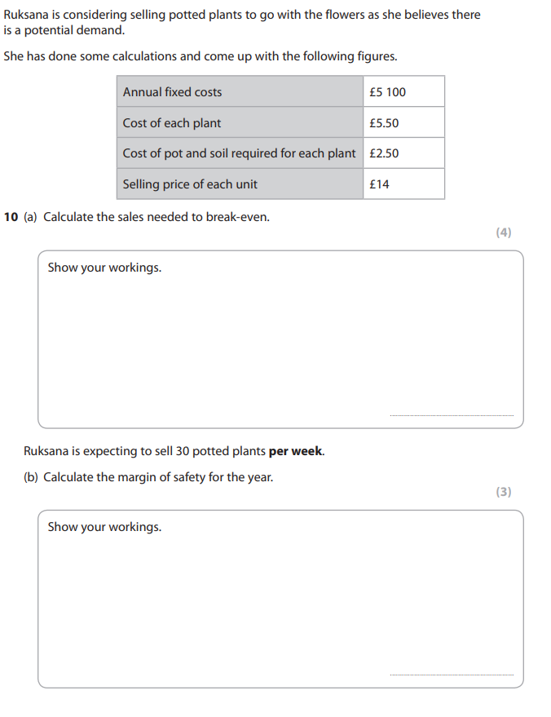The following questions are from a 2020 exam paper and are worth a combined 10 marks.

**Type or write your answer here. Show your workings.**

**Type or write your answer here. Show your workings.**

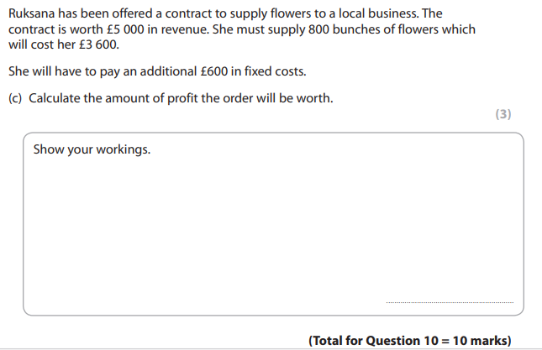

**Type or write your answer here. Show your workings.**

**Activity 24 – Knowledge Check E2 Break-even Analysis**

Explain what break-even is.

Explain what a variable cost is.

Explain what sales revenue is.

How do you calculate total revenue?

How do you calculate total costs?

How do you calculate contribution per unit?

What is the calculation for the break-even point? And explain what the break-even point is.

What is the calculation for the margin of safety? And explain what the margin of safety is.

List the 4 uses for doing a break-even analysis.

1. 3.

2. 4.

Assess the benefits and limitations of using break-even analysis.

**Activity 26 – Word Scramble Learning Outcome E**

1. LOTTA STSOC _______________________________________

2. LSOIGNC ACBLENA ___________________________________

3. GELLSIN ERCPI ERP TIUN ____________________________

4. IRTCDE ESALS ______________________________________

5. ABEKR EENV OTPNI __________________________________

6. TLAOT ACSH AAVIBLLEA ______________________________

7. CSHA OFWL SFATCSEOR _______________________________

8. IELRVBAA CSOST ____________________________________

9. IWSLFNO ___________________________________________

10. LTTAO VNEEREU _____________________________________

11. MIRANG OF TYSAFE __________________________________

12. ABEKR VEEN YLSINSAA _______________________________

13. IGNNEPO LABNAEC ___________________________________

14. TBUICRNOONIT EPR TNUI _____________________________

15. UTLWFSOO __________________________________________

**Activity 27 – Word Search Learning Outcome E**

|  |  |  |  |  |  |  |  |  |  |  |  |  |  |  |  |  |  |  |  |  |  |  |  |
| --- | --- | --- | --- | --- | --- | --- | --- | --- | --- | --- | --- | --- | --- | --- | --- | --- | --- | --- | --- | --- | --- | --- | --- |
| K | Q | T | O | W | N | E | R | S | C | A | P | I | T | A | L | Y | L | R | I | U | X | R | A |
| S | A | V | I | Q | M | M | B | M | W | I | W | K | M | I | P | W | E | I | Y | K | D | B | H |
| B | B | E | X | F | R | Q | E | Y | R | F | C | I | A | K | N | T | G | M | C | U | S | B | B |
| F | Q | H | W | C | A | S | H | S | A | L | E | S | O | V | G | D | Z | D | B | N | Z | R | B |
| I | X | C | A | S | H | F | L | O | W | F | O | R | E | C | A | S | T | S | K | F | N | S | I |
| B | K | O | C | C | N | R | F | F | H | F | I | X | E | D | C | O | S | T | S | Q | B | N | R |
| V | W | Z | M | O | N | B | L | W | S | F | C | G | W | X | P | E | P | A | O | K | F | S | G |
| T | L | T | S | L | N | R | L | Q | V | Q | D | T | Z | W | K | A | Q | L | X | L | T | E | F |
| Y | Y | O | C | R | E | D | I | T | P | U | R | C | H | A | S | E | S | J | O | S | B | K | H |
| C | R | T | N | I | O | P | N | E | V | E | K | A | E | R | B | P | Q | W | O | A | N | G | I |
| V | D | A | Y | I | D | J | F | Y | S | W | O | L | F | T | U | O | S | C | C | L | A | E | R |
| P | V | L | D | V | G | D | F | F | A | S | R | Y | H | G | X | M | L | T | E | E | Y | C | W |
| W | H | S | K | T | Y | S | N | P | R | X | K | E | B | N | W | A | Y | R | Z | S | W | W | U |
| X | M | A | Y | S | N | L | S | W | Y | A | L | G | Z | D | T | G | B | P | D | I | L | U | E |
| T | W | L | W | Y | P | Z | M | Z | Z | N | R | N | D | O | O | K | K | E | L | N | G | V | O |
| M | H | E | W | G | K | B | T | O | J | K | S | J | T | Y | D | R | D | Y | I | V | U | I | P |
| O | B | S | C | R | C | M | A | R | G | I | N | O | F | S | A | F | E | T | Y | A | E | M | C |
| C | P | G | L | P | P | X | M | L | P | D | J | G | I | E | K | O | A | G | D | L | L | C | L |
| Z | S | R | L | Z | J | E | B | Q | L | G | A | D | F | Y | S | E | S | B | Y | U | A | Q | L |
| O | Y | U | T | E | J | T | A | U | E | K | P | Q | B | Q | O | X | P | T | P | E | I | T | E |
| D | O | R | R | V | D | V | F | P | L | E | C | N | A | L | A | B | G | N | I | S | O | L | C |
| F | X | K | T | X | T | Y | F | F | C | X | O | K | I | H | Y | W | Q | Y | R | A | J | S | L |
| C | O | N | T | R | I | B | U | T | I | O | N | P | E | R | U | N | I | T | F | U | W | P | V |
| Y | Z | S | T | S | O | C | E | L | B | A | I | R | A | V | I | M | E | S | T | M | O | Z | T |

 Outflows       Contribution Per Unit       Owners Capital       Sales in Value        Margin of Safety       Total Sales       Inflows       Fixed Costs      Cash Flow Forecasts        Credit Purchases       Break Even Point       Cash Sales      Semi Variable Costs       Closing Balance       Total Costs

**Activity 28 – Crossword Learning Outcome E**

|  |  |  |  |  |  |  |  |  |  |  |  |  |  |  |  |  |  |  |  |
| --- | --- | --- | --- | --- | --- | --- | --- | --- | --- | --- | --- | --- | --- | --- | --- | --- | --- | --- | --- |
|  |  |  |  |  |  |  |  |  |  |  |  |  |  |  |  |  |  |  |  |
|  |  |  |  |  |  |  |  |  |  | 1 |  | 2 |  |  |  |  |  |  |  |
|  |  |  |  |  |  |  |  |  |  |  |  |  |  |  |  |  |  |  |  |
|  |  | 3 |  |  |  |  |  |  |  |  |  |  |  |  |  |  |  |  |  |
|  |  |  |  |  |  |  |  |  |  |  |  |  |  |  |  |  |  |  |  |
|  |  | 4 |  |  |  |  |  |  |  |  |  |  |  |  |  |  | 5 |  | 6 |
|  |  |  |  |  |  |  |  |  |  |  |  |  |  |  |  |  |  |  |  |
|  |  |  |  |  |  |  |  |  |  |  |  |  |  | 7 |  |  |  |  |  |
|  |  |  |  |  |  |  |  |  | 8 |  |  |  |  |  |  |  |  |  |  |
|  |  |  |  |  |  |  |  |  |  |  |  |  |  |  |  |  |  |  |  |
|  |  |  |  | 9 |  |  |  |  |  |  |  |  |  |  |  |  |  |  |  |
|  |  |  |  |  |  |  |  |  |  |  |  |  |  |  |  |  |  |  |  |
|  |  |  |  |  |  |  |  |  |  |  |  |  |  |  |  |  |  |  |  |
|  | 10 |  |  |  |  |  |  |  |  |  |  |  |  |  |  |  |  |  |  |
|  |  |  |  |  |  |  |  |  |  |  |  |  |  |  |  |  |  |  |  |
|  |  |  |  |  |  |  |  |  |  |  |  |  |  |  |  |  |  |  |  |
|  |  |  |  |  |  |  |  |  |  |  |  |  |  |  |  |  |  |  |  |
|  |  |  |  |  |  |  |  |  |  |  |  |  |  |  |  |  |  |  |  |
|  |  |  |  |  |  |  |  |  |  |  |  |  |  |  |  |  |  |  |  |
|  |  |  |  |  |  |  |  |  |  |  |  |  |  |  |  |  |  |  |  |

|  |  |
| --- | --- |
| **Across**  **3.** _________________ allows the business to forecast the money flowing into the business and the money flowing out of the business.  **8.** The money going out of the business is called an.  **9.** The name for the amount of money available at the start of the month on a cash flow forecast.  **10.** What do you take away from the selling price to get the contribution per unit? | **Down**  **1.** The money coming into a business is call an.  **2.** What is it called when a business is producing and selling more than the break-even level of output?  **4.** Total cash available minus total outflows equals.  **5.** Fixed costs divided by contribution per unit equals.  **6.** Fixed costs plus variable costs equals  **7.** Quantity sold multiplied by selling price equals. |