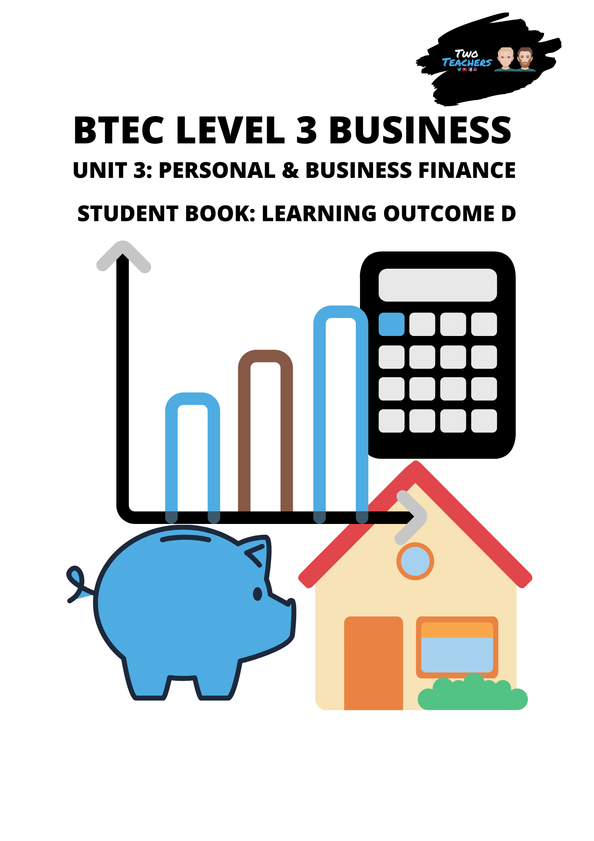
Name:
Learning Outcome D - Select and Evaluate Different Sources of Business Finance

Activity 1 – Internal Sources of Finance
As we go through each source of internal finance take down what that source of finance is and, in the table, write the advantages and disadvantages of using that source of finance.
Internal source of finance | Explain the source | Advantages | Disadvantages
Retained Profit
Net Current Assets
Sale of Assets

Activity 2 – Internal Source Scenario

Ross has decided to buy a van at a cost of £18,000. He has decided to use an internal source of finance to fund this purchase. His business has made £36,000 in profit this year.
Evaluate whether using retained profits would be a good source of finance for his business.

Activity 3 – Knowledge Check Internal Sources of Finance
Outline two advantages of using retained profits as a source of finance

Explain what retained profits are

Suggest two disadvantages of using net current assets as a source of finance

Explain a benefit of selling assets to finance a business

Describe how net current assets can be used as a source of finance

Activity 4 - External Sources of Finance
From research or knowledge of external sources of finance complete the spider diagram with as many external sources as you can. We will go over these in more detail next.

External Sources of Finance

Activity 5 - External Sources
As we go through the types of external sources of finance fill out the description of each one along with the advantages and disadvantages of using that source of finance.

Owner’s capital
Description of source of finance:

Advantages | Disadvantages

Loans
Description of source of finance:

Advantages | Disadvantages

Crowd funding
Description of source of finance:

Advantages | Disadvantages

Activity 6 – Key Questions
Complete the questions below from memory. If you don’t know the answer look it up in your booklet or via internet research and put your answer in a different colour.

Explain what a loan is

Compare using owner’s capital as a source of finance with acquiring a loan

Discuss crowd funding as a source of finance

Activity 7 - External Sources Continued

Mortgages
Description of source of finance:

Advantages | Disadvantages

Venture capital
Description of source of finance:

Advantages | Disadvantages

Debt factoring
Description of source of finance:

Advantages | Disadvantages

Activity 8 – Advantages & Disadvantages
These advantages and disadvantages match with either a mortgage, venture capital or debt factoring. Answer the correct source of finance for each advantage or disadvantage.

- Improves the businesses cash flow

- Loss of ownership and control

- Reduces risk of default on payments

- Interest charged on amount borrowed

- Conflict may occur over the direction of the business

- Large amounts of finance can be acquired

- Only receive a percentage of the amount the business is owed

- Secured against asset that could be seized

- Finance is made available along with advice and mentoring

- Not a Suitable short-term form of finance

Activity 9 - External Sources Continued

Hire purchase
Description of source of finance:

Advantages | Disadvantages

Leasing
Description of source of finance:

Advantages | Disadvantages

Trade credit
Description of source of finance:

Advantages | Disadvantages

Activity 10 – Hire Purchase, Leasing, Trade Credit Fill in the Blank
Complete the sentences by filling in the blanks for the content we have just covered for hire purchase, leasing and trade credit.

_______________ is used to purchase an asset, such as a delivery van or piece of equipment. A _________ is paid and the remaining amount for the asset is paid in monthly instalments over a set period of time. The business does not own the _______ until all ____________ are made. An advantage of this method is that the business makes _________ __________ which is good for __________, however it is only suitable for ________ cost items.

This source of finance is when you _____ an asset that the business requires, such as a coffee machine. Unlike hire purchase the item is not ________ at the end of the payments by the business. One advantage of _____________ is that all maintenance and repairs are the responsibility of the supplier. However, a disadvantage of this method is that it is likely to cost _____ than ________ the item outright.

This source of finance allows a business to obtain raw materials and stock but pay for them at a later date. This method is called ____________. The business may lose discounts for paying in cash this is a ____________ for the business. Despite this it may improve their _______ ________. One thing that the business does not lose from using this source of finance is ________ and __________. This method is mainly used as a _______ term source of finance.
Activity 11 – External Sources Continued
Grants
Description of source of finance:

Advantages | Disadvantages

Donations
Description of source of finance:

Advantages | Disadvantages

Peer to Peer Lending
Description of source of finance:

Advantages | Disadvantages

Invoice discounting
Description of source of finance:

Advantages | Disadvantages

Activity 13 – Sources Scenario 1
Holly has just completed a business qualification and has decided to set up a small business buying and selling limited edition trainers. She knows that there is a wide range of finance sources available to her but finds it very complicated. She has £750 saved up in her bank account but has come to you for advice on which 3 sources of finance you would recommend.
Evaluate 3 sources of finance and suggest the best one for her situation.

Activity 14 – Sources Scenario 2
One year ago, Aman started a high street premium burger restaurant which allows customers to customise their burger to their exact specification. It has been incredibly successful, and Aman is now looking to open a second restaurant in a nearby town. However, he is unsure which is the best way to source finance for this expansion. He is considering using retained profits, venture capital or crowdfunding.
Make clear comparisons between the options Aman is considering and then support this with justified recommendations of which he should choose for this burger restaurant expansion.

Activity 15 – Sources Scenario 3
Alister is currently running a successful business but needs to purchase 5 new company cars for his sales team. He currently has enough money in retained profit in the business to buy the cars outright but is wanting to investigate getting a bank loan or leasing the vehicles.
Discuss all three options that Alister is considering and provide him with a clear recommendation.

Activity 17 – Word Scramble Learning Outcome D

1. OSUCERS FO NCFINAE ________________________________
2. NATINELR SRUOESC __________________________________
3. XRALNETE ESCOSUR __________________________________
4. NCVIEIO IIDCUOTGNNS _______________________________
5. DOONIATSN _________________________________________
6. PEER OT EEPR DLNNGIE ______________________________
7. DREAT ECRITD ______________________________________
8. EHRI ECHSRPAU _____________________________________
9. ERENTUV ICPLAAT ___________________________________
10. TDRNEIAE TOISPFR __________________________________
11. ESAL OF ASESST ____________________________________
12. TNE ENRTUCR ESTSAS ________________________________

Activity 18 – Word Search Learning Outcome D

C | G | W | W | Q | H | T | K | O | I | K | E | G | A | G | T | R | O | M | W | X | Q | V | O
I | C | M | Y | K | E | X | N | C | D | M | T | R | A | D | E | C | R | E | D | I | T | D | D
V | A | C | I | L | I | K | W | L | A | T | I | P | A | C | E | R | U | T | N | E | V | T | D
T | M | S | N | G | Z | D | E | B | T | F | A | C | T | O | R | I | N | G | R | E | O | S | A
Z | X | U | V | F | E | K | C | B | S | E | C | R | U | O | S | L | A | N | R | E | T | N | I
N | W | P | O | A | R | W | Y | Y | R | B | A | Y | V | A | T | Y | G | T | W | X | M | L | Y
K | W | G | I | Q | J | M | N | Z | O | V | F | R | L | N | H | P | M | C | Y | H | B | P | B
F | H | P | C | Y | K | D | H | P | M | C | V | E | G | U | F | R | Z | P | L | P | P | D | X
V | M | N | E | P | O | H | Q | E | S | N | O | S | G | A | X | Y | D | C | Z | Z | J | Y | M
O | H | O | D | U | I | O | R | R | Y | F | H | K | X | F | V | S | E | K | A | C | V | R | J
H | W | H | I | O | O | F | V | P | A | E | S | A | H | C | R | U | P | E | R | I | H | M | V
D | W | U | S | G | D | N | S | S | I | H | X | W | J | Z | U | F | M | T | Y | K | P | I | K
R | W | I | C | C | H | N | S | Q | K | R | A | V | R | U | M | E | T | M | C | F | Q | V | R
Q | H | A | O | M | N | E | T | C | U | R | R | E | N | T | A | S | S | E | T | S | J | H | N
U | Z | O | U | K | T | A | D | C | Z | K | W | L | X | M | W | D | L | I | Z | R | G | H | W
B | F | W | N | S | J | O | F | D | C | L | A | K | Q | Y | X | M | U | M | S | I | N | K | A
C | B | V | T | F | H | F | S | E | C | R | U | O | S | L | A | N | R | E | T | X | E | Z | F
I | U | G | I | P | A | G | X | W | O | E | I | T | S | M | F | B | P | Y | C | V | Z | B | W
P | W | D | N | F | L | C | T | E | C | X | C | D | E | O | Q | R | D | J | D | I | U | R | S
Y | P | W | G | G | R | V | E | C | N | A | N | I | F | F | O | S | E | C | R | U | O | S | I
J | E | Y | E | C | H | V | S | M | M | A | O | W | G | A | F | P | B | O | H | U | R | Q | Z
H | M | D | M | N | R | E | T | A | I | N | E | D | P | R | O | F | I | T | S | Z | X | V | X
R | Q | W | R | I | B | M | G | J | F | T | V | P | Y | D | R | B | N | M | A | X | P | P | W
U | M | I | O | T | O | Z | B | S | G | M | L | H | M | D | F | H | Y | U | R | V | M | Y | N
net current assets sale of assets retained profits venture capital hire purchase trade credit debt factoring mortgage invoice discounting external sources internal sources sources of finance

Activity 19 – Crossword Learning Outcome D
 |  |  |  |  |  |  |  |  | 1
 |  |  | 2 | 3
 |  |  |  |  |  |  |  |  |  |  | 4
 |  |  |  |  |  | 5
 |  | 6 |  |  |  |  | 7
 |  |  |  |  |  | 8
 |  |  |  |  | 9
 |  |  |  |  | 10

Across  2. Money invested by an individual or group that is willing to take the risk of funding a new business in exchange for an agreed share of the profits.  5. This type of finance is paid back within one year.  6. This source of finance is money lent to an individual or business that is paid off with interest over an agreed period of time. Usually this rate of interest is fixed.  8. A sum of money borrowed from the bank that is secured against a property, usually over 25 years.  9. This type of finance is paid back over a period more than a year.  10. This source of external finance is from the owner’s personal finances and is used to finance the business. | Down  1. Current assets minus current liabilities.  3. __________ sources of finance refer to money that comes from outside a business.  4. ___________ sources of finance come from within the business.  7. A large number of people investing small amounts of money in a business, usually online.

Activity 20 – Personal and Business Finance Learning Outcome D
Unit 3: Personal and Business Finance Checklist

Learning Outcome D: Select and Evaluate Different Sources of Business Finance
Topic | Your explanation of the terminology | Exam ready?
D1 – Sources of Finance
Internal Sources

Retained profit

Net current assets

Sale of assets

External Sources

Owner’s capital

Loans

Crowd-funding

Mortgages

Venture capital

Debt factoring

Hire purchase

Leasing

Trade credit

Grants

Donations

Peer to peer lending

Invoice discounting

