BTEC LEVEL 3 BUSINESS

**Unit 3: Personal and Business Finance**

**Lesson Booklet A**

**NAME…………………………………………………………………………………………..**

**Teacher………………………………………………………………………………………..**

**Unit Specification: Unit 3 – Personal and Business Finance**

**Method of assessment**

Externally marked exam (80 marks – 2 hours)

**Unit in brief**

Learners study the purpose and importance of personal and business finance. They will develop the skills and knowledge needed to understand, analyse and prepare financial information.

**Unit introduction**

This unit includes aspects of both personal and business finance. Personal finance involves the understanding of why money is important and how managing your money can help prevent future financial difficulties. It is vital you understand the financial decisions you will need to take throughout your life and how risk can affect you and your choices. This unit will also give you an insight into where you can get financial advice and support.

The business finance aspects of the unit introduce you to accounting terminology, the purpose and importance of business accounts and the different sources of finance available to businesses. Planning tools, such as cash flow forecasts and break-even, will be prepared and analysed. Measuring the financial performance of a business will require you to prepare and analyse statements of comprehensive income and statements of financial position.

This unit will provide a foundation for a number of other finance and business units and will help you to analyse profitability, liquidity and business efficiency. It will give you the knowledge and understanding to manage your personal finances and will give you a background to business finance and accounting as you progress to employment or further training.

**Summary of assessment**

This unit is assessed by a written examination set by Pearson. The examination will be two hours in length. The number of marks for the examination is 80. (Section A contains questions on the personal finance unit content and approximately one-third of the marks, and Section B contains questions on the business finance unit content and approximately two-thirds of the marks).

**Assessment outcomes**

AO1 Demonstrate knowledge and understanding of business and personal finance principles, concepts, key terms, functions and theories. Command words: describe, explain, give, identify, outline Marks: ranges from 1 to 4 marks.

AO2 Apply knowledge and understanding of financial issues and accounting processes to real-life business and personal scenarios Command words: analyse, assess, calculate, describe, discuss, evaluate, explain Marks: ranges from 2 to 12 marks.

AO3 Analyse business and personal financial information and data, demonstrating the ability to interpret the potential impact and outcome in context Command words: analyse, assess, discuss, evaluate Marks: ranges from 6 to 12 marks.

AO4 Evaluate how financial information and data can be used, and interrelate, in order to justify conclusions related to business and personal finance Command words: analyse, assess, discuss, evaluate Marks: ranges from 6 to 12 marks.

**Learning Outcome A1 – Function & Role of Money**

**Activity 1 - What would the world be like without money?**

What would the world be like without money?

How would you pay for things?

Could you save anything of value?

How would you know the value of assets you had?

**Activity 2 - What are the Functions of Money?**

Whilst watching the video describe the 4 functions of money. Video: [Functions of Money Link](https://youtu.be/0jF7ksia71g)

Unit of account

Means of exchange

Store of value

Legal tender

Justify which function of money is most important.

**Activity 3 - The Role of Money**

Complete the spider diagram about the role of money adding detail to each section with key notes.

**Interest rates**

**Life stages**

**External influences & trends**

**Life events**

**Culture**

**Personal attitudes**

Explain where your personal attitude to money has come from

If parents & guardians are the ones where financial education comes from, assess the limitations this has and what can be done to improve financial education.

**Activity 4 - Life Stages**

Discussion. What are the wants of people at each stage of their life? & what are the implications from that?

Match the correct needs and implications with the correct life stage. Put the correct number in the correct box.

|  |  |  |
| --- | --- | --- |
| **Life Stage** | **Financial needs** | **Implications** |
| Childhood |  |  |
| Adolescence |  |  |
| Young adult |  |  |
| Middle age |  |  |
| Old age |  |  |

**Financial needs**

**2.** Support family

Improve lifestyle

Save for future

**3.** Limited needs

Reliant on parents

Purchases sweets & toys

**1.** Fewer dependants

Fewer financial needs

May downsize

**5.** University / Early career

More independent

Buying cars, renting, buying homes

Starting a family / getting married

**4.** Want independence

Less reliant on family

Start socialising away from home

**Implications**

**2.** Money from parents in the form of pocket money.

Spent on non-essentials

May be encouraged to save

**1.** Paying a mortgage

Paying into a pension

High income & high expenses

**5.** Student loan

Car finance and borrowing

Job & mortgage

Eligible for credit cards

**3.** No mortgage payments

Income from pension not a salary

**4.** Still reliant mainly on money from parents

May look for a job

Get cash as gifts & save for larger purchases

Explain the financial needs of someone in the Childhood life stage

What are the implications of some at the old age stage of their life when it comes to finances?

Compare the needs of someone in the childhood stage of their life compared with the middle age stage.

Assess the needs and implications of someone in the childhood life stage.

**Activity 5 - Planning Expenditure and Personal Finances**

In the table create a basic personal budget for a month and then answer the questions below regarding your personal finances.

|  |  |  |
| --- | --- | --- |
|  | **In (£)** | **Out (£)** |
| Wages |  |  |
| Travel |  |  |
| Eating out |  |  |
|  |  |  |
|  |  |  |
|  |  |  |
|  |  |  |
|  |  |  |
|  |  |  |
| **Total** |  |  |

Explain whether your finances are healthy or not

Explain the importance of having healthy finances

What are the consequences of not planning expenditure and personal finance?

Assess what would happen to you if any income you have stopped

Suggest how your expenses and income will change as you progress through your life.

**Activity 6 – Why Plan Expenditure?**

While we cover why planning expenditure is important take notes on key points.

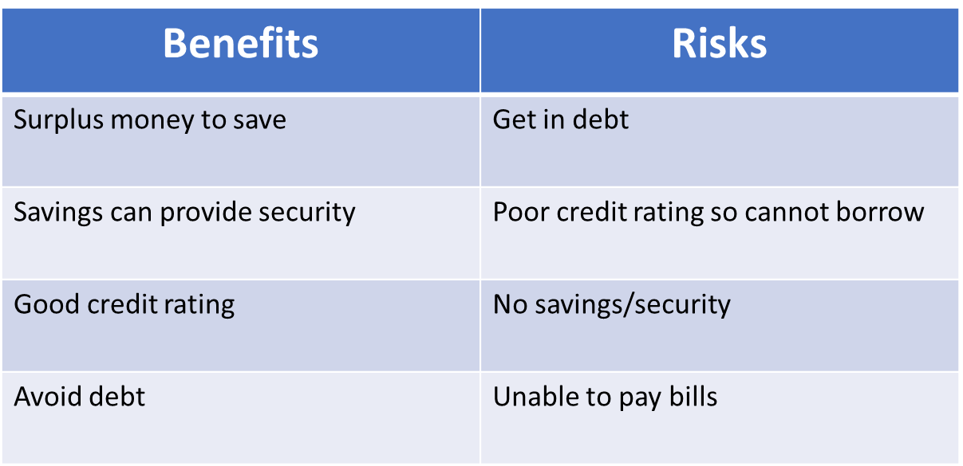**Activity 7 – Benefits and risks of not managing money**

Using the benefits and risks evaluate the importance of managing personal finances**.**

**Activity 8 – Knowledge Check A1**

List the four functions of money

Describe unit of account

Describe 3 roles of money

Explain the financial needs & implications of someone at the middle age stage

Outline 2 common principals when planning personal finance.

**Learning Outcome A2 – Different ways to Pay**

**Activity 9 - How do you pay for Goods and Services?**

List as many methods of payment as you can

Which one do you use the most and why?

Explain what makes something an effective payment method.

**Activity 10 - Word Search Different Ways to Pay**

|  |  |  |  |  |  |  |  |  |  |  |  |  |  |  |  |  |  |  |  |  |  |  |  |
| --- | --- | --- | --- | --- | --- | --- | --- | --- | --- | --- | --- | --- | --- | --- | --- | --- | --- | --- | --- | --- | --- | --- | --- |
| O | N | Y | S | C | S | P | I | Y | P | H | K | U | C | B | J | B | F | R | H | R | L | C | S |
| U | L | H | S | J | Z | W | W | D | R | G | T | G | Z | K | O | G | R | E | P | D | L | A | C |
| T | M | S | T | B | B | X | D | A | E | P | O | B | G | L | U | G | C | F | M | C | L | U | P |
| O | K | A | O | H | C | S | T | H | P | K | V | P | J | X | K | G | O | S | R | O | J | Y | V |
| N | Q | C | R | M | G | E | N | W | A | I | R | W | W | W | W | Q | N | N | D | W | Q | V | M |
| S | Q | F | E | N | I | G | G | B | I | M | R | S | H | O | K | C | T | A | O | S | X | D | F |
| D | P | M | C | I | J | R | M | Y | D | S | O | W | E | G | R | A | A | R | U | K | H | J | B |
| I | M | F | A | W | I | A | U | C | C | O | F | B | W | E | D | Q | C | T | A | I | O | Q | G |
| R | L | U | R | D | A | A | Q | H | A | X | U | H | D | R | C | K | T | C | L | F | W | N | F |
| E | P | H | D | C | T | Y | N | F | R | H | F | R | A | H | B | J | L | I | Y | D | K | Q | X |
| C | C | F | S | I | V | Q | S | Z | D | E | O | C | A | P | A | V | E | N | I | W | I | E | Y |
| T | U | N | V | V | G | I | P | W | S | G | T | R | I | M | U | Q | S | O | A | B | I | E | F |
| D | A | A | H | Y | U | U | H | C | N | I | G | E | X | A | N | U | S | R | Q | X | A | A | K |
| E | R | L | S | L | L | S | F | I | B | E | B | I | N | W | P | B | C | T | T | G | L | C | A |
| B | S | S | L | D | M | Q | D | E | C | E | X | S | V | H | X | Y | A | C | P | O | Y | A | S |
| I | Z | W | E | K | Y | N | D | A | H | C | P | M | U | U | H | Z | R | E | K | T | O | V | H |
| T | T | D | N | Q | A | U | R | L | F | S | L | G | U | J | N | E | D | L | U | U | P | D | L |
| U | G | R | Y | T | U | D | F | C | E | G | O | Q | T | Q | T | D | S | E | X | K | F | X | O |
| J | Q | N | S | H | S | R | W | P | F | D | X | C | N | G | E | T | I | Y | R | D | T | C | H |
| H | G | N | I | K | N | A | B | E | L | I | B | O | M | T | S | S | R | S | F | S | W | G | V |
| W | C | J | K | P | L | O | Z | H | C | Q | G | K | L | I | P | E | I | Y | P | I | U | S | B |
| K | T | C | H | E | Q | U | E | C | R | E | D | I | T | C | A | R | D | A | N | F | R | E | C |
| P | C | X | R | I | Z | F | Z | P | A | Q | B | H | U | T | O | N | H | P | V | W | N | A | R |
| Y | P | V | B | P | Q | T | U | H | Y | K | F | T | V | S | E | C | H | T | W | C | J | B | Y |

  CHAPS       FPS       BACS       mobile banking       store cards       charge cards       contactless cards       prepaid cards       standing order       direct debit       electronic transfer       cheque       credit card       debit card       cash

**Activity 11 – Methods of Payment**

If you have finished the word search for the methods of payment, then start filling in the explanations of each payment method in the table.

|  |  |  |  |
| --- | --- | --- | --- |
| **Payment Method** | **Explanation** | **Advantages** | **Disadvantages** |
| **Cash** |  |  |  |
| **Credit** |  |  |  |
| **Debit** |  |  |  |
| **Cheque** |  |  |  |
| **Contactless** |  |  |  |
| **Mobile banking** |  |  |  |
| **Direct debit** |  |  |  |
| **Standing order** |  |  |  |
| **Electronic transfer** |  |  |  |
| **Pre-paid card** |  |  |  |
| **Charge card** |  |  |  |
| **Store card** |  |  |  |
| **BACS** |  |  |  |
| **CHAPS** |  |  |  |

**Activity 12 – Payment Advantages & Disadvantages**

Go back to the table and write down the advantages and disadvantages of as many of the payment methods as possible.

**Activity 13 – Knowledge Check A2**

Using the explanation, advantages & disadvantages answer the following example exams questions.

Explain the difference between a debit card and a credit card

Explain the benefits of using BACS as a method of payment

Assess the benefits & drawbacks of using cash to pay for goods and services

Evaluate store cards as a method of payment

**Scenario**

Jason’s goes on holiday next week and cannot decide what payment method to use whilst on holiday. He has £1000 in spending money.

Argue whether he should use cash, debit card or credit card to pay for goods and services whilst on holiday.

Could you answer these questions if different methods of payment came up?

**Learning Outcome A3 – Current Accounts**

**Activity 14 - What are Current Accounts?**

Research and explain what a current account is and the common features that are part of a current account.

A current account is…

Common features of a current account are…

**Activity 15 - Video Activity on Current Accounts**

Along with an explanation of the accounts provide pros and cons of those accounts.

[Current Accounts Video Link](https://youtu.be/8HBF7SRXUhQ)

|  |  |
| --- | --- |
| **Standard** | **Premium/Packaged** |
| **Basic** | **Student** |

**Activity 16 - Current Accounts and Scenarios**

Read the information provided regarding a variety of accounts. Then for each scenario provide a **justified** recommendation of which account would be most appropriate for each scenario.

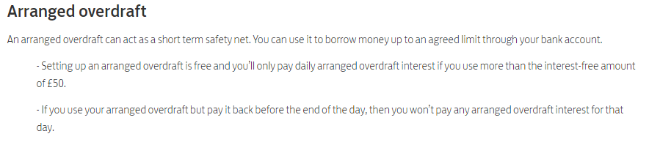**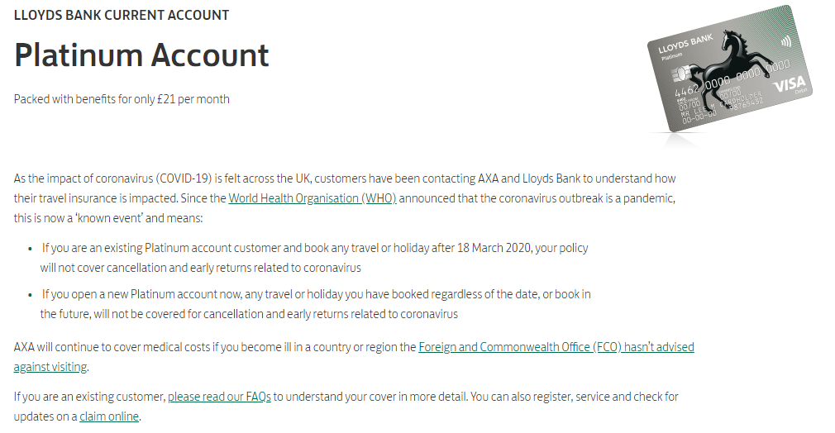Account 1:**

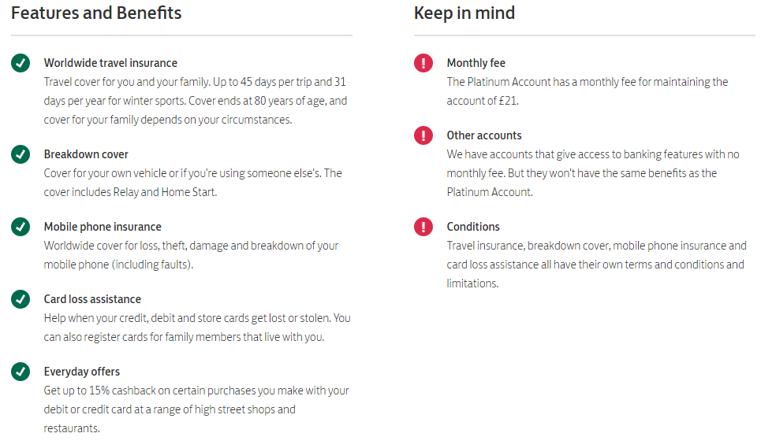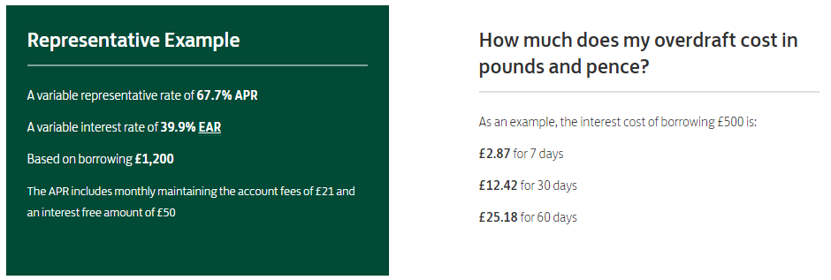

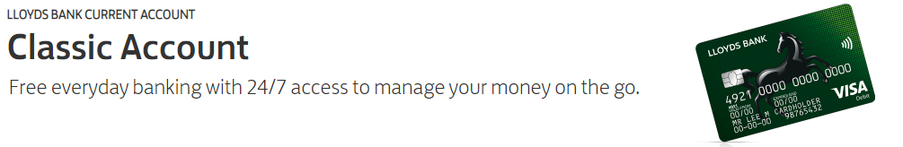**Account 2:**

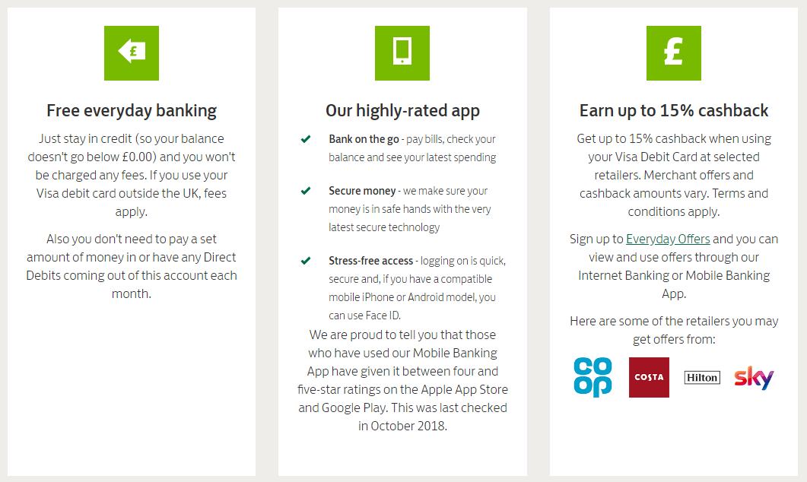

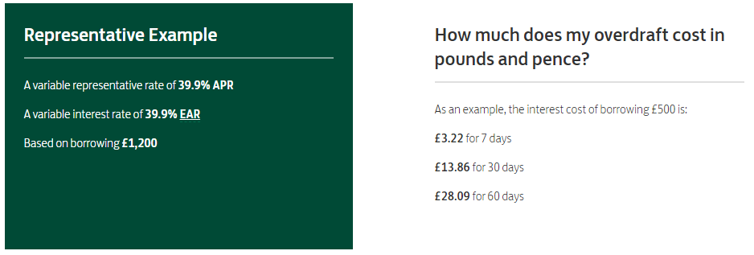

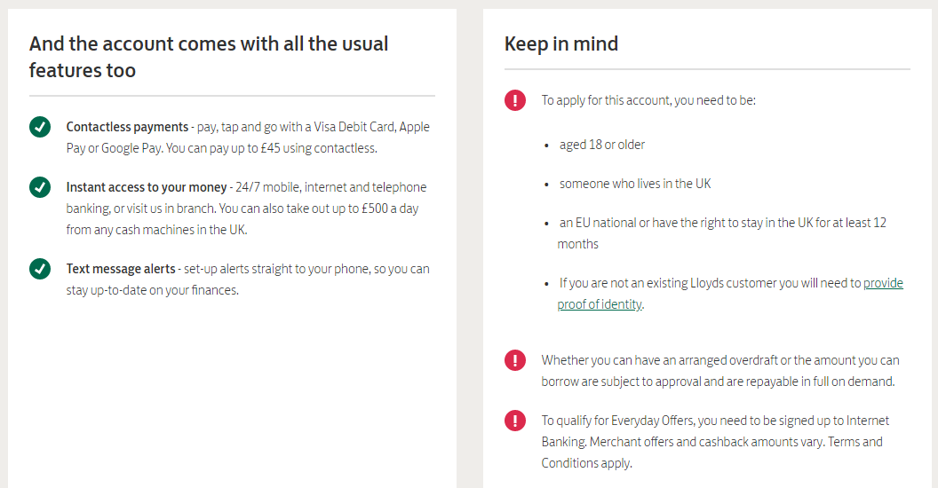

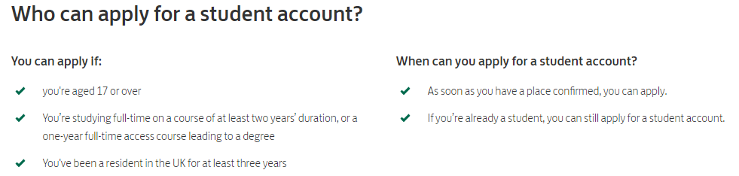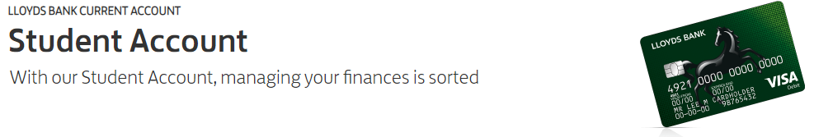**Account 3:**

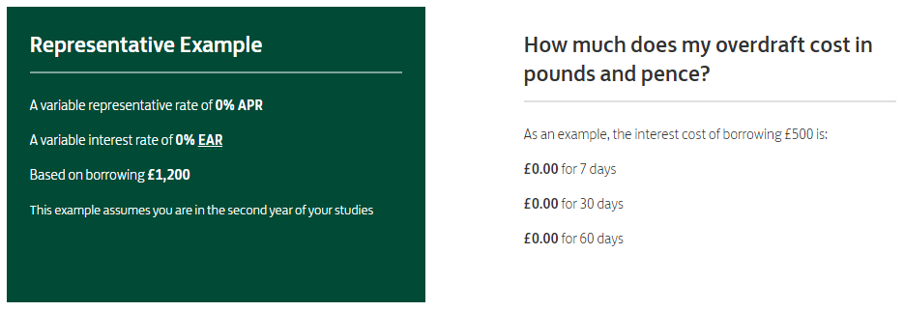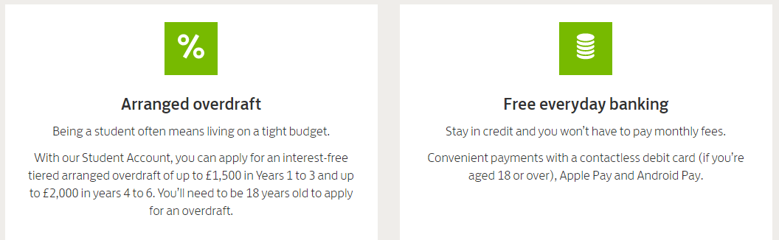

**Scenario 1**

Misha has a well-paying career, husband and 2 teenage children. They enjoy going on holiday abroad twice a year, have two cars and eat out often.

Assess the three account and justify which one would be suitable for Misha.

**Scenario 2**

Murray has a full-time job and lives alone. He is a part time studying a university degree. He travels to university once a week by train and very rarely eats out. His finances are good and has paid for his university fees with a student loan.

Assess the three accounts and justify which one would be most appropriate for Murray.

**Scenario 3**

**Kara is a full-time student and lives in student halls. She has no income except for £200 a month from parents. She enjoys socialising and has a lot of friends at university.**

Assess the three accounts and justify which one would be most appropriate for Kara.

**Activity 17 - Exam question**

Yasmin has just started university and is living away from home. She needs to open a current account so she can pay in her student loan. She is also looking for a part-time job and will need to have her wages paid into the current account each month. Her parents are worried that she might get herself into debt if she has a large overdraft. However, Yasmin will need books for her course and wants to make new friends through socialising and eating out.

Accounts available:

|  |  |  |  |  |
| --- | --- | --- | --- | --- |
| **Account** | **Interest paid on credit** | **Overdraft** | **Conditions** | **Perks** |
| 123 Student | None | £1000 year 1  £3000 year 2  £4000 year 3 | Must pay in £50 a month | Bose headphones  Laptop  Rail card |
| Student Smart | 1% | Up to £2000 a year | Online only | Food card  Breakdown cover |
| Student Wise | 1% up to £500  2% up to £1500  3% £1500+ | £1500 maximum | Must pay in £250 | Food card  Book club discount  Rail card |
| UniWise | None | £4000 maximum | None | Laptop when signing up  Rail card |

Evaluate the different current accounts available to Yasmin and recommend which type of current account would be best for her to open.

**Activity 18 – Knowledge Check A3**

List the 4 types of current account

Describe who a basic current account would be suitable for

Outline 2 features of a premium/package current account

Explain the key features of a student current account stating why these are useful for students

**Learning Outcome A4 – Managing Personal Finances**

**Activity 19 – Borrowing**

****Before we discuss the types of borrowing available. We need to see how you feel about borrowing money.

Assess how much you agree with this attitude to money expressed in the quote above (think about good and bad things that borrowing money may bring).

List the types of borrowing available

**1.**

**2.**

**3.**

**4.**

**5.**

**6.**

**Activity 20 - Different Types of Borrowing Crossword**

|  |  |  |  |  |  |  |  |  |  |  |  |  |  |  |  |  |  |  |  |
| --- | --- | --- | --- | --- | --- | --- | --- | --- | --- | --- | --- | --- | --- | --- | --- | --- | --- | --- | --- |
|  |  |  |  |  |  |  |  |  |  |  |  |  |  |  |  |  |  |  |  |
|  |  |  |  |  |  |  |  |  |  |  |  |  |  |  |  |  |  |  |  |
|  |  |  |  |  |  |  |  |  |  |  |  |  |  |  |  |  |  |  |  |
|  |  |  |  |  |  |  |  |  |  |  |  |  |  |  |  |  |  |  |  |
|  |  |  |  |  |  | 1 |  |  | 2 |  |  |  |  |  |  |  |  |  |  |
|  |  |  |  |  |  |  |  |  |  |  |  |  | 3 |  |  |  |  |  |  |
|  |  |  |  |  |  |  |  |  |  |  |  |  |  |  |  |  |  |  |  |
|  |  |  |  |  |  |  |  |  |  |  |  |  |  |  |  |  |  |  |  |
|  |  |  |  |  |  |  |  |  | 4 |  |  |  |  |  |  |  |  |  |  |
|  |  |  |  |  |  |  |  |  |  |  |  |  |  |  |  |  |  |  |  |
|  |  |  |  | 5 |  |  |  |  |  |  |  |  |  |  |  |  |  |  |  |
|  |  |  |  |  |  |  |  |  |  |  |  |  |  |  |  |  |  |  |  |
|  |  |  |  |  |  |  |  |  |  |  |  |  |  |  |  |  |  |  |  |
|  |  | 6 |  |  |  |  |  |  |  |  |  |  |  |  |  |  |  |  |  |
|  |  |  |  |  |  |  |  |  |  |  |  |  |  |  |  |  |  |  |  |
|  |  |  |  |  |  |  |  |  |  |  |  |  |  |  |  |  |  |  |  |
|  |  |  |  |  |  |  |  |  |  |  |  |  |  |  |  |  |  |  |  |
|  |  |  |  |  |  |  |  |  |  |  |  |  |  |  |  |  |  |  |  |
|  |  |  |  |  |  |  |  |  |  |  |  |  |  |  |  |  |  |  |  |
|  |  |  |  |  |  |  |  |  |  |  |  |  |  |  |  |  |  |  |  |

|  |  |
| --- | --- |
| **Across**  **4.** Withdraw money that you don't have from a current account & is suitable to meet short term needs  **5.** Long term loan to fund the purchase of assets. Paid back over a long period of time (25 years).  **6.** Short term source of finance to bridge the gap between wages. Suitable in emergencies at very high interest rates. | **Down**  **1.** Purchase an item in regular instalments. Item remains property of the seller until all payment are made.  **2.** Borrow a set amount of money for a specific purpose. Purchase items of higher value with regular payments  **3.** Goods are paid for by card. Paid at the end of a set period when a statement is issued. A minimum payment can be paid or the full amount. |

**Activity 21 - Provide Pros and Cons of Borrowing Options.**

Imagine you are working for a bank and you have been asked by your manager to create a guide to different types of borrowing available at the bank.

This can be in any format you wish but should include at least the following:

* An explanation of the type of borrowing
* The positives of that type of borrowing
* The drawbacks of that type
* Examples of when it would be appropriate to use this form of borrowing.

*Create your guide in this space, copy & paste it in from somewhere else or stick it in if created on another document.*

**Activity 22 - Case Study on Payday Loans and Questions**

Link - <https://www.thisismoney.co.uk/money/cardsloans/article-6232745/I-borrowed-100-night-payday-loan-sharks-ended-owing-19-000.html>

**Just when you thought you had read it all about payday loan sharks... 'I borrowed £100 for a night out and ended up owing £19,000'**

**Danny Cheetham got into debt after taking out a number of payday loans**

**Even though he was in financial difficult, firms kept loaning him money**

**Many payday loan companies use tactics to encourage you to borrow from them.**

He was a 19-year-old student at Salford University at the time and paying back £128 after 22 days didn’t sound like a bad deal.

But as soon as he cleared the first loan, the now-defunct Wonga offered him another. This time, he could have £420 for 38 days.

But when the time came to repay £585, an unexpected bill meant he didn’t have the money.

So, he went to another high-cost short-term lender to borrow £275. This grew into £538 with interest.

Over a decade, things began to spiral, with Danny bouncing between payday lenders, borrowing hundreds at a time to pay off the firms chasing him.

High-cost loans were transferred to his bank accounts within minutes following a text. Loans were approved despite Danny’s overwhelming debts.

Towards the end of last year, he was offered three separate loans totalling £1,240 before he had paid off the first.

In total, he thinks he has paid almost £19,000 in interest to payday lenders.

Danny, who had kept the mounting debts a secret from his family and friends, says: ‘It’s shocking how easy companies made it for me to borrow more. I was in trouble and thought these loans would ease the stress. But it never went to plan.’

Danny, now 29, has his debts under control and is set to be clear of them by the time he is 30.

But experts say his story highlights just how easy payday loan firms make it for people to rack up expensive debt.

And while Wonga is no more, there are dozens of other firms popping up in its place with even more ruthless tactics.

Some promise to put money in your account in as little as 90 seconds. Others allow borrowers to extend their loan just by sending a text message.

Some offer bonuses if you refer a friend and pay cashback if you borrow more. Another says it monitors customers bank balances and automatically tops up their account if it falls below a certain amount.

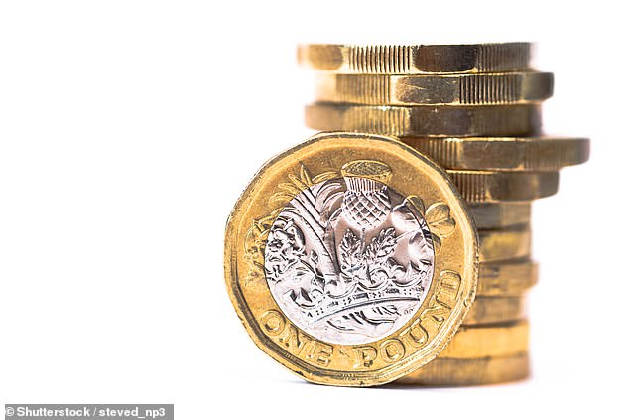Experts say that adverts targeting families and young people are normalising what is a very costly way to borrow money.

Some firms claim to be an ‘alternative’ to payday loans when, in fact, they work in much the same way.

Stella Creasy, Labour MP for Walthamstow, said: ‘High-cost credit companies hook people into a spiral of debt. Rather than treat people fairly and mend their ways, those same companies which offered eye-watering rates of interest are now simply changing the label on their loans.’

Lending Stream, which was set up in 2008, claims to be a responsible provider of alternatives to payday loans.

The firm, based in north London, says it can send money to your account in 90 seconds and will allow customers to take out multiple loans at a time.

New customers can borrow up to £800, while those returning can get loans of up to £1,500 over six months. Standard interest rates are 1,333 per cent but can be as much as 1,721 per cent.

Someone borrowing £200 over six months, for example, would have to pay back more than £386 including £186 in interest.

Another short-term lender, Oakam, also based in north London, offers borrowers points for referring friends and for making repayments, which can be turned into cash or vouchers.

You will also be paid £1 for every friend you invite to take out a loan through Oakam (up to five a week).

If they apply for a loan, you will get a further £3, plus £10 if they are approved.

The firm, set up in 2006, even rewards you with points for downloading and signing up for its mobile app.

But it charges up to 1,421 per cent interest on loans. So, if you were to borrow £800 over six months, you’d pay back £1,502.

Debt charity Stepchange says it is concerned that any incentives encouraging taking out credit could distract from the important things such as rates.

Launched in 2012, Safety Net Credit claims to be cheaper than an overdraft.

Customers are required to give the firm their sort code, account number, debit card details as well as internet banking passwords, so it can have access to their bank account. You set a balance level and when it falls below this, the firm automatically tops it up.

When you have enough funds, it helps itself to a repayment. Safety Net Credit charges 80p a day per £100 borrowed.

Interest is 68.7 per cent. So, £500 borrowed for a week would cost £28 in interest. The same overdraft would cost 70p with First Direct.

Ferratum, which was founded in Helsinki and has been operating in the UK since 2011, allows customers to apply for loans of between £50 and £1,000 by text message which can be approved within an hour. Interest is typically charged at 1,270 pc.

A spokesman for the Financial Conduct Authority (FCA) says: ‘Where we see breaches of our rules, we have a range of powers we can use to ensure people are being treated fairly and stop further harm. We welcome intelligence of firms failing to comply with our requirements and we assess all evidence we receive.’

A spokesman for Safety Net Credit says it offers a cheaper alternative to overdrafts and makes affordability checks. If the credit line becomes hard to manage it says it will work to resolve the situation.

Frederic Nze, founder of Oakam, says the firm was set up to help those with damaged credit histories gain access to funds and build better credit.’

Lending Stream says it makes detailed affordability checks. Ferratum did not respond to requests for comment.

**Case Study Questions**

**Ensure you have read the case study above.**

Why did Danny borrow from a payday lender?

What percentage did he have to pay back on top of his initial £100 loan?

%

Explain whether you think it is difficult to get approved for a payday loan

Over a decade how much has Danny paid back in interest?

£

How long can it take to get approved for a loan via text?

What tactics are payday lenders using to gain more customers and get existing customers to borrow more?

Generally, Credit cards have an interest rate of around 19%. What are the standard interest rates for the firm Lending Stream?

%

If you borrowed £800 from Oakam how much would you have to pay back over 6 months?

£

Using the questions you have answered above. **Evaluate the pros and cons of using Payday loans as a form of borrowing**

**Activity 23 – Borrowing Exam Question**

Assess the use of a credit card as a form of borrowing.

**Activity 24 - What ways can you save & invest?**

Deposit Account

ISA

Bonds & gilts

Premium bonds

**Saving & Investment**

Pension

Shares

**Activity 26 - Risks and Rewards of Saving Versus Investment**

[Risk and Rewards Video Link](https://youtu.be/_VHHq9BEnV8)

What would you do with £10,000 cash? (circle)

Spend Save Invest

Based on your answer above, explain your own attitude to saving and investment (are you high or low risk?).

Savings & investments advantages and disadvantages

|  |  |  |
| --- | --- | --- |
|  | **Advantages** | **Disadvantages** |
| Saving |  |  |
| Investment |  |  |

**Activity 27 – Which Account is Best?**

Georgia has just been given £25,000 from her Grandfather and wants to use this money for a deposit on a house in roughly 5 years’ time. She is aware that interest rates are low and has found 4 accounts that she thinks might be suitable to put the money she has received from her Grandfather. She is wanting to also save an additional £100 a month towards the deposit.

|  |  |  |
| --- | --- | --- |
| **Account** | **Interest & Charges** | **Features** |
| TT Cash ISA | No charges  1.4% AER return | Minimum of £500 to open  No withdrawal limits  Fixed interest rate |
| ABC Regular saver | No charges  0.6% AER return | No minimum investment amount  Instant access  Fixed interest rate |
| DC Fixed Rate Bond | No charges  2% AER Return | Minimum investment £4000  Five year bond  No withdrawals for 5 years |
| AN Stocks & Shares ISA | £50 annual account charge  0.5% dealing charge  Average 8% return (not guaranteed) | Tracks the top 500 USA companies  Withdraw investment anytime  Minimum monthly investment of £50 |

Evaluate which account would be most suited for Georgia in this situation

**Activity 28 - Insurance Types**

Car





Home





Life





Travel

Pet





Pet





Health





**Activity 29 – Insurance Higher or Lower?**

How much are these celebrities body parts allegedly insured for?

|  |  |
| --- | --- |
| **Celebrity & body part** | **Amount** |
| Rhianna Legs |  |
| Miley Cyrus Tongue |  |
| Ronaldo Legs |  |
| Keith Richards Hands |  |
| Daniel Craig Whole Body |  |
| Kim Kardashian Bum |  |
| Mariah Carey Legs |  |

Outline why these celebrities would insure their body parts for such large amounts.

Real Madrid was the ones that insured Cristiano Ronaldo’s legs. Explain the benefits & drawbacks of them doing this.

**Activity 30 – Knowledge Check A4**

Identify two advantages of using credit cards

Provide two disadvantages of a mortgage

Describe what a bond is

List the advantages and disadvantages of ISAs

Explain the risks and rewards of investing

Discuss the advantages and disadvantages of travel insurance

**Activity 32 – Learning Outcome A Word Scramble**

1. LLEAG TRNDEE ______________________________________

2. LTEOSNV ___________________________________________

3. EINTRTES RTAE _____________________________________

4. TFNOAINLI _________________________________________

5. HECARG CDRA _______________________________________

6. RTVAOEDFR _________________________________________

7. RNUCETR UNOCATC ___________________________________

8. OERMGTAG __________________________________________

9. MIRPEMU NBDO ______________________________________

10. FELI NCNEIASUR ____________________________________

**Activity 33 – Learning Outcome A Word Search**

|  |  |  |  |  |  |  |  |  |  |  |  |  |  |  |  |  |  |  |  |  |  |  |  |
| --- | --- | --- | --- | --- | --- | --- | --- | --- | --- | --- | --- | --- | --- | --- | --- | --- | --- | --- | --- | --- | --- | --- | --- |
| F | T | F | E | X | K | L | Q | P | L | I | F | E | E | V | E | N | T | S | R | T | A | T | V |
| K | Q | X | M | I | S | T | O | R | E | O | F | V | A | L | U | E | D | L | E | I | D | F | L |
| B | B | F | W | Y | C | C | C | A | Q | J | W | C | V | W | U | D | G | C | D | I | T | R | R |
| G | V | U | B | V | A | F | W | W | A | I | J | S | Z | Q | A | L | B | L | R | V | E | G | D |
| R | A | Y | J | E | C | N | A | R | U | S | N | I | E | F | I | L | Q | C | O | C | J | I | A |
| O | M | Z | D | E | B | I | T | C | A | R | D | I | U | X | G | P | P | V | G | O | N | V | W |
| X | P | P | Q | P | S | R | W | Q | S | W | O | P | A | P | I | Z | G | K | N | N | A | O | O |
| X | N | E | A | D | O | L | E | S | C | E | N | C | E | P | F | S | L | S | I | T | W | O | V |
| F | E | I | R | Y | X | P | N | J | V | S | E | T | S | T | O | T | T | S | D | R | H | T | Z |
| A | L | P | M | S | D | A | L | F | W | I | V | U | Y | B | H | F | B | D | N | O | L | G | D |
| W | J | S | C | K | O | A | Q | W | F | F | G | T | P | W | M | A | E | N | A | L | S | F | Y |
| E | D | F | R | K | W | N | Y | R | Q | U | H | A | B | J | I | R | D | O | T | C | T | M | H |
| A | P | Y | K | X | W | E | A | L | B | J | C | S | S | R | W | D | D | B | S | O | R | C | O |
| G | P | J | R | M | F | C | D | L | O | K | J | P | B | E | P | R | I | M | A | S | T | D | L |
| E | B | A | F | G | J | L | E | A | A | A | G | F | J | E | W | E | O | U | D | T | S | C | S |
| S | C | M | R | E | R | X | R | G | W | T | N | V | N | H | S | V | V | I | M | S | Z | Q | U |
| H | B | F | X | P | Z | P | E | U | S | V | T | S | Q | Y | J | O | A | M | W | H | T | V | F |
| P | I | Y | C | L | Y | A | A | P | R | T | I | I | B | G | Z | F | X | E | I | F | H | X | K |
| E | X | L | F | F | C | P | P | C | O | O | J | B | T | B | Y | Z | L | R | G | L | R | H | Q |
| N | Z | Y | Y | C | L | N | G | A | N | L | Z | K | F | U | F | B | T | P | N | V | K | A | B |
| U | L | R | O | N | S | K | J | S | I | M | S | B | N | U | D | P | K | V | V | O | T | Y | O |
| G | B | U | H | M | P | F | B | X | H | F | X | J | G | M | D | E | T | T | N | H | R | C | R |
| Z | N | Y | T | S | N | R | C | I | E | E | S | S | O | W | T | E | S | N | F | H | B | J | O |
| T | K | U | E | I | N | V | E | S | T | M | E | N | T | S | G | H | L | W | V | F | F | Q | V |

   Pensions       Life insurance       Investments       Premium bonds       Payday loan       Overdraft       Package account       Standing order       Debit card       Avoid debt       Control costs       Adolescence       Life events       Personal attitudes       Store of value

**Activity 34 – Learning Outcome A Crossword**

|  |  |  |  |  |  |  |  |  |  |  |  |  |  |  |  |  |  |  |  |
| --- | --- | --- | --- | --- | --- | --- | --- | --- | --- | --- | --- | --- | --- | --- | --- | --- | --- | --- | --- |
|  |  |  |  |  |  |  |  |  |  |  |  |  |  |  |  |  |  |  |  |
|  |  |  |  |  |  | 1 |  |  |  |  |  |  |  |  | 2 |  |  |  |  |
|  |  |  |  |  |  |  |  | 3 |  |  |  |  |  |  |  |  |  |  |  |
|  |  |  |  |  |  |  |  |  |  |  | 4 |  |  |  |  |  |  |  |  |
|  |  | 5 |  |  |  |  |  |  |  |  |  |  | 6 |  |  |  |  |  |  |
|  |  |  |  |  |  |  |  |  |  |  |  |  |  |  |  |  |  |  |  |
|  |  |  |  | 7 |  |  |  |  |  |  |  |  |  |  |  |  |  |  |  |
|  |  |  |  |  |  |  |  |  |  |  |  |  |  |  |  |  |  |  |  |
|  |  |  |  | 8 |  |  |  | 9 |  |  |  |  |  |  |  |  |  |  |  |
|  |  |  |  |  |  |  |  |  |  |  |  |  |  |  |  |  |  |  |  |
|  |  |  |  |  |  |  |  |  |  |  |  |  |  |  |  |  |  |  |  |
|  |  |  |  |  |  |  |  |  |  |  |  |  |  |  |  |  |  |  |  |
|  |  |  | 10 |  |  |  |  |  |  |  |  |  |  |  |  |  |  |  |  |
|  |  |  |  |  |  |  |  |  |  |  |  |  |  |  |  |  |  |  |  |
|  |  |  |  |  |  |  |  |  |  |  |  |  |  |  |  |  |  |  |  |
|  |  |  |  |  |  |  |  |  |  |  |  |  |  |  |  |  |  |  |  |
|  |  |  |  |  |  |  |  |  |  |  |  |  |  |  |  |  |  |  |  |

|  |  |
| --- | --- |
| **Across**  **5.** This is the normal account offered to customers with a reasonable credit rating  **7.** When these are low people are more willing to borrow money. When they are high there is more incentive to save.  **8.** Tax is not charged on interest earned in this type of saving or investment  **9.** At this life stage you have; fewer dependents, may downsize and have fewer financial needs.  **10.** This function of money allows us to trade easily and purchase items using money rather than a barter system | **Down**  **1.** This type of borrowing can encourage overspending on consumer goods  **2.** This method of payment is convenient as it can be accessed 24/7  **3.** Third party, third party fire and theft and fully comprehensive are types of what insurance?  **4.** An advantage of this type of borrowing is that it allows customers to spread the cost of an expensive item over a long period (25 years)  **6.** Prices fluctuate, and this investment is considered higher risk |

**Activity 35 - Personal & Business Finance Outcome A Checklist**

Well done, you have now completed the input and set activities for Learning Outcome A, you have one final task which is to complete the specification checklist below. First, you should explain the terminology and topic areas in the space provided and then tick the box in the last column when you feel exam ready with regards to that specific element of the specification.

|  |  |  |
| --- | --- | --- |
| **Unit 3: Personal and Business Finance Checklist** | | |
| **Learning Outcome A: Understand the importance of managing personal finance.** | | |
| **Topic** | **Your explanation of the terminology** | **Exam ready?** |
| **A1 - Functions and Role of Money** | |  |
| Functions of money:   * unit of account * means of exchange * store of value * legal tender |  |  |
| Role of money is affected and influenced by a number of factors:   * personal attitudes * life stages * culture * life events * external influences * interest rates |  |  |
| Planning expenditure, common principles to be considered in planning personal finances:   * to avoid getting into debt * to control costs * avoid legal action and/or repossession * remain solvent * maintain a good credit rating * avoid bankruptcy * to manage money to fund purchases * generate income and savings * set financial targets and goals * provide insurance against loss or illness * counter the effects of inflation. |  |  |
| **A2 – Different Ways to Pay** | |  |
| The use of money as a payment method, advantages and disadvantages of:   * cash * debit card * credit card * cheque * electronic transfer * direct debit * standing order * pre-paid cards * contactless cards * charge cards * store cards * mobile banking * Banker’s Automated Clearing Services (BACS) * Clearing House Automated Payment System (CHAPS) |  |  |
| **A3 – Current Accounts** | |  |
| Different types, features, advantages and disadvantages, different services offered:   * standard * packaged, premium * basic * student |  |  |
| **A4 – Managing Personal Finance** | |  |
| Different types of borrowing, features, advantages and disadvantages:   * overdraft * personal loans * hire purchase * mortgages * credit cards * payday loans |  |  |
| Different types of saving and investment features, advantages and disadvantages:   * individual savings accounts (ISAs) * deposit and savings accounts * premium bonds * bonds and gilts * shares * pensions |  |  |
| Risks and rewards of saving versus investment |  |  |
| Different insurance products:   * products (car, home and contents, life assurance and insurance, travel, pet, health) * different types of insurance policy for each product * features of different types of insurance * advantages and disadvantages of different types and features. |  |  |