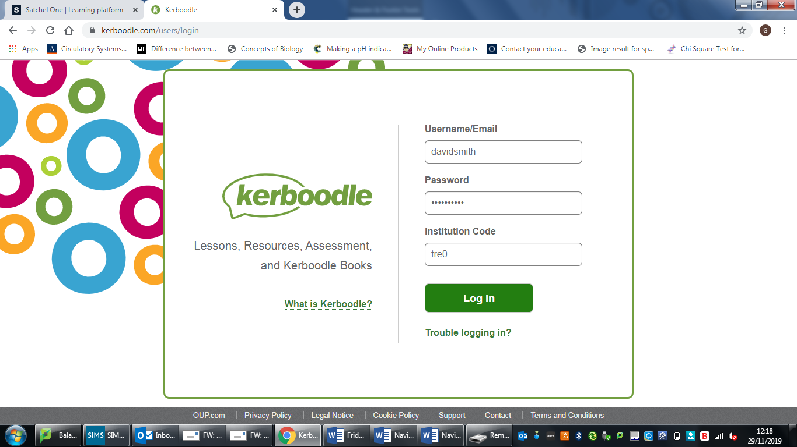

Fill in your username, password and institution code.

Then click on ‘Log in’.

e.g. username - davidsmith

password - davidsmith

Institution code - tre0

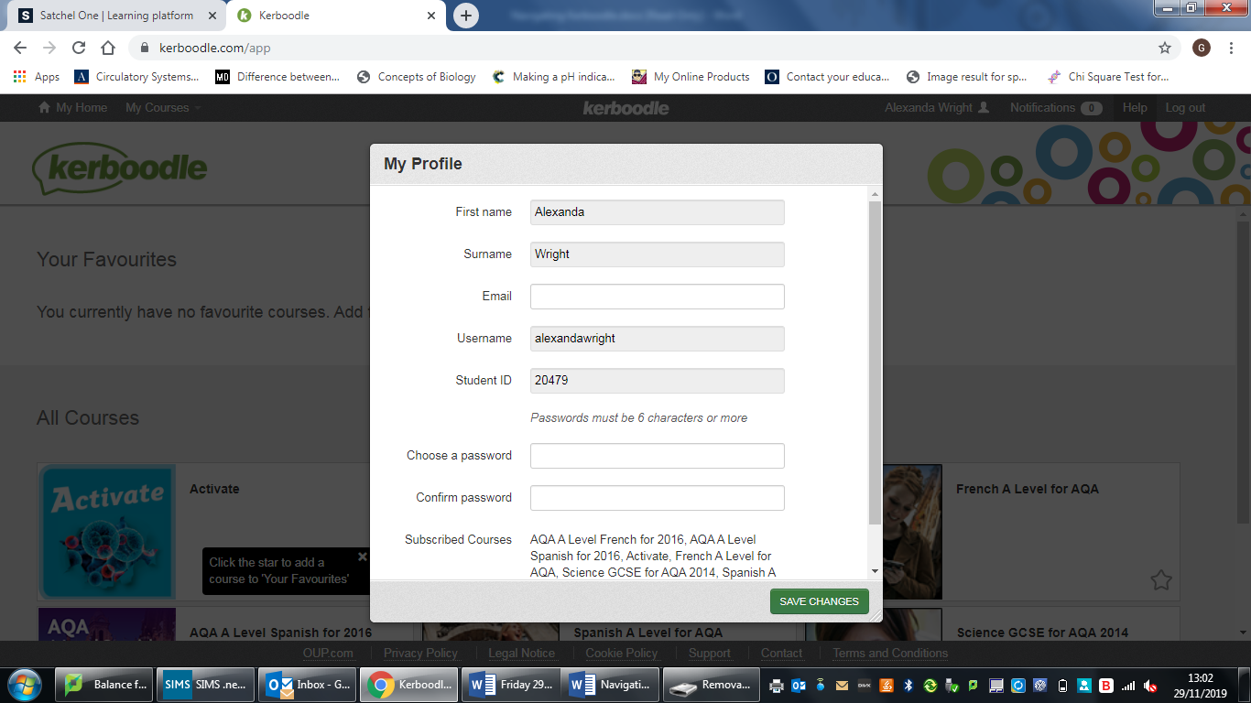

davidsmith

Smith

David

You will need to enter a new password in the section “choose a password”.

You will then need to retype this password in the “confirm password” section.

Then click the “SAVE CHANGES” button.

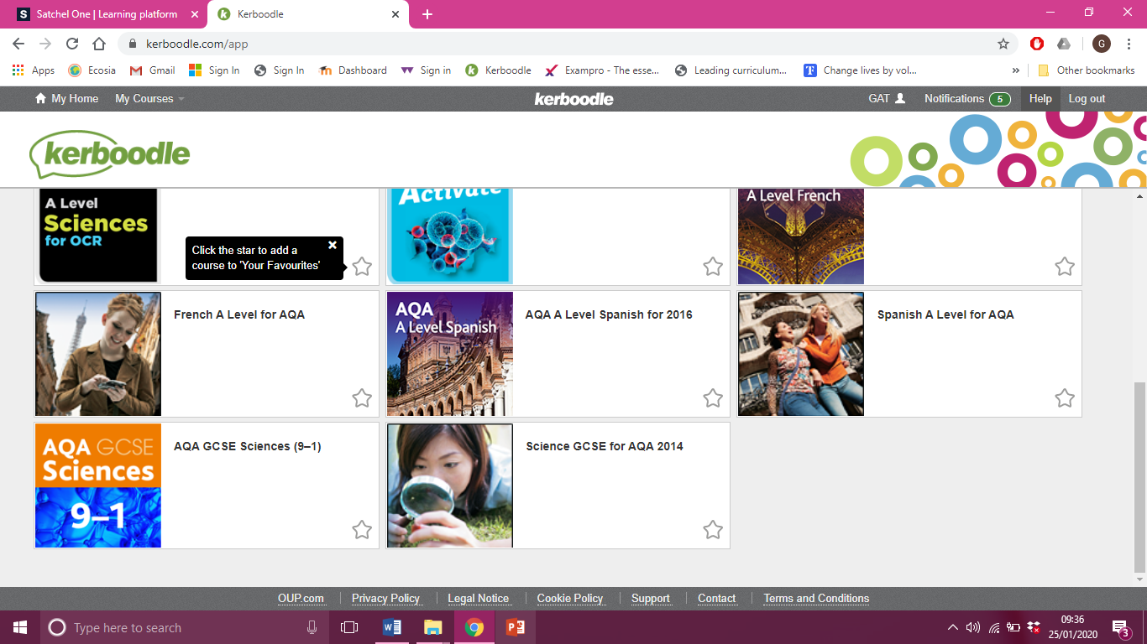

Once logged in you will see the courses, select ‘A Level Sciences for OCR’.

Click the star to mark this course as a ‘favourite’ so that it is easier to find next time.

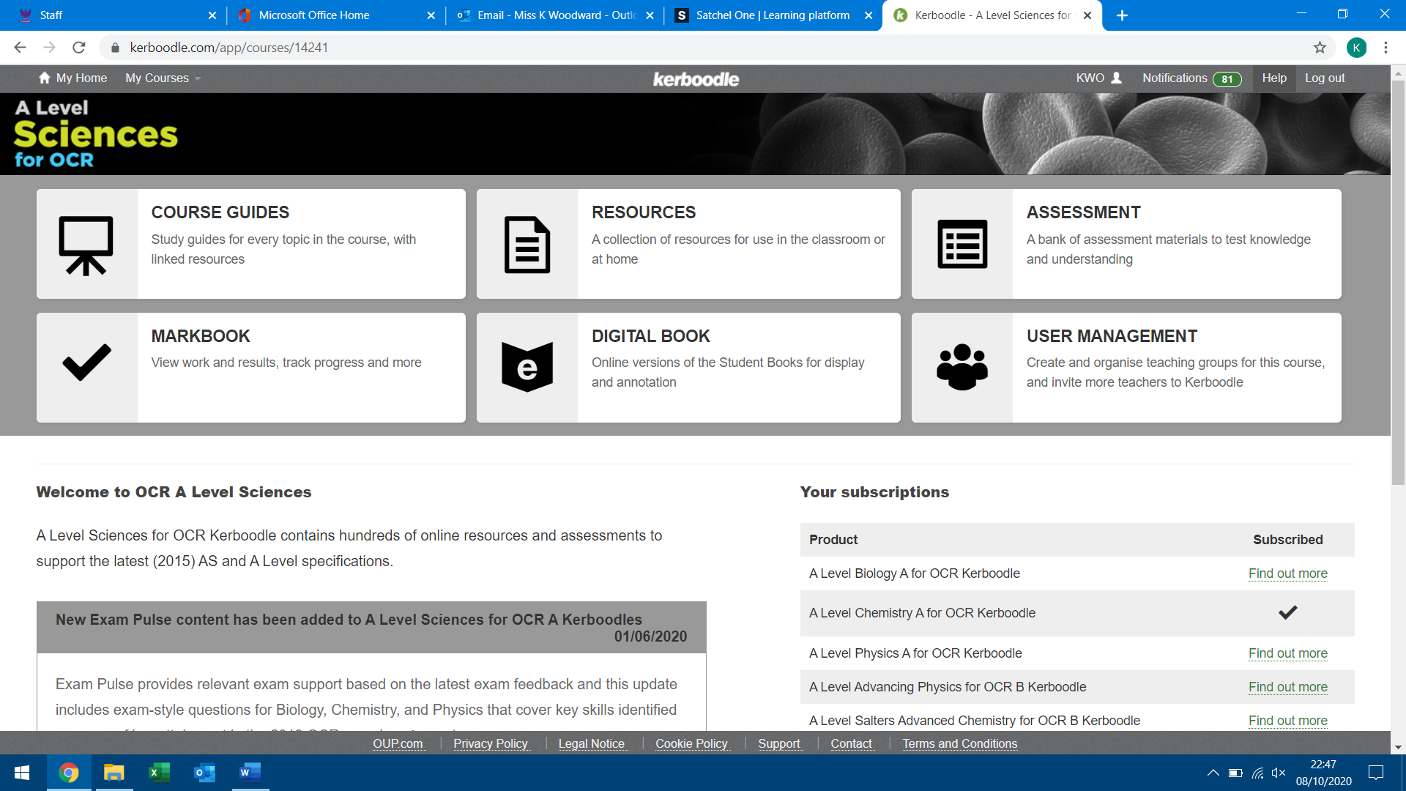

Click here to get to the online textbook.

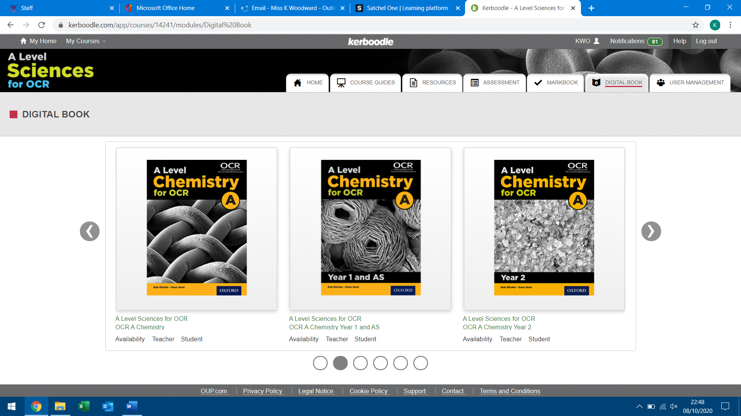

Select the correct OCR Chemistry A digital book – the first one covers both years. Alternatively select Year 1 for Y12 content or Year 2 for Y13 content.

There are many books to choose from, click the arrows to scroll through. For example, if you study triple biology you will need to click the book “AQA Biology Third Edition”. I have highlighted this book with a red border in the image above.