|  |
| --- |
| Name: Date: |

# 2. Statement of financial position

Do now activity

|  |  |
| --- | --- |
| **Question:** | **Your answer:** |
| What is the ‘break-even point’? |  |
| Where is profit on the break even graph? |  |
| Explain what is meant by opening balance in cash flow forecasts |  |
| What is meant by ‘margin of safety’? |  |
| What is net profit? |  |

**Statement of financial position**

A statement of financial position is a snapshot of a business’ net worth at a particular moment in time, normally at the end of a financial year. It is a summary of everything that the business owns (assets) and everything that the business owes (liabilities). A statement of financial position therefore states the value of a business.

|  |  |
| --- | --- |
| **Assets** |  |
| **Liabilities** |  |

In our own words describe what a statement of financial position is:

|  |
| --- |
|  |

Statements of financial position can be shown in a vertical or horizontal format, vertical being the most common, and therefore the style of presentation you will use in the exam

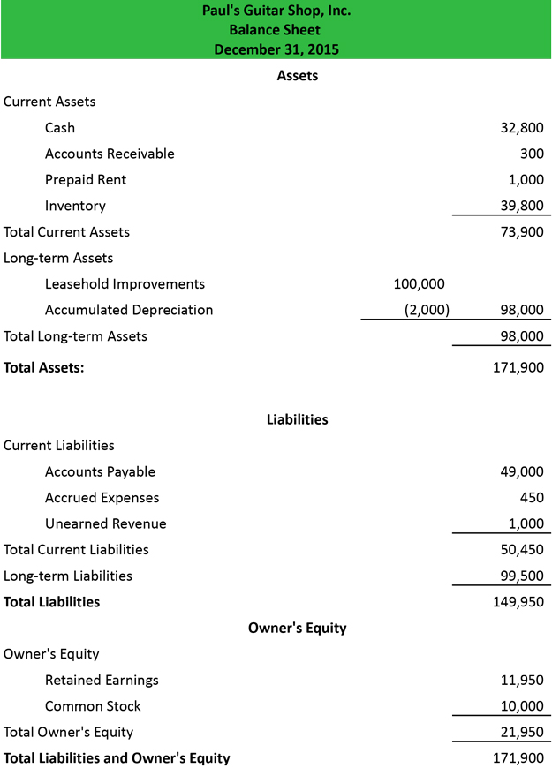A vertical statement of financial position will be presented like this:

|  |  |
| --- | --- |
| **Current assets** |  |
| **Non-current assets** |  |
| **Current liabilities** |  |
| **Non-current liabilities** |  |

***Task:*** sort the following into the correct headings

Inventories, overdrafts, trade receivables, pre-payments, cash, trade payables

|  |  |
| --- | --- |
| **Current assets** | **Current liabilities** |
|  |  |
|  |  |
|  |  |

**Net current assets/liabilities** (also known as working capital)

This represents the business’ ability to meet short-term debts

*Formula:*

*Current assets – Current liabilities*

If the number is positive, the business is able to cover its liabilities

If the number is negative, the business is unable to cover its liabilities

**Net assets**

This is also known as net worth.

*Formula:*

*Assets – Liabilities*

***Task:***

1. Amin’s business is at the end of its first year of trading. He has £110,00 of assets and £80,000 of liabilities. What information can be discovered using these figures?

___________________________________________________________________________

___________________________________________________________________________

|  |  |
| --- | --- |
| **Capital** | Either cash or other assets that have been introduced or removed from the business |
| **Retained profit** | Profits kept from previous years plus the net profit from the current year |
| **Drawings** | Withdrawals made by owners (wages, salaries) |
| **Capital employed** | The total amount of capital tied up in a business at a point in time |

1. Which **two** of these statements best describe a statement of a financial position?

* **A snapshot of the profit and loss made by a business**
* **A snapshot of a business’ finances at a particular point in time**
* **An account of cash flow over a 12-month period**
* **A summary of the money invested in a business and what it has been spent on**
* **A summary of the liabilities of a business**

1. Create a statement of financial position for Ben’s Factory using the following information:

Overdraft = £12,389

Debtors = £21,455

Capital = £60,000

Stock = £34,294

Retained profit = £126,682

Bank loans = £50,998

Premises = £189,120

Creditors = £17,881

Fixtures and fittings = £22,700

Cash in hand = £381

Ensure you work out which are current assets, non-current assets, current liabilities and non-current liabilities.

You will also need to work out the WORKING CAPITAL and CAPITAL EMPLOYED.