Name: Date:

Learning aim F: Complete statements of income & financial position and evaluate performance

Statement of comprehensive income
Question: | Your answer:
Give an example of a cash inflow
Give an example of a cash outflow
Explain what the break-even point means
What is meant by margin of safety?
Identify one internal source of finance
Identify one external source of finance
Do now activity:

Statement of comprehensive income
At the end of the year, there are two financial documents businesses will produce:
- Statement of comprehensive income
- Statement of financial position (next lesson)
A statement of comprehensive income, if produced correctly, will give an accurate calculation showing how much profit or loss the business has made. It records sales, costs and profit over a period of time (normally a year).
Statement of comprehensive income | Shows the trading position of the business which is used to calculated gross profit. It then takes into account all other expenses to calculate the profit or loss for the year.
Statement of financial position | A snapshot of a business’ net worth at a particular moment in time, normally the end of the financial year
Gross profit:
Gross profit is the amount of money left or the surplus after the costs of goods sold has been deducted from the sales revenue/turnover. This is not the business’ final profit as there are still other expenses to deduct in the next part of the account.
Gross profit = sales turnover – cost of goods sold
Cost of goods sold = opening inventories + purchases – closing inventories
Profit or loss for the year:
Profit or loss for the year = gross profit – expenses + other income

Statement of comprehensive income formula sheet
Turnover
Cost of sales/costs of goods sold | Opening inventories + purchases – closing inventories
Gross profit | Turnover – cost of sales
Expenses | All the indirect costs of a business eg salaries, admin, bills
Net profit | Gross profit – expenses  (Amount of money left after all expenses are deducted)
Revenue
- Cost of sales
= Gross profit
- Expenses
= Net profit

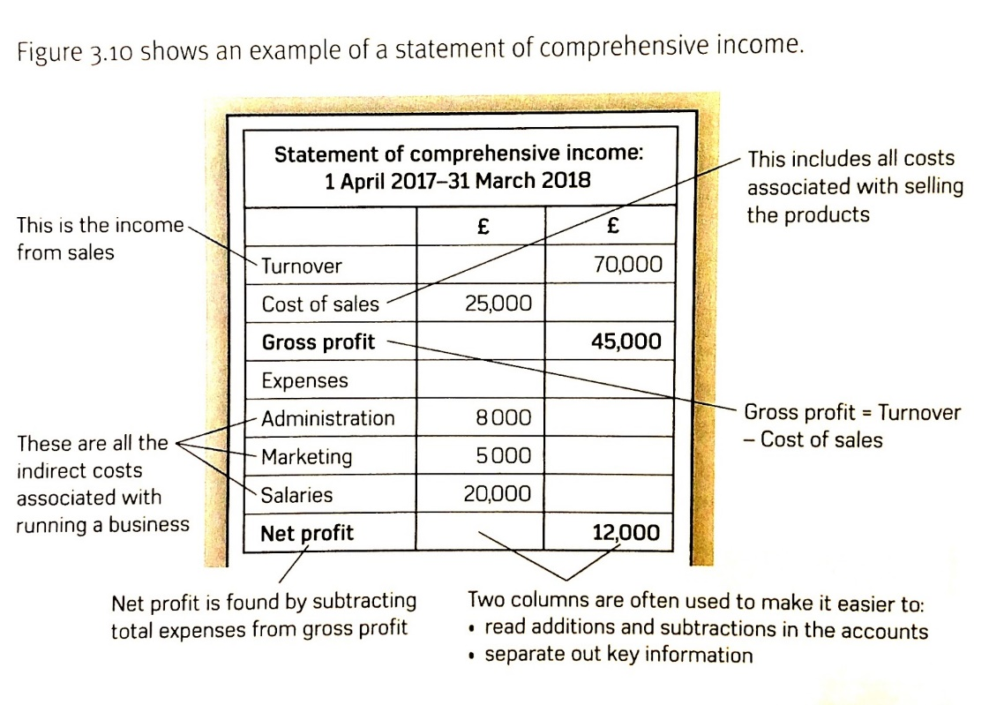
Statement of comprehensive income:

The difference between expenses and cost of sales:
Expenses | Cost of sales
These are the indirect costs the company incurs. They are not associated with the products themselves.  Examples:  - Advertising  - Rent  - Manager’s salaries  - Utility bills | The cost of producing the business’ products. These are directly related to the products themselves.  Examples:  - Raw materials  - Labour

Task: Using a furniture company as an example, label whether these are expenses or cost of sales
- Rent
- Wood
- Nails and screws
- Transport
- Electricity
- Insurance
- Marketing
- Wages (direct or indirect)
- Salaries

What is the purpose of a statement of comprehensive income? (discuss in your pairs for 1 minute and be ready to share your ideas)

Practice:
- Tony has started a taxi business in his hometown. He made £55,000 from customers in sales revenue. His cost of sales was £22,000. His other expenses are as follows:
Advertising = £12,300
Car leasing = £5,600
Salaries = £7000
Utility bills = £6,500

Using the information above (you can refer to the statement given to you on page 2 so you know how to set it out), draw a statement of comprehensive income. Once you have done this calculate net profit and add it to the statement of comprehensive income.

- How will Tony’s net profit change if the minimum wage increases?
___________________________________________________________________________

- Mo has started a waffle house in his Shepherd’s Bush. He made £43,000 in his first year of opening. His cost of sales was £10,000. His other expenses are as follows:
Advertising = £7000
Rent = £10,000
Salaries = £5500
Utility bills = £6,000
Using the information provided draw up a statement of comprehensive income.

Depreciation
Some assets such as machinery, equipment, furniture and vehicles lose their value over time. Depreciation is used to show the fall in value. It is an expense on the business’ accounts.
There are two methods to look at depreciation:
- Straight line depreciation: an asset is depreciated by a set amount each year
- Reducing balance depreciation: an asset is depreciated by a set % of its remaining value each year

- Straight line depreciation:
Historic value – residual value
Expected life

Practice
Calculate the depreciation of a Ford transit van that cost £16,000 and was expected to be used in the business for 4 years with a resale value of £4000.

- Reducing balance depreciation
The reducing balance method involved reducing the value of the asset by a set percentage each year. The percentage is decided by a senior accountant and stated in the financial reports. This method depreciates an asset by a lower amount as the asset ages.
If, therefore, a Ford transit cost £16,000 and a decision was made to depreciate it by 20 per cent per year the depreciation would be calculated as:
Historic cost = £16,000
Year 1 depreciation = £16,000 × 0.20 = £3200
Net book value = £16,000 – £3200 = £12,800
Year 2 depreciation = £12,800 × 0.20 = £2560
Net book value = £12,800 – £2560 = £10,240
Year 3 depreciation = £10,240 × 0.20 = £2480
Net book value = £10,240 – £2480 = £7760

Practice
The historic cost of a car is £20,000. If the car is bought for £10,000 and a decision was made to depreciate it by 16% per year, calculate the worth of the car after three years.

Knowledge check questions
What are the two methods of depreciation?

Explain what depreciation is?
What is the purpose of a comprehensive statement of income?
Does money leaving the account go on the right or the left side of the comprehensive statement of income?
What is the difference between expenses and cost of goods sold?

How do you calculate gross profit?
How do you calculate net profit?
Explain how net profit is different to gross profit.

Are salaries an expense of a cost of sales?
Are raw materials an expense or a cost of sales?
Is rent an expense or a cost of sales?

