|  |
| --- |
| Name: Date: |

# 2. Communicating with customers

Do now activity:

|  |  |
| --- | --- |
| **Question:** | **Your answer:** |
| State 3 financial organisations |  |
| What is a pension? |  |
| What is a credit union? |  |
| What is the gold vault? |  |

**Communicating with customers**

Traditionally, banking was carried out face-to-face where there was a personal relationship between the bank manager and clerk and the customer. The bank manager was seen as as a figure of authority in the community. Over time, this relationship has become less common and, as banking organisations have grown, the service has become less personal.

Changes in technology have also changed the way in which the banking industry operates.

***Think, Pair, Share:***

1. How has technology affected how banking operates?
2. Has it had a positive or negative effect?
3. How has it affected customers of different ages?
4. How has it affected employees?

|  |
| --- |
|  |

***Task: List the different ways a bank could communicate with its customers: (independent task)***

|  |
| --- |
|  |

***Task:*** Read through the advantages and disadvantages of each method of communicating with customers and fill the empty box with which method of communicating it is.

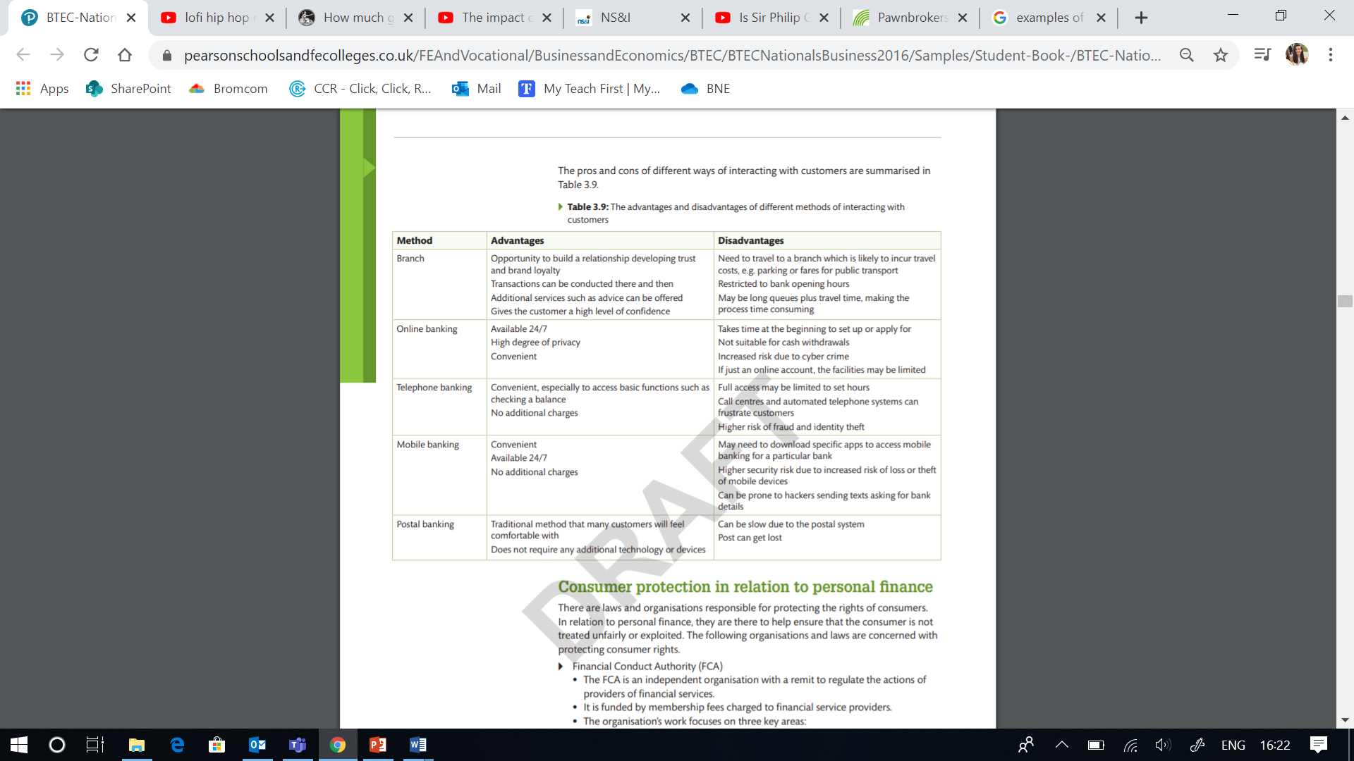

**Knowledge check questions:**

|  |  |
| --- | --- |
| State 3 methods of communicating with customers |  |
| What are the advantages of communicating with customers in person? |  |
| Why might a customer not be happy to communicate over a mobile device? |  |
| Which age group may wish to communicate with a person in a branch? Why? |  |
| Which method of communicating has a high risk of fraud or identity theft? |  |
| Why might someone prefer to do online banking than mobile banking? |  |
| State an issue that may occur with postal banking |  |
| What is the most traditional way to communicate with customers? |  |
| In what method of banking/communicating should people be wary/careful of hackers? |  |