|  |
| --- |
| Name: Date: |

# Learning Aim B: Explore the personal finance sector

# Features of financial institutions

Do now activity:

|  |  |
| --- | --- |
| **Question** | **Your answer** |
| Give two examples of a financial service |  |
| State two types of borrowing |  |
| What is insurance? |  |
| State three methods of payment |  |
| What is expenditure? |  |
| What is bankruptcy? |  |

**Features of financial institutions**

Financial institutions are organisations that offer financial services to individuals or businesses. The services include the ability to deposit or withdraw money, obtain credit and make investments, as well as offering advice on matters of personal and business finance.

Financial institutions:

1. Bank of England
2. Banks
3. Building societies
4. Credit unions
5. National Savings and Investments
6. Insurance companies
7. Pension companies
8. Pawnbrokers

. 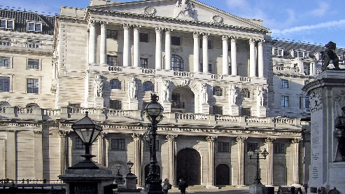

1. **Bank of England**

* This is the UK’s central bank with responsibility for maintaining a healthy level of financial stability for the UK as a whole.

***Think, Pair, Share:*** In pairs – what do you think the Bank of England does? Think back to what you learnt at GCSE.

|  |
| --- |
|  |

Video - <https://www.youtube.com/watch?v=cmzXGgzWH7g>

***Task:*** Watch the video and take notes:

|  |
| --- |
|  |

The Bank of England has an extensive ‘Gold Vault’, with a value of over £100 billion.

<https://www.bankofengland.co.uk/knowledgebank/how-much-gold-is-kept-in-the-bank-of-england>

***Task:*** Watch the video and take notes:

|  |
| --- |
|  |

1. **Banks**

* Banks handle all manner of financial transactions and stores money on behalf of their customers.
* Services include holding deposits, making payments and supplying credit.

***Think, Pair Share –*** Banks are in decline in the UK, why is this?

|  |
| --- |
|  |

<https://www.youtube.com/watch?v=uhqAxj-B_S8>

|  |
| --- |
| Video notes:  Impact of banks closing –  Why banks are in decline – |

1. **Building societies**

* A building society is partially owned by its members. A building society carries out the same primary functions of a bank but has a different ownership structure.
* Nationwide is the world’s largest building society and has over £15 million members.
* Nationwide has no shareholders (in the way that banks do).

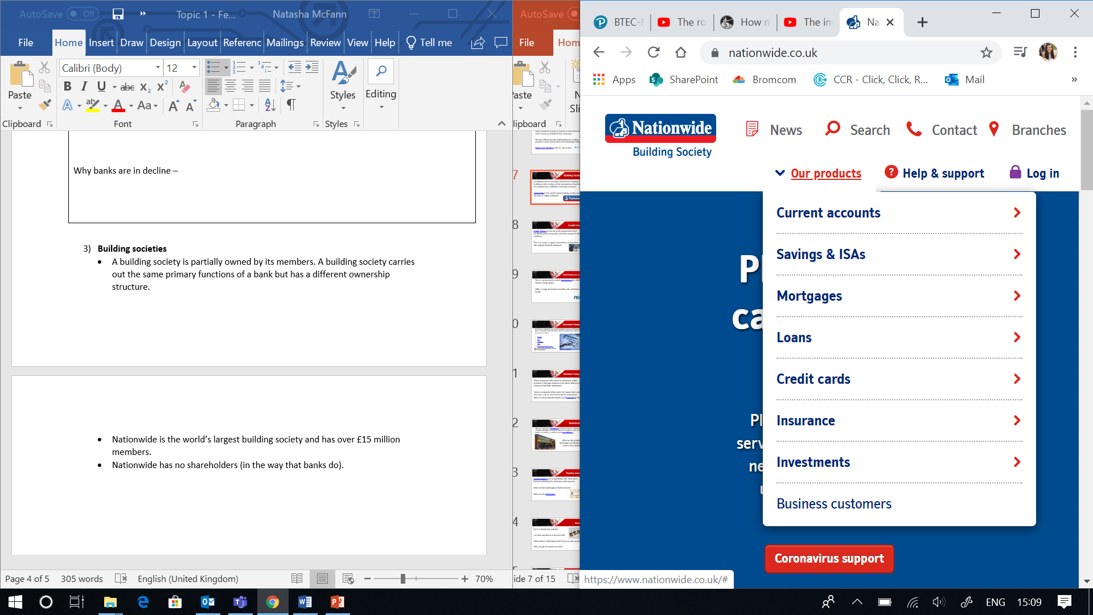

1. **Credit unions**

* Credit unions are not-for-profit organisations that can handle financial transactions and store money for their members.
* This is to create a support network for communities who require financial assistance.

<https://www.youtube.com/watch?v=_UgjGjf3sOk>

|  |
| --- |
| In your own words explain what you understand by a credit union (based on the video): |

1. **National Savings and Investments**

* This is a government backed organisation that offers a secure savings option
* 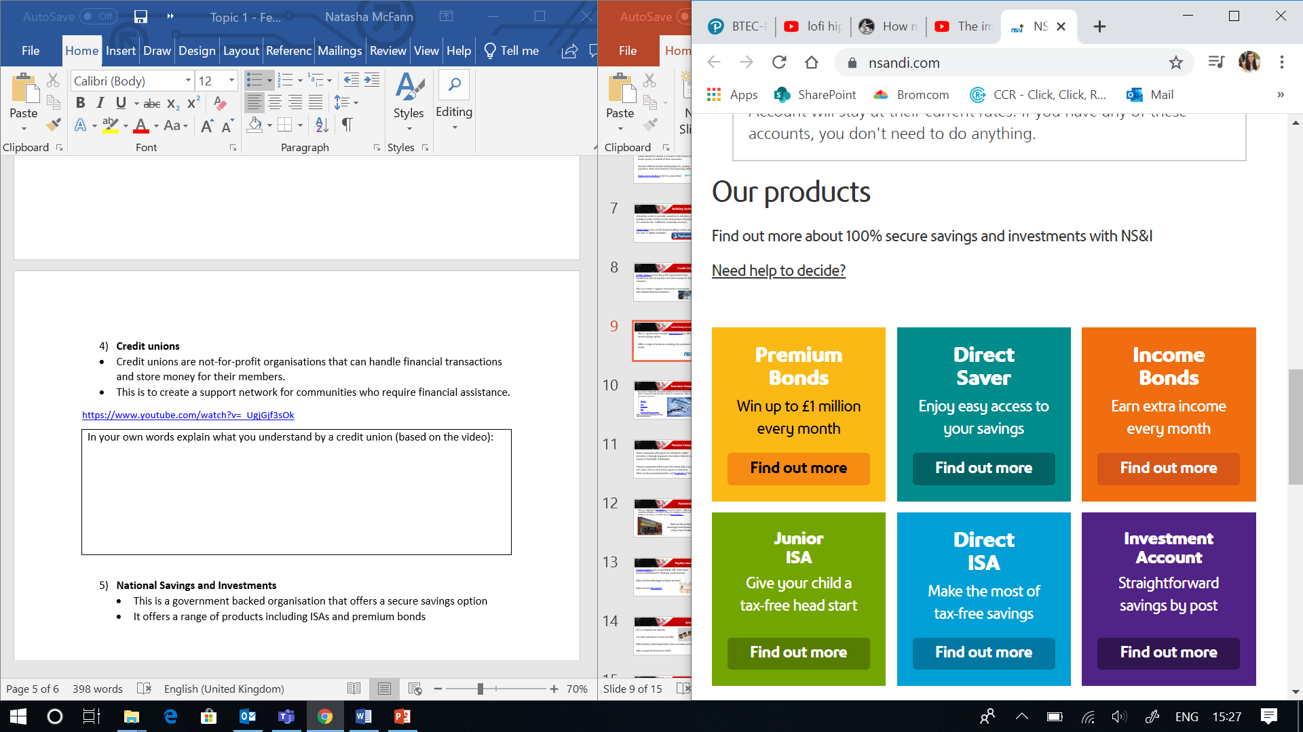It offers a range of products including ISAs and premium bonds

<https://www.nsandi.com/>

1. **Insurance companies**

* Insurance companies are profit-making businesses that protect their customers from the risk of loss for a premiums.

***Task:*** List as many types of insurance you can remember –

|  |
| --- |
|  |

What is the disadvantage of having insurance? _____________________________________

1. **Pension companies**

* These companies sell policies to individuals, either privately or through employers that allow them to save money to fund their retirements.
* Pension companies often invest the money that is saved into areas such as stock and property investments.

|  |
| --- |
| In your own words (based on teacher explanation) explain what you understand by ‘a pension’: |

<https://www.youtube.com/watch?v=zZN0w3ElOtY>

Drawbacks of pensions – make notes on key findings from video:

|  |
| --- |
|  |

1. **Pawnbrokers**

* When you approach a pawnbroker, you have 2 choices: either to leave something valuable as security for a loan, for example, an asset such as jewellery or an antique, or sell the item to the pawnbroker.
* You hand over the item to the pawnbroker and they will value it for you. You will then get your loan and you sign an agreement which sets out how long the loan lasts and how much it will cost. It will usually be a minimum of 6 months but you can agree longer or shorter.
* You can redeem the pawn at any time by paying what you owe and getting the item back. If you don’t repay the loan during the redemption period, the pawnbroker can sell it to recover the cash.

<https://www.youtube.com/watch?v=S6xludu4jgY>

**Questions**

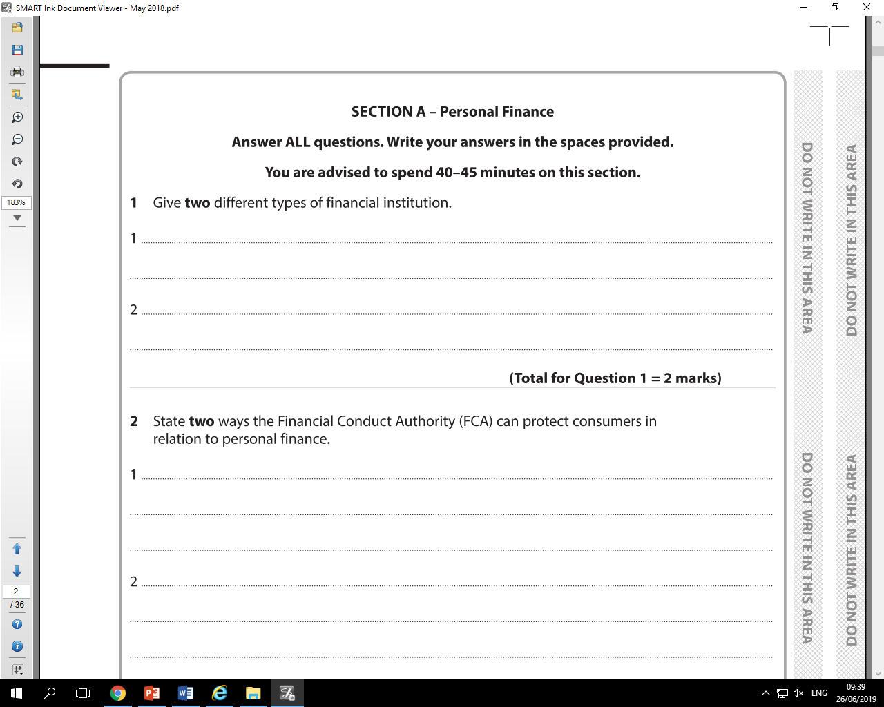

2) What is the difference between a credit union and a bank?

___________________________________________________________________________

___________________________________________________________________________

___________________________________________________________________________

___________________________________________________________________________

3) What is the difference between a bank and a credit union?

___________________________________________________________________________

___________________________________________________________________________

4) What is the difference between a bank and a building society?

___________________________________________________________________________

___________________________________________________________________________

5) Describe what a pawnbroker is

___________________________________________________________________________

___________________________________________________________________________

___________________________________________________________________________

___________________________________________________________________________

___________________________________________________________________________

___________________________________________________________________________