|  |
| --- |
| Name: Date: |

# Managing personal finance

|  |  |
| --- | --- |
| **Question:** | **Your answer:** |
| What are the 4 types of current account? |  |
| Give two features of a current account |  |
| Give two factors which influence the role of money |  |
| List 4 ways to pay |  |
| What is inflation? |  |
| What is a key difference between a debit card and a credit card? |  |

Do now activity:

Businesses usually offer more than one product. They offer different products to appeal to different customers. For example, Ford will have different cars to match different incomes, lifestyles, family sizes and preferences. This is also true of banks. Banks offer a range of products to match the needs of different individuals. Financial services include borrowing. There are different types of borrowing to suit different customers.

**Different types of borrowing**

|  |  |  |  |
| --- | --- | --- | --- |
| **Type of borrowing** | **Explanation** | **Advantages** | **Disadvantages** |
| *Overdraft* | This allows you to withdraw money that you do not have from a current account  It may be suitable to meet short term needs, for example a shortage of cash just before payday |  |  |
| *Personal loan* | This gives you the ability to borrow a set amount of money, normally for a specific purpose, to be repaid in regular instalments with interest  It may be suitable to fund the purchase of a high price items such as a car or home improvements |  |  |
| *Hire purchase* | This allows you to have use of an item immediately but pay for it in regular instalments. The item remains the property of the seller until all instalments have been paid.  It may be suitable for one-off purchases for example a TV or fridge. |  |  |
| *Mortgage* | This is a long term loan to fund the purchase of assets, normally paid back over a long time, for example 25 years. It is secured against an item, for example a house.  It is suitable for assets that will maintain value for a long term and cannot normally be paid for outright. |  |  |
| *Credit card* | Goods are paid for by card and can be paid for either at the end of a set period, normally a month, when a statement is issued or over time with the card provider stating a minimum payment each month.  Suitable when buying high priced goods eg holiday.  It may also just be used for convenience and safety as alternative to using cash |  |  |
| *Payday loan* | This is a short term source of finance used to bridge the gap between now and next receiving a wage. It will normally only be available for relatively small amounts at very high rates  It may be suitable in an emergency to meet cash shortages |  |  |

**Questions**

1. What are the most important features people may consider before choosing which type of borrowing to use?

___________________________________________________________________________

___________________________________________________________________________

___________________________________________________________________________

1. Which type of borrowing would be suitable for someone wanting to purchase a house?

___________________________________________________________________________

1. Suggest two types of borrowing which would be suitable for someone wanting to purchase a car.

___________________________________________________________________________

1. Why do people try to avoid going into their overdraft?

___________________________________________________________________________

___________________________________________________________________________

1. What is the purpose of a payday loan?

___________________________________________________________________________

___________________________________________________________________________

**Different types of saving and investment**

Managing personal finance also includes saving and investment. These options are open to you when you are earning or receiving more money than you need to cover your expenditure. Even when income and expenditure are the same or similar, it can be wise to take advantage of opportunities to save and invest to increase future wealth.

***Think, Pair, Share:*** In your pairs, discuss these types of saving and investment. Have you heard of any of them? What do you know about any of them?

|  |  |  |  |
| --- | --- | --- | --- |
| **Type of saving and investment** | **Explanation** | **Advantages** | **Disadvantages** |
| *Individual savings account (ISAs)* |  |  |  |
| *Deposit and savings account* |  |  |  |
| *Premium bonds* |  |  |  |
| *Bonds and gilts* |  |  |  |
| *Shares* |  |  |  |
| *Pensions* |  |  |  |

***Questions***

1. Explain the difference between saving and investment

___________________________________________________________________________

___________________________________________________________________________

1. Which of the methods of saving and investment do you think has the highest risk?

___________________________________________________________________________

1. Which method of saving and investment do you think has the lowest risk?

___________________________________________________________________________

**Risks and rewards of saving vs investment**

Saving and investment both involve forfeiting current spending in the hope of gaining greater wealth in the future.

**Saving** involves placing any extra money in a secure place where it will hopefully grow as it gains interest. If you are saving your money, it is often with a view to buying a specific good in the future or to support a planned future lifestyle. Many parents will start to save when a child is born to pay future college fees.

**Investment** involves making a commitment to a project in the hope that it is successful and a healthy return is made on the investment. This could involve investing in the shares of a business.

|  |  |
| --- | --- |
| **Saving** | Placing money in a secure place so that it grows in value and can be used in the future. |
| **Investment** | Speculative commitment to a business venture in the hope it generates a financial reward in the future. |

*Risks and Rewards:*

|  |  |  |
| --- | --- | --- |
|  | **Risks** | **Rewards** |
| **Saving** |  |  |
| **Investment** |  |  |

***Think, Pair, Share:*** Discuss in your pairs:

* is it riskier to save or invest? Why?
* Which is a bigger reward, saving or investing?
* Would you rather save or invest? Why?

|  |
| --- |
|  |

**Different types of insurance products**

Insurance is a form of protection. Specific items as well as individuals and pets can be insured. Insurance policies cover the cost of loss, damage or illness up to prearranged levels in return for regular payments called premiums.

***Task:*** Explain in your **own** words what is meant by insurance:

|  |
| --- |
|  |

Premiums = regular payments made by an individual or company to an insurance provider in return for protection.

***Think, Pair, Share –*** Write a list of as many types of insurance you can have (one has been done for you)

|  |
| --- |
| 1. Pet insurance |

Insurance can be taken out against anything deemed to have worth or where there is a risk of financial loss. A common type of insurance is against mobile devices such as your phone. The premium paid will vary depending upon the amount of cover provided and the amount of risk as assessed by the insurance provider.

Read through the advantages and disadvantages and fill in which type of insurance is being discussed.

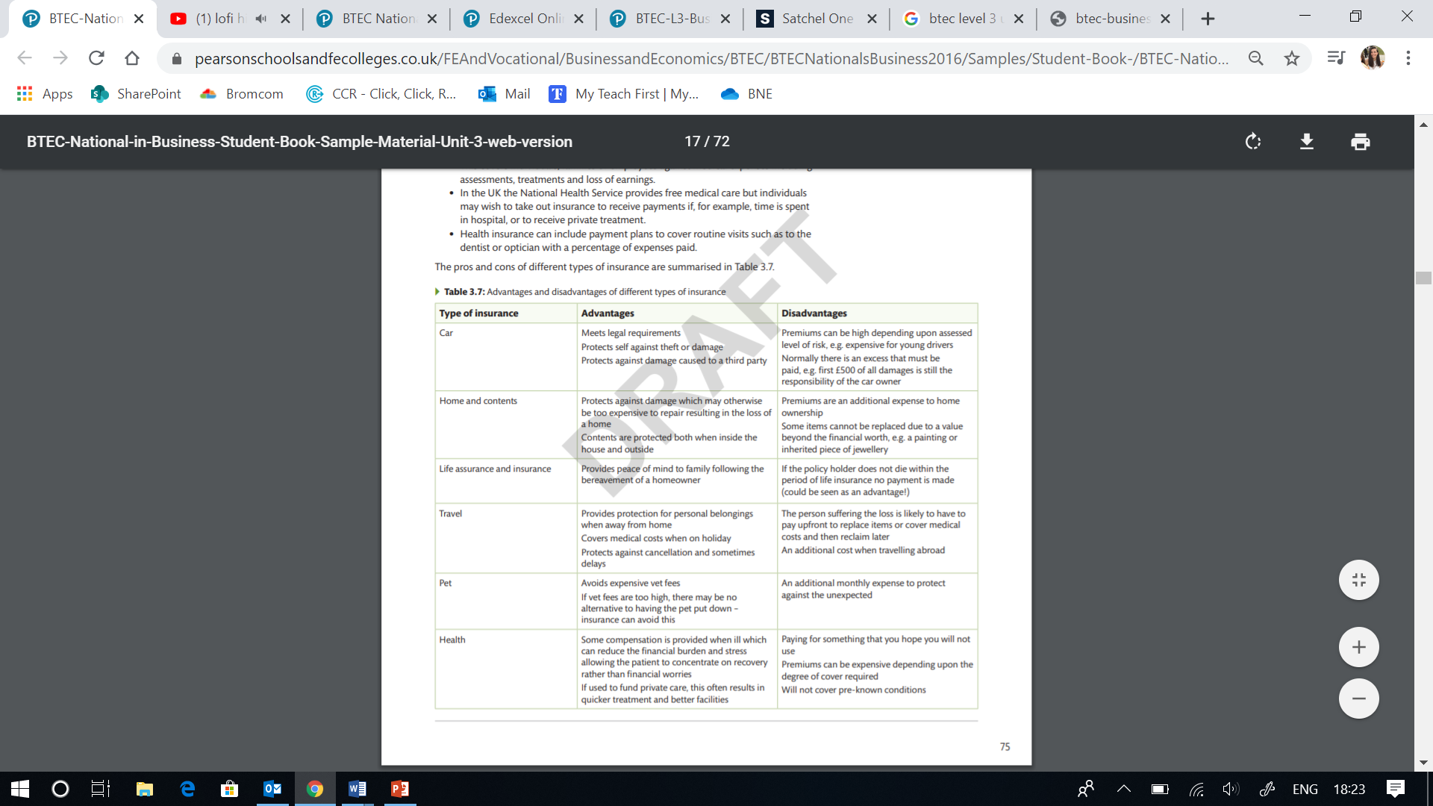

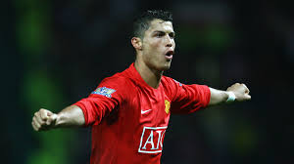**Insurance**

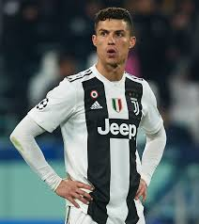

Members of the public are likely to protect their home, their home’s contents, their car and maybe their health or pet. For celebrities, it seems they protect a whole lot more. Sporting stars can insure against damage to limbs which would ultimately lead to a huge loss of earnings. When Christiano Ronaldo played for Real Madrid, the club obviously felt that his legs were an asset worth insuring and protecting. They insured his legs for £90 million in 2013.

The music business also sees professionals insuring their voice, hands or other body parts. Jennifer Lopez insured her bottom to the sum of £180 million while Mariah Carey insured her legs for £1 billion. Following his role as James Bond, Daniel Craig insured his body for £6 million; not to be outdone, Joey Essex insured his hair for £1 million.

***Questions:***

|  |  |
| --- | --- |
| Why do the general public insure their homes and content? |  |
| Why were Christiano Ronaldo’s legs insured? |  |
| What is the benefit to Real Madrid of insuring Ronaldo’s legs? |  |
| Explain why insurance companies would be willing to issue these types of insurance policies? |  |

**Knowledge check questions**

|  |  |
| --- | --- |
| Describe two types of borrowing |  |
| Describe one type of saving |  |
| Compare the risk and reward of saving vs investing |  |
| What is a premium? |  |
| List 3 types of insurance |  |