|  |
| --- |
| Name: Date: |

# 2. Different ways to pay

|  |  |
| --- | --- |
| **Question:** | **Your answer:** |
| What is meant by a ‘credit score’? |  |
| Explain what is meant by ‘debt’. |  |
| State two factors which impact the role of money. |  |
| Describe what is meant by inflation. |  |

Do now activity:

One of the functions of money is as a means of exchange. This means you can use it to pay for things. There are a number of way to pay for things, not just using notes and coins. Any method of payment is classed as money.

We need to learn the different methods of payment, their features, advantages and disadvantages.

|  |  |  |  |
| --- | --- | --- | --- |
| **Method of Payment** | **Explanation/features** | **Advantages** | **Disadvantages** |
| *Cash* | Notes and coins | * Most widely accepted form of exchange * Physical not virtual * Consumers feel confident when using * Makes budgeting easier | * Can be lost or stolen * Threat of counterfeit * Only really appropriate on purchases up to a certain amount * Cannot be used online |
| *Debit card* | Issued by banks with payments for goods and services being deducted directly from a current account | * No need to carry cash * Secure method of payment with low risk of theft * Widely accepted * Offers a degree of protection on purchases * Suitable for online transactions | * Short time lapse between making the transaction and the money being withdrawn from account may result in overspending * Not accepted for small transactions |
| *Credit card* | Issued by financial institutions allowing customers to delay payments for goods and services | * Allows a period of credit that is interest free (eg one month) * Most cards are widely accepted * Loyalty schemes are often offered eg collect points or cash back * Offers a degree of protection on purchases * Suitable for online transactions | * Interest is charge on balances not paid off within a month * Can encourage a customer to overspend and get into debt * Interest is charged on cash withdrawals * A limit will be set on the amount of credit allowed |
| *Cheque* | A written order to a bank to make a payment for a specific amount of money from one person’s account to another account | * Low risk form of payment as the cheque can only be cashed by the named payee * Widely accepted for face-to face and postal transactions * No need to provide change as can be written for an exact amount | * Expensive for the consumer if the bank refuses to clear the cheque, i.e. it ‘bounces’ * The time delay between writing the cheque and it being cashed could cause a consumer to go overdrawn * Viewed as old fashioned * Easy for the consumer to make errors when writing the cheque which will create problems for both the consumer and the recipient |
| *Electronic transfer* | Payment is transferred directly from one bank account to another | * Almost instantaneous * Provides a record of payment * No additional costs incurred * Easy to use for one-off and more frequent transactions | * Risk of loss if the transfer is incorrectly set up * Not appropriate for face-to-face transactions |
| *Direct debit* | An agreement made with a bank allowing a third party to withdraw money from an account on a set day to pay for goods or services received, e.g. pay a gas bill | * An easy way to make regular payments, e.g. utility bills * Amount paid can vary to ensure the payment matches the amount required by the vendor * Quick and easy to set up | * If the payer makes a mistake and takes too much it is the payee’s responsibility to claim back the money * The payer determines the amount paid each time making it difficult for the payee to plan and budget |
| *Standing order* | An agreement made with a bank to transfer a fixed sum of money to a third party account on a set date on a regular basis, e.g. pay £30 for a phone contract each month | * The same amount is paid each time making it easier for the payee to plan and budget * Easy both to set up and to cancel * No need to remember to make regular, standard payments | * Payments are taken regardless of the customer’s balance which could lead to the unplanned use of an overdraft facility * Payments will continue to be made unless cancelled |
| *Pre-paid card* | Money is uploaded onto a card with transactions then being withdrawn to reduce the balance | * Can set a budget in advance to avoid overspending * If lost or stolen the loss is limited to the remaining balance * An effective way of controlling the amount spent by children and where money is spent, e.g. upload money for school lunches or transport | * No protection if lost * Sometimes requires an initial fee to purchase or set up the card, e.g. Oyster travelcards |
| *Contactless card* | Cards containing antennae allow money to be transferred when the card touches a contactless terminal | * Increasing in popularity * Secure method of making payments | * Often only accepted for relatively small transactions * Still not widely accepted as seen as new technology |
| *Charge card* | Issued by financial institutions allowing customers to delay payments for goods and services for a short period of time; the balance must be paid off in full when a statement is issued | * Reduces risk of running up debts * Allows a short period of credit * Avoids the need to carry cash * Often offers additional perk | * Must be paid in full each month * Often an annual fixed fee is applied |
| *Store card* | Issued by a retail outlet so that customers can delay payments for goods and services (similar to a credit card but only accepted by stores specified) | * Allows a short period of credit that is interest free (eg one month) * Often offer loyalty schemes, discounts and special promotions or privileges | * Only accepted in issuing store or linked associations * Interest is paid on outstanding balances * Can encourage overspending and result in a consumer getting into debt, particularly if they hold multiple cards |
| *Mobile banking* | The ability to carry out financial transactions using mobile devices such as phones or tablets | * Convenient as can be used at any time and place * Secure | * Features are still limited and hence mobile banking does not offer all of the functionality of internet banking |
| *Banker’s Automated Clearing Service (BACS) Faster Payment* | A system that allows the transfer of payments directly from one bank account to another | * Faster payment allows almost instant transfers that are guaranteed within 2 hours * Can be accessed in a number of ways including in a branch, over the telephone and online * No additional costs | * Faster payment is not offered by all banks or branches and the customer may therefore have to default to BACs which can take three days to transfer payments * A limit is set on the amount that can be transferred in any single transaction |
| *Clearing house automated payment systems (CHAPS)* | A system that allows the transfer of payments directly from one bank account to another | * Transfers can be made the same day assuming instructions are received prior to a set time, e.g. 2 pm at Barclays * There is no limit on the amount that can be transferred in a single transaction | * Normally, there is a fixed charge per transaction regardless of the amount transferred |

***Activity:*** In pairs discuss:

1. Which payment methods you have used and why you use those methods.
2. What does your choice of payment method depend on?

Write down what you discuss in the box:

|  |
| --- |
|  |

***Practice***

1. Explain one advantage to the consumer of using pre-paid credit cards when on holiday (2 marks).

________________________________________________________________

________________________________________________________________

________________________________________________________________

________________________________________________________________

________________________________________________________________

1. When might it be suitable to use a direct debit?

________________________________________________________________

________________________________________________________________

1. Explain one difference between a standing order and a direct debit.

________________________________________________________________

________________________________________________________________

________________________________________________________________

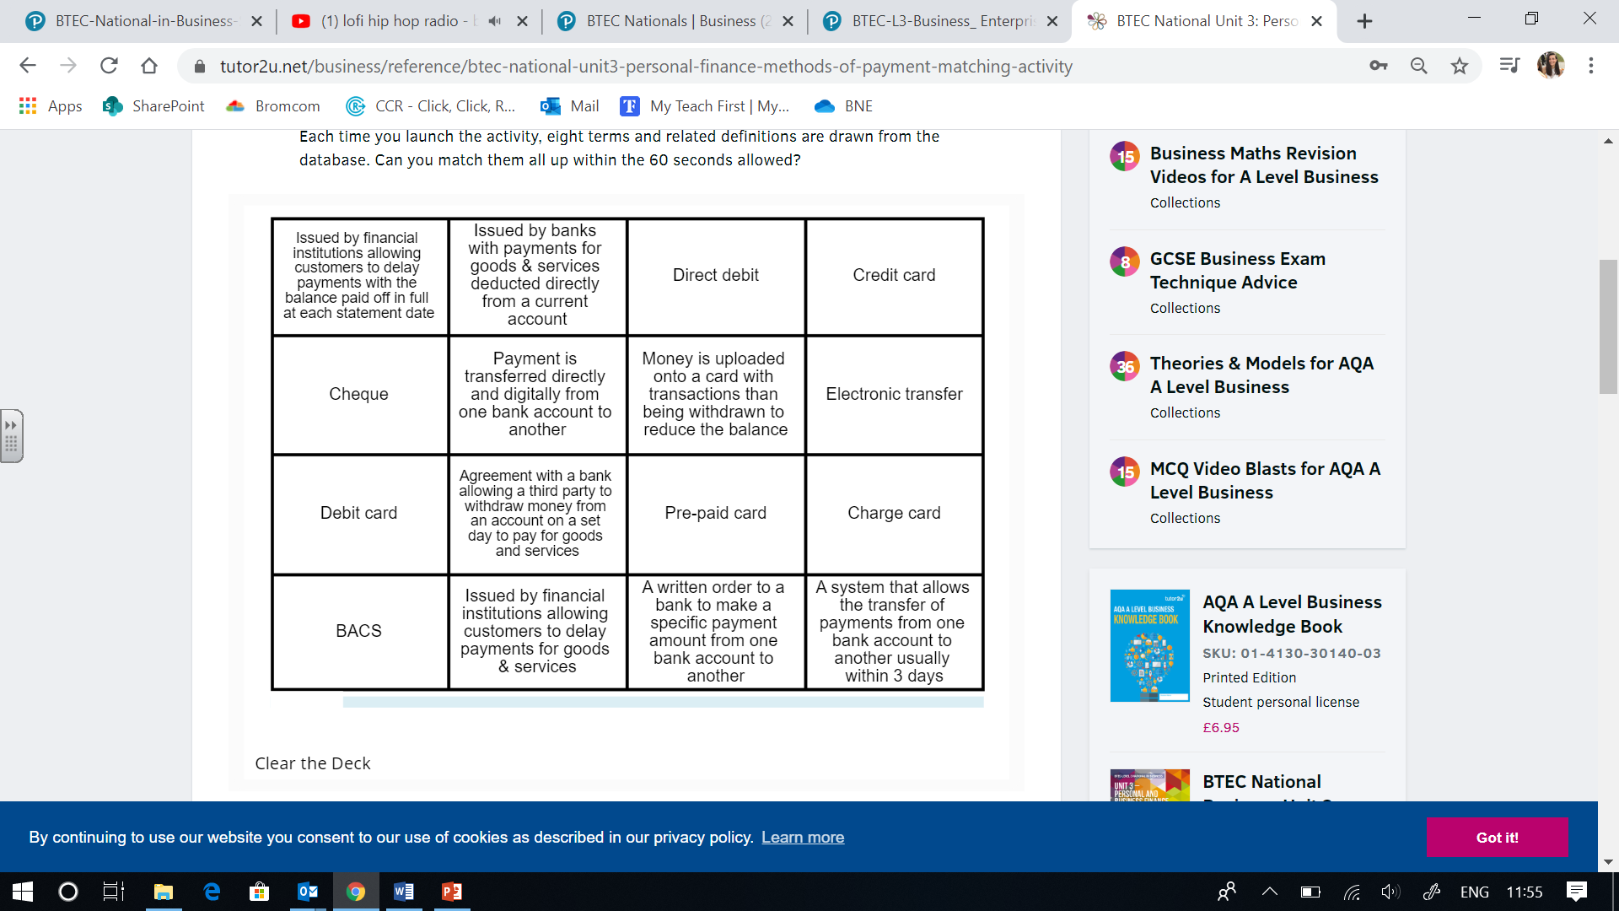***Task:*** match up the payment method to the correct definition. (You can either draw lines or you could number them.

***Task:*** Select the most appropriate method of payment in each scenario -

|  |  |  |  |  |  |  |  |
| --- | --- | --- | --- | --- | --- | --- | --- |
| Credit card | BACS | Cash | Direct debit | Store card | Cheque | Standing order | Debit card |

|  |  |  |
| --- | --- | --- |
|  | **Most appropriate method of payment** | **Justification** |
| Philip want needs to decide on the best method of payment for his quarterly gas bill |  |  |
| Lucy regularly shops for clothes at a high street department store. |  |  |
| A shop needs to pay for a suppliers invoice |  |  |
| Damien has recently bought a car and will need to pay insurance |  |  |
| Cassie wants to buy some clothes online |  |  |
| Helen wants to post her nephew a £50 birthday gift |  |  |
| Paying for a holiday abroad |  |  |
| Buying an ice-cream from an  ice-cream van |  |  |

**Homework:**   
You have each been given 14 flashcards. Your homework task is to fill in each flashcard with the payment method on one side and the explanation with an advantage and disadvantage on the other side. You have until next week to have all flashcards completed. Make sure you bring them to the lesson!