|  |
| --- |
| Name: Date: |

# Introduction to unit 3 – Finance

*What you need to bring to every lesson:*A blue or black pen

**Lesson expectations:**

* Bring all the necessary equipment
* Bring completed homework
* Start the do now activity as soon as you sit down
* Sit in your assigned seat
* Do not talk while anyone else is speaking
* Ask when unsure (there really are no such thing as stupid questions)
* Show respect to each other
* A green pen
* A highlighter
* A calculator
* Your finance folder
* Your planner

*How you will be assessed:*

* External unseen exam
* The exam is 2 hours
* 80 marks available
* The exam involves short answers, calculations and extended writing

*Overview of content:*

|  |  |
| --- | --- |
| Content area A | Understanding the importance of managing personal finance |
| Content area B | Explore the personal finance sector |
| Content area C | Understanding the purpose of accounting |
| Content area D | Select and evaluate different sources of business |
| Content area E | Break-even and cash flow forecasts |
| Content area F | Complete statements of comprehensive income and financial position and evaluate a business’ performance |

# Understanding the importance of managing personal finance: Functions and role of money

Do now activity:

|  |  |
| --- | --- |
| **Question:** | **Your answer:** |
| What do you think are the biggest financial decisions you will ever make in your life? |  |
| Suggest a source of money (where do you get money from?) |  |
| What forms can money take? |  |

**Functions of money**

|  |  |
| --- | --- |
| Unit of account |  |
| Means of exchange |  |
| Store of value |  |
| Legal tender |  |

**Role of money**

Different people have different attitudes to money.

|  |
| --- |
| Do you prefer to save or spend your money? Explain why. |

The role of money is affected by a wide number of factors including:

|  |  |
| --- | --- |
| Personal attitudes |  |
| Life stages |  |
| Culture |  |
| Life events |  |
| External influences |  |
| Interest rates |  |

**Activity**

For each life stage write down what you think the financial needs and implications are. The first one has been done for you.

|  |  |  |
| --- | --- | --- |
| **Life stage** | **Financial needs** | **Implications** |
| *Childhood* | * Limited needs * Mainly reliant on parents * May want to buy sweets or toys | Money received from parents may be spent.  May be encouraged to save or parents may set up a savings account which they make regular payments into  May rely on pocket money |
| *Adolescence* |  |  |
| *Young adult* |  |  |
| *Middle age* |  |  |
| *Old age* |  |  |

**Planning expenditure**

Expenditure = money that is paid out

|  |
| --- |
| List as many expenditures as you can think of: |

If you overspend you will be at risk of financial difficulties both now and in the future. If your spending is too high, this may mean more money is going out than is coming in. This will lead to a build up of **debt**. Debt is expensive because as interest will be charged on money owed. If debts are not paid or not paid on time, this will affect your **credit rating.** A poor credit rating will affect your ability to borrow money in the future.

|  |  |
| --- | --- |
| **Debt** | Money owed |
| **Credit rating** | a score given to individuals on how likely they are to repay debts based upon their previous actions |
| **Bankrupt** | When an individual or organisation legally states its inability to repay debts |
| **Solvent** | the ability to meet day-to-day expenditure and repay debts |

***Task:*** In your own words, explain the dangers of overspending

___________________________________________________________________________

___________________________________________________________________________

___________________________________________________________________________

___________________________________________________________________________

___________________________________________________________________________

To remain **solvent,** you should set financial targets and goals. These should consider how much money you want to earn and place limits on how much you will spend. If you save some of your income, this can help generate future income as money saved will earn interest.

**Activity**

1. Sam decides to save £4000. The interest rate is 0.25%. How much money will Sam have at the end of the year?

___________________________________________________________________________

___________________________________________________________________________

___________________________________________________________________________

1. Amira saves £7,500. The interest rate is 0.1%. How much money will Amira have at the end of the year?

___________________________________________________________________________

___________________________________________________________________________

___________________________________________________________________________

***Think, Pair, Share:*** In your pairs, discuss why you think interest rates were cut to the lowest they have been in 325 years at 0.1% during the coronavirus outbreak. Write down your thoughts in the box.

|  |
| --- |
|  |

***Question:*** Other than gaining money due to interest, why else might saving be beneficial?

___________________________________________________________________________

___________________________________________________________________________

___________________________________________________________________________

**Inflation**

Inflation is a general rise in prices. This leads to the value of money falling. £10 today is worth less than £10 ten years ago. Expenditure (spending the money) can help counter the effects of inflation. For example, if you spent £150,000 on a house, the value of the house would increase. But if you left £150,000 in a savings account, the amount would go up (due to interest) but the spending power of your money would go down.

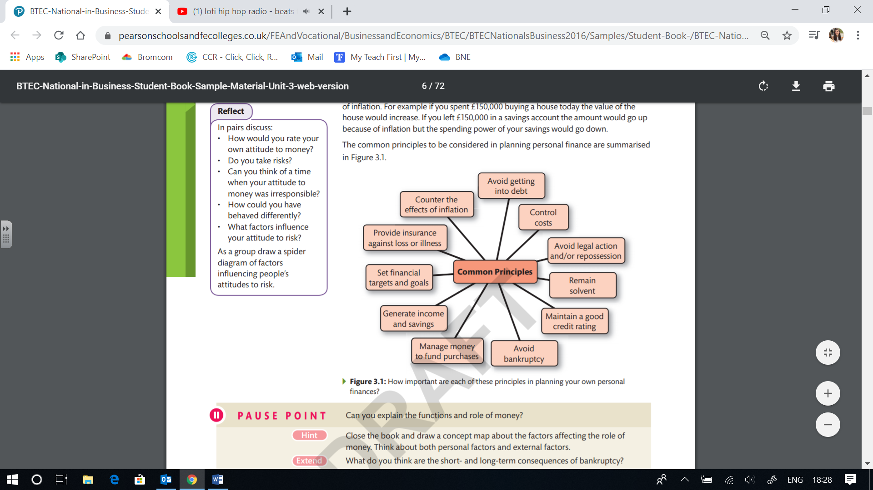**Principles of planning personal finance**

**Knowledge check questions**

|  |  |
| --- | --- |
| **Question:** | **Your answer:** |
| Explain one function of money |  |
| Explain one factor which affects the role of money |  |
| When you have more money going out than coming in, what might start to build up? |  |
| What are interest rates? |  |
| What is meant by ‘inflation’? |  |