

Additional Assessment Materials

Summer 2021

Pearson Edexcel Advanced Level Politics,

9PL0 01

Resource Set 3

Core Political Ideas

# **Pearson: helping people progress, everywhere**

Pearson aspires to be the world’s leading learning company. Our aim is to help everyone progress in their lives through education. We believe in every kind of learning, for all kinds of people, wherever they are in the world. We’ve been involved in education for over 150 years, and by working across 70 countries, in 100 languages, we have built an international reputation for our commitment to high standards and raising achievement through innovation in education. Find out more about how we can help you and your students at: [www.pearson.com/uk](http://www.pearson.com/uk)

Additional Assessment Materials, Summer 2021

All the material in this publication is copyright

© Pearson Education Ltd 2021

**General guidance to Additional Assessment Materials for use in 2021**

**Context**

* Additional Assessment Materials are being produced for GCSE, AS and A levels (with the exception of Art and Design).
* The Additional Assessment materials presented in this booklet are an **optional** part of the range of evidence you may use when deciding on a candidate’s grade.
* 2021 Additional Assessment Materials have been drawn from previous examination materials, namely past papers.
* Additional Assessment Materials have come from past papers both published (those materials available publicly) and unpublished (those currently under padlock to our centres) presented in a different format to allow you to adapt them to use with your candidates.

**Purpose**

* The purpose of this resource to provide qualification-specific sets/groups of questions covering the knowledge, skills and understanding relevant to this Pearson qualification.
* This document should be used in conjunction with the mapping guidance which will map content and/or skills covered within each set of questions. The mapping guidance will also highlight where the question originally came from to allow you to access further support materials (mark schemes, examiner reports).
* Use of these assessment materials will assist you in assessing candidates’ current performance in areas not assessed elsewhere. Their use will also provide an extra opportunity for candidates to demonstrate their performance at the end of their course of study.
* Specific guidance relating to this selection of material for this subject is detailed below.
* These materials are only intended to support the summer 2021 series.

**Subject Specific Guidance**

Indicative content in the mark schemes reproduced was reflective of current affairs at the time of the original examination and has not been updated; some limited updating by centres may be appropriate. Contemporary information which is relevant to the question must be rewarded

**9PL0: Advanced Level Politics**

**Paper 1, Section B: Core Political Ideas**

**Sample Assessment Material**

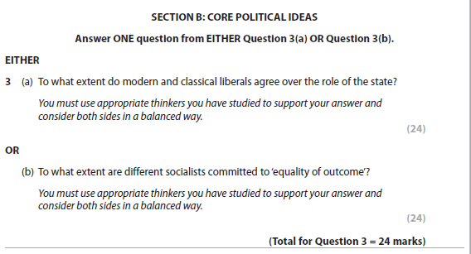

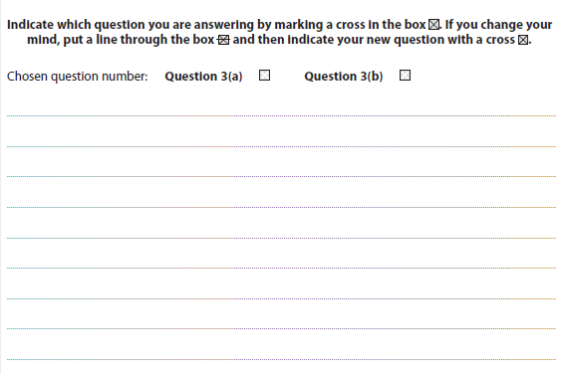 

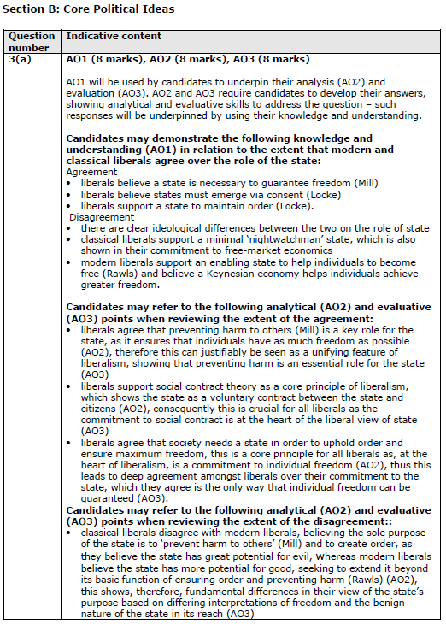 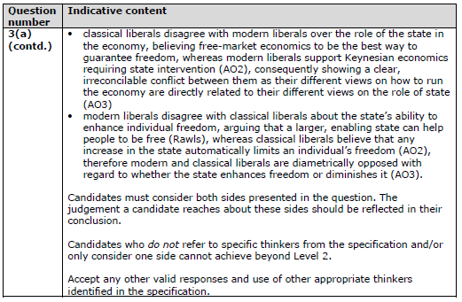

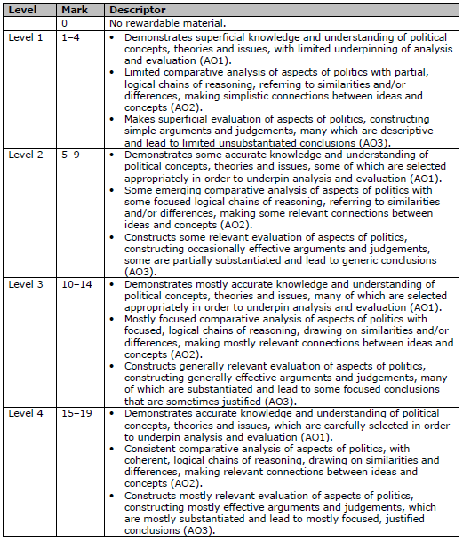 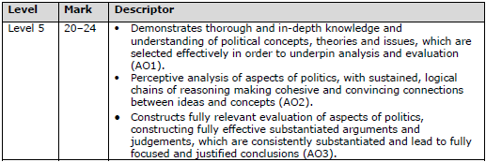 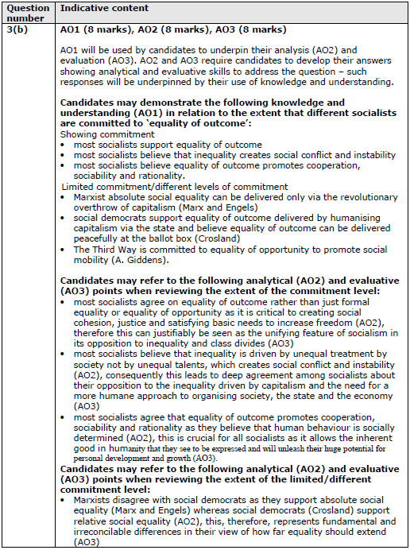 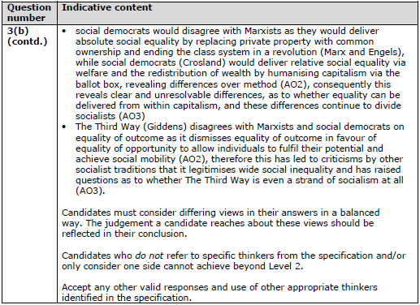

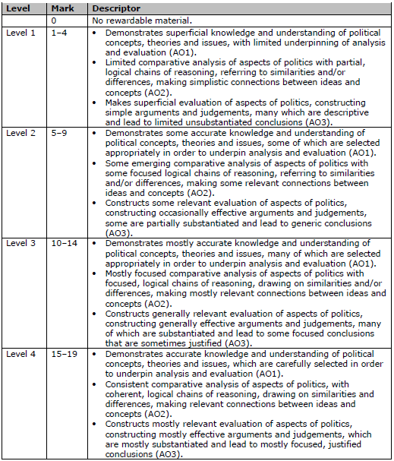 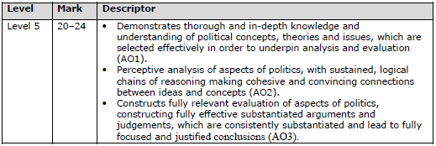

**9PL0: Advanced Level Politics**

**Paper 1, Section B: Core Political Ideas**

**Specimen Paper**

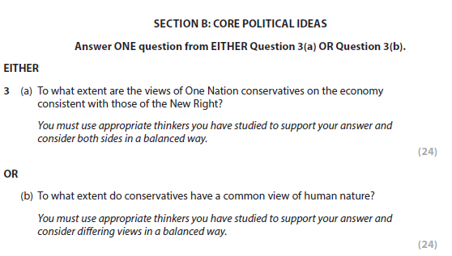



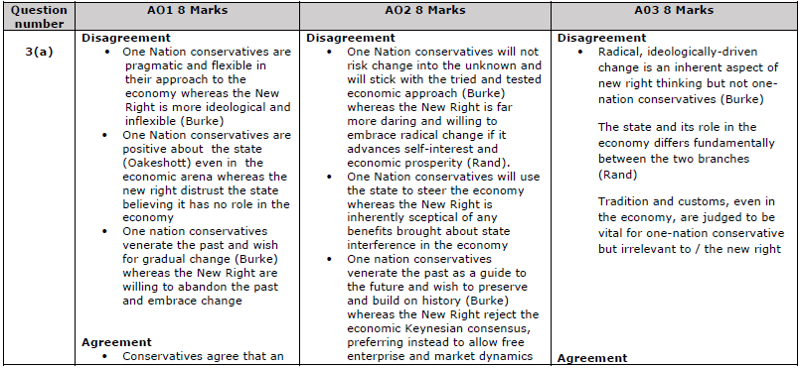

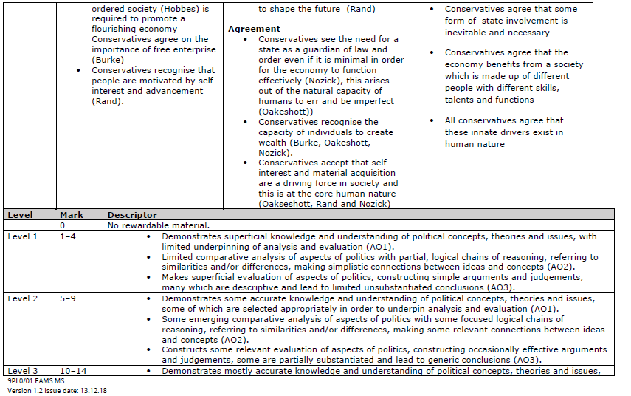

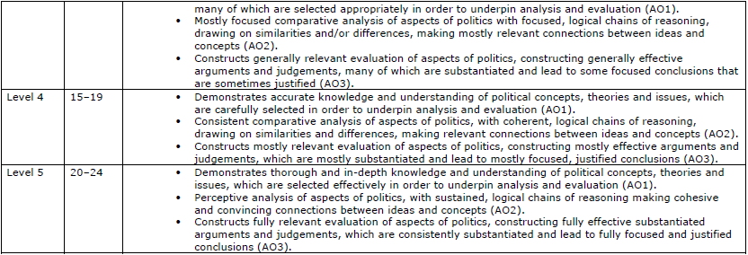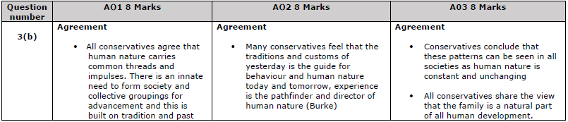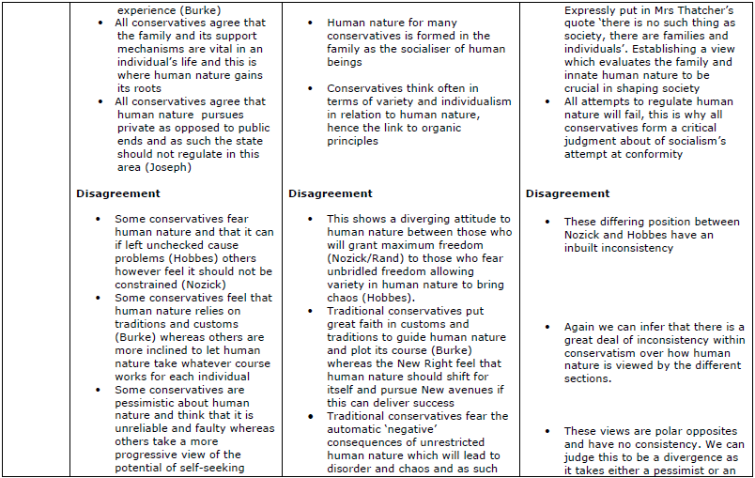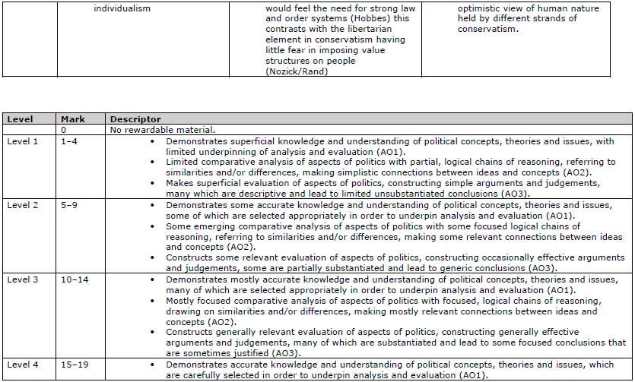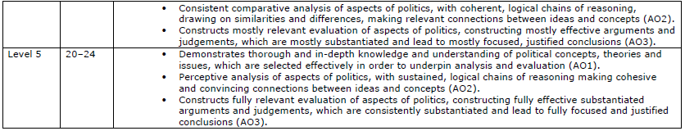

**9PL0: Advanced Level Politics**

**Paper 1, Section B: Core Political Ideas**

**2019 Exam**

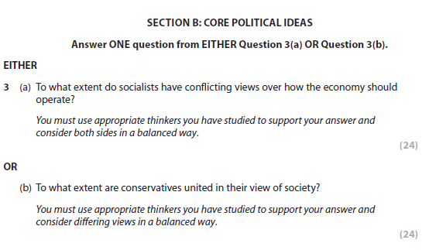

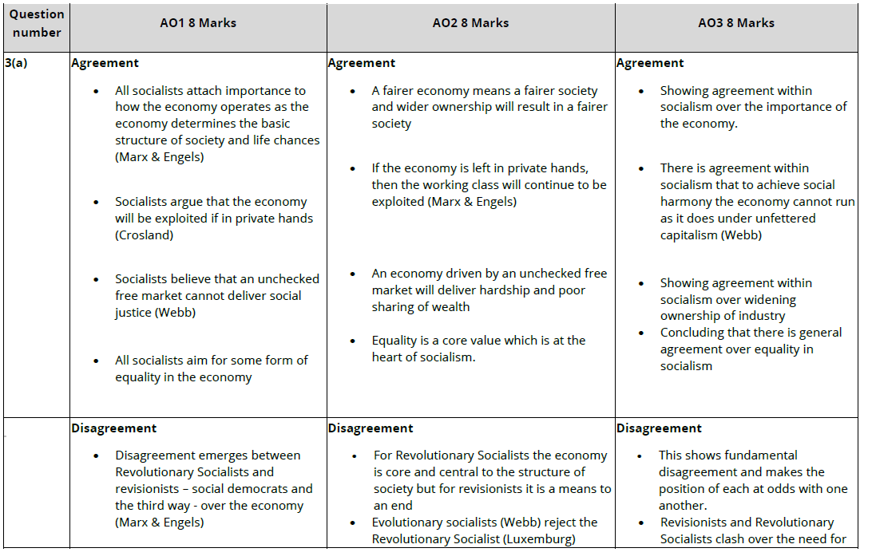

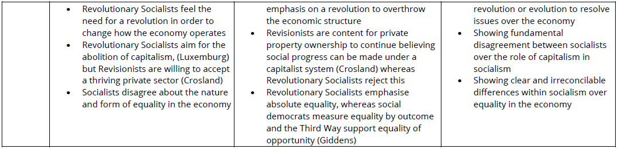

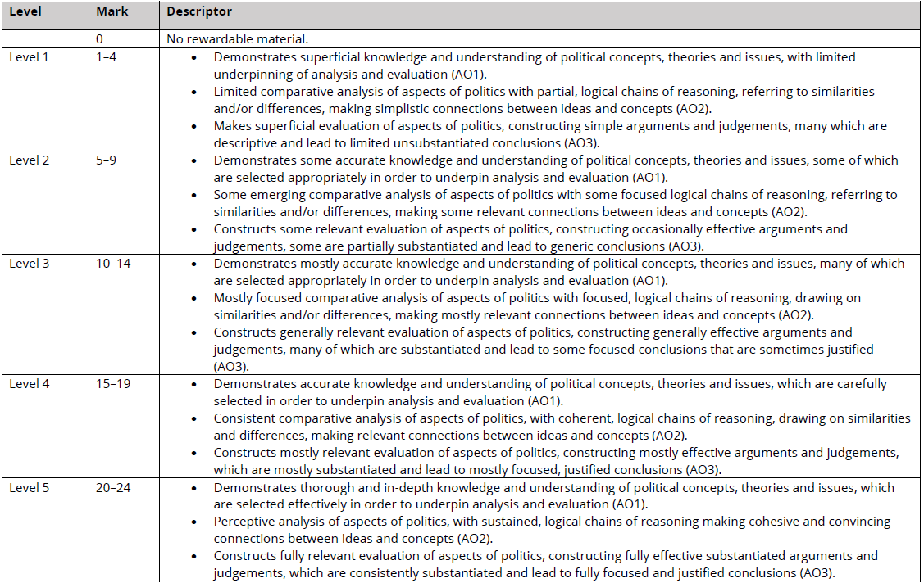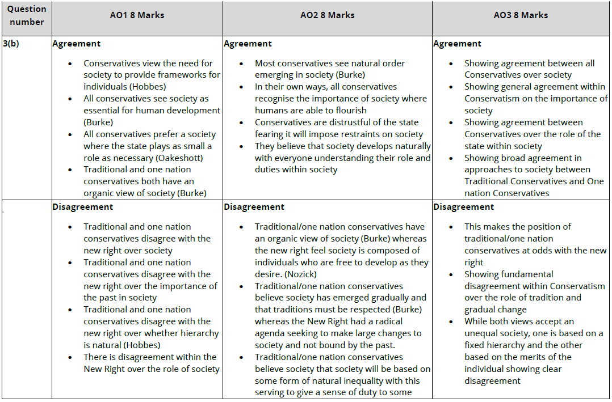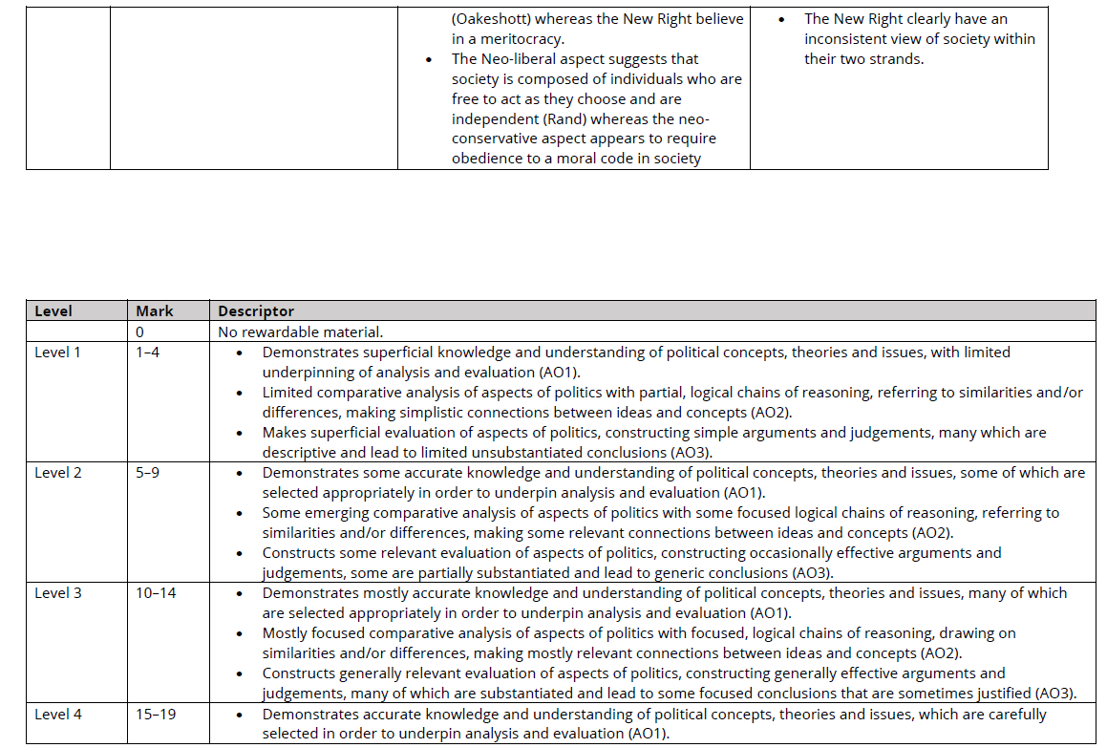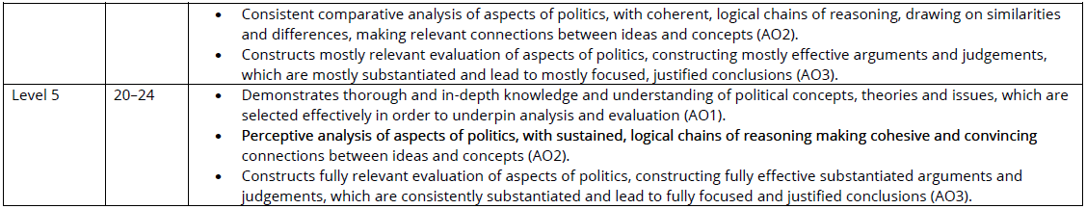

**9PL0: Advanced Level Politics**

**Paper 1, Section B: Core Political Ideas**

**2020 Exam**

