**[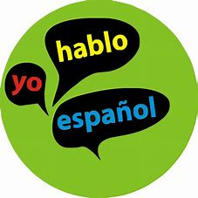](https://www.bing.com/images/search?view=detailV2&ccid=fq9iN4kg&id=A69FED70590F790AA89433D644014E4673ABACEC&thid=OIP.fq9iN4kgNhcqVie_ULjUKgHaHa&mediaurl=http://www.aspiresa.com/wp-content/uploads/2015/06/beginningspanish.jpg&exph=2310&expw=2310&q=Spanish&simid=607988503450158077&selectedIndex=0)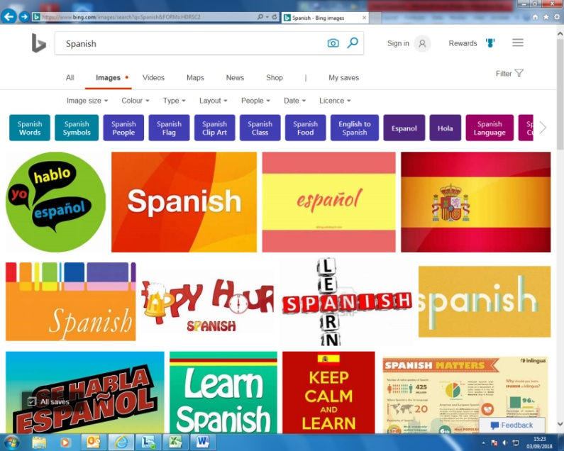 Y12 STUDENT PERSONAL LEARNING CHECKLIST (PLC)**

**A level exam format**

**Your exam board for Spanish is AQA. Your official exams will be in Y13 in April (S) and June (R/L/W). You will have the following 4 exams in Y12:**

**1. Listening, reading & writing (translation): 45%  
2. Writing: 25 % on modules/film**

**3. Speaking: 30%: 15 min prep. time + 2 photo cards (in Y13: 5 min prep. time + 1 card/2 + IRP)**

**ONGOING TASKS TO BE DONE IN EACH MODULE**

|  |  |  |  |  |  |  |  |
| --- | --- | --- | --- | --- | --- | --- | --- |
| **Tasks** | | **M1** | **M2** | **M3** | **M4** | **M5** | **M6** |
| 1. Familiarising with **A level success criteria** and **what each paper contains** | Y/P/N |  |  |  |  |  |  |
| 1. Keeping your **subject and working folder** well organised | Y/P/N |  |  |  |  |  |  |
| 1. Updating **timeline with data/facts/information** on each module | Y/P/N |  |  |  |  |  |  |
| 1. Updating **document of 2 Hispanic examples** **for each unit** **in each module** | Y/P/N |  |  |  |  |  |  |
| 1. Updating your **vocabulary list/glossaries** with vocabulary in homework and IW | Y/P/N |  |  |  |  |  |  |
| 1. **Weekly independent work (IW)** | Y/P/N |  |  |  |  |  |  |

|  |  |  |  |  |  |  |
| --- | --- | --- | --- | --- | --- | --- |
| **AUTUMN TERM By the end of this term I will learn ...** | **Aut1** | **Aut1** | **Spr1** | **Spr2** | **Sum1** | **Sum2** |
| **\*Module 1 – Traditional and modern values LWA** | | | | | | |
| U1. Changes in family models |  |  |  |  |  |  |
| U2. Attitudes towards marriage and divorce |  |  |  |  |  |  |
| U3. The influence of the Catholic church |  |  |  |  |  |  |
| **Grammar** | | | | | | |
| Imperfect tense |  |  |  |  |  |  |
| Imperfect continuous tense |  |  |  |  |  |  |
| Preterite |  |  |  |  |  |  |
| Connecting nous with their corresponding verbs |  |  |  |  |  |  |

|  |  |  |  |  |  |  |
| --- | --- | --- | --- | --- | --- | --- |
| **\*Module 2 – Cyberspace VLO** | | | | | | |
| U1. The influence of internet |  |  |  |  |  |  |
| U2. Smartphones in our society |  |  |  |  |  |  |
| U3. Social networks: benefits and dangers |  |  |  |  |  |  |
| **Grammar** | | | | | | |
| Present tense |  |  |  |  |  |  |
| Present continuous tenses |  |  |  |  |  |  |
| Comparatives and superlatives |  |  |  |  |  |  |
| Ser vs estar |  |  |  |  |  |  |
| Future tense |  |  |  |  |  |  |
| Conditonal tense |  |  |  |  |  |  |

|  |  |  |  |  |  |  |  |  |
| --- | --- | --- | --- | --- | --- | --- | --- | --- |
| **SPRING TERM: By the end of this term I will learn ...** | **Aut1** | | **Aut2** | **Spr1** | **Spr2** | **Sum1** | **Sum2** | |
| **\*Module 3 – Gender equality LWA** | | | | | | | | |
| U1. Women in the job market |  | |  |  |  |  |  | |
| U2. Sexism and Feminism |  | |  |  |  |  |  | |
| U3. The rights of the LGQT community |  | |  |  |  |  |  | |
| **Grammar** | | | | | | | | |
| Indefinite adjectives and pronouns |  | |  |  |  |  |  | |
| Perfect tense |  | |  |  |  |  |  | |
| Pluperfect tense |  | |  |  |  |  |  | |
| Saying percentages and expressions to describe graphs |  | |  |  |  |  |  | |
| **\*Module 4 – The influence of celebrities VLO** |  | |  |  |  |  |  | |
| U1. Singers and musicians |  | |  |  |  |  |  | |
| U2. TV and cinema stars |  | |  |  |  |  |  | |
| U3. Models |  | |  |  |  |  |  | |
| **Grammar** |  | |  |  |  |  |  | |
| Direct object pronouns |  | |  |  |  |  |  | |
| Indirect object pronouns |  | |  |  |  |  |  | |
| Passive voice |  | |  |  |  |  |  | |
| **SUMMER TERM By the end of this term I will learn ...** | **Aut1** | | **Aut2** | **Spr1** | **Spr2** | **Sum1** | | **Sum2** |
| **\*Module 5 – Regional identity LWA** | | | | | | | | |
| U1. Traditions and customs | |  |  |  |  |  | |  |
| U2. Gastronomy | |  |  |  |  |  | |  |
| U3. Languages | |  |  |  |  |  | |  |
| **Grammar** | | | | | | | | |
| Present subjunctive of regular verbs | |  |  |  |  |  | |  |
| Perfect tense in subjunctive | |  |  |  |  |  | |  |
| Numerals | |  |  |  |  |  | |  |
| **\*Module 6 Cultural heritage LWA** | | | | | | | | |
| U1. Historical sites and pre-Hispanic civilizations | |  |  |  |  |  | |  |
| U2. Art and architecture | |  |  |  |  |  | |  |
| U3. El matrimonio musical y diversidad | |  |  |  |  |  | |  |
| **Grammar** | | | | | | | | |
| Subjunctive after verbs of emotion, surprise and doubt | |  |  |  |  |  | |  |
| Demonstrative and possessive adjectives | |  |  |  |  |  | |  |
| Imperatives | |  |  |  |  |  | |  |
| Irregular endings in nouns | |  |  |  |  |  | |  |
| **\*Film: “Volver” VLO** | | | | | | | | |
| U1. Historical and cultural context | |  |  |  |  |  | |  |
| U2. Director and plot | |  |  |  |  |  | |  |
| U3. Actresses and analysis of scenes | |  |  |  |  |  | |  |
| U4. Analysis of themes and characters | |  |  |  |  |  | |  |
| U5. Director’s techniques and essay writing | |  |  |  |  |  | |  |
| **Introduction to IRP and summer bridging work in preparation for Y13** | | | | | | | | |
| **Revision** | | | | | | | | |