Chemistry Bridging Work
Basic Chemistry Competencies

Scientific knowledge
Balancing equations
1. …..C + …..O₂ |  | …..CO
2. …..Ba + …..H₂O |  | …..Ba(OH)₂ + …..H₂
3. …..C₂H₆ + …..O₂ |  | …..CO₂ + …..H₂O
4. …..HCl + …..Mg(OH)₂ |  | …..MgCl₂ + H₂O
5. …..N₂ + …..O₂ |  | …..NO
6. …..Fe₂O₃ + …..C |  | …..Fe + …..CO₂
7. …..CH₃CH₂OH + …..[O] |  | …..CH₃COOH + …..H₂O
8. …..HNO₃ + …..CuO |  | …..Cu(NO₃)₂ + H₂O
9. …..Al³⁺ + …..e– |  | …..Al
10. …..[Fe(H₂O)₆]³⁺ + …..CO₃^{2–} |  | …..Fe(OH)₃(H₂O)₃ + …..CO₂ + …..H₂O

Constructing ionic formulae

1. For each of the following ionic salts, determine the cation and anion present and use these to construct the formula of the salt. (5 marks)
- Magnesium oxide
- Sodium sulfate
- Calcium hydroxide
- Aluminium oxide
- Copper(I) oxide

2. When an acid is added to water it dissociates to form H⁺ ions (which make it acidic) and an anion. These acidic hydrogen atoms can be used to determine the charge on the anion.
Deduce the charge on the anions in the following acids. The acidic H atoms, H⁺, have been underlined for you. (5 marks)
- H₂SO₃
- HNO₃
- H₃PO₄
- HCOOH
- H₂CO₃

Writing equations from text

The following questions contain a written description of a reaction. In some cases the products may be missing as you will be expected to predict the product using your prior knowledge.
For more advanced equations you may be given some of the formulae you need.
For each one, write a balanced symbol equation for the process. (10 marks)
1. The reaction between silicon and nitrogen to form silicon nitride Si₃N₄.

2. The neutralisation of sulfuric acid with sodium hydroxide.

3. The preparation of boron trichloride from its elements.

4. The reaction of nitrogen and oxygen to form nitrogen monoxide.

5. The combustion of ethanol (C₂H₅OH) to form carbon dioxide and water only.

6. The formation of silicon tetrachloride (SiCl₄) from SiO₂ using chlorine gas and carbon.

7. The extraction of iron from iron(III) oxide (Fe₂O₃) using carbon monoxide.

8. The complete combustion of methane.

9. The formation of one molecule of ClF₃ from chlorine and fluorine molecules.

10. The reaction of nitrogen dioxide with water and oxygen to form nitric acid.

Mathematical Skills
Rearranging equations
The amount of substance in moles (n) in a solution can be calculated when the concentration given in mol/dm³ (c) and volume (v) in cm³ are known by using the equation:
$$\text{n = }\frac{\text{cv}}{\text{1000}}$$
- Rearrange this equation making c the subject of the equation. (1 mark)
- Rearrange this equation making v the subject of the equation. (1 mark)

2. The density of a substance can be calculated from its mass (m) and volume (v) using the equation:
$$\text{d = }\frac{\text{m}}{\text{v}}$$
- Rearrange this equation so that the mass of a substance can be calculated given its density and volume. (1 mark)
Chemists most commonly work with masses expressed in grams and volumes in cm³. However, the SI unit for density is kg/m³.
- Write an expression for the calculation of density in the SI unit of kg/m³ when the mass (m) of the substance is given in g and the volume (v) of the substance is given in cm³. (2 marks)

3. The kinetic energy (KE) of a particle in a time of flight mass spectrometer can be calculated using the following equation.
$$\text{KE =}\frac{\text{1}}{\text{2}}\text{m}{\text{v}}^{\text{2}}$$
Rearrange this equation to make v the subject of the equation. (2 marks)

Significant figures, decimal places and rounding
For each of the numbers in questions 1–6, state the number of significant figures and the number of decimal places.
 |  | Significant figures | Decimal places
1 | 3.131 88
2 | 1000
3 | 0.000 65
4 | 1006
5 | 560.0
6 | 0.000 480
(6 marks)
1. Round the following numbers to (i) 3 significant figures and (ii) 2 decimal places.
- 0.075 84
- 231.456

(4 marks)

Moles and mass
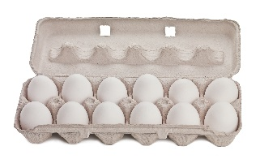
One mole of a substance is equal to 6.02 × 10²³ atoms, ions or particles of that substance. This number is called the Avogadro constant.
How is a mole similar to a dozen?
The value of the Avogadro constant was chosen so that the relative formula mass of a substance weighed out in grams is known to contain exactly 6.02 × 10²³ particles. We call this mass its molar mass.
Stating the amount of substance in moles is just the same as describing a quantity of eggs in dozens. You could say you had 24 or 2 dozen eggs.
We can use the equation below when calculating an amount in moles:
amount of substance (mol) | = | mass (g)
molar mass
(g mol^{–1})

Use the equation above to help you answer the following questions.
1. Calculate the amount of substance, in moles, in: (3 marks)
a. 32 g of methane, CH₄ (molar mass, 16.0 g mol^{–1})
b. 175 g of calcium carbonate, CaCO₃
c. 200 mg of aspirin, C₉H₈O₄

2. Calculate the mass in grams of: (3 marks)
a. 20 moles of glucose molecules (molar mass, 180 g mol^{–1})
b. 5.00 × 10^{–3} moles of copper ions, Cu²⁺
c. 42.0 moles of hydrated copper sulfate, CuSO₄•5H₂O

3. a. 3.09 g of a transition metal carbonate was known to contain 0.0250 mol.
i. Determine the molar mass of the transition metal carbonate. (1 mark)
ii. Choose the most likely identity for the transition metal carbonate from the list below:
CoCO₃ | CuCO₃ | ZnCO₃ | (1 mark)
b. 4.26 g of a sample of chromium carbonate was known to contain 0.015 mol.
Which of the following is the correct formula for the chromium carbonate? (2 marks)
CrCO₃ | Cr₂(CO₃)₃ | Cr(CO₃)₃

BONUS QUESTION
If you had 1 mole of pennies which you could share with every person on earth how much could you give each person? Approximate world population = 7 500 000 000.

Moles and concentration

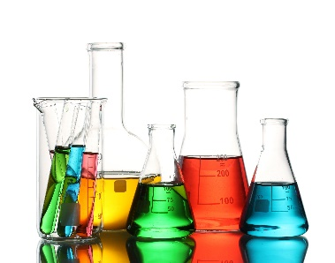
To calculate the concentration of a solution we use the equation:
concentration (mol dm^{–3}) | = | amount of substance (mol)
 |  | volume (dm³)
Use the equation to help you complete each of the statements in the questions below.
1. a. 1.5 mol of NaCl dissolved in 0.25 dm³ of water produces a solution with a concentration of mol dm^{–3}.
(1 mark)
b. 250 cm³ of a solution of HCl(aq) with a concentration of 0.0150 mol dm^{–3} contains
moles. (1 mark)
c. A solution with a concentration of 0.85 mol dm^{–3} that contains 0.125 mol has a volume of dm³. (1 mark)

2. In this question you will need to convert between an amount in moles and a mass as well as using the equation above.
Space for working is given beneath each question.
a. 5.0 g of NaHCO₃ dissolved in 100 cm³ of water produces a solution with a concentration
of mol dm^{–3}. (2 marks)

b. 25.0 cm³ of a solution of NaOH(aq) with a concentration of 3.8 mol dm^{–3} contains
g of NaOH. (2 marks)

c. The volume of a solution of cobalt(II) chloride, CoCl₂, with a concentration of 1.3 mol dm^{–3}
that contains 2.5 g of CoCl₂ is cm³. (3 marks)

Unit conversions– Volume
The SI unit for volume is metre cubed, m³. However as volumes in chemistry are often smaller than 1 m³, fractions of this unit are used as an alternative.
centimetre cubed, cm³ | decimetre cubed, dm³
centi- prefix one hundredth | deci- prefix one tenth
1 cm = $\frac{1}{100}$ m so, | 1 dm = $\frac{1}{10}$ m so,
1 cm³ = $\left(\frac{1}{100}\right)$³ m³ = $\left(\frac{1}{1 000 000}\right)$m³ | 1 dm³ = $\left(\frac{1}{10}\right)$³ m³ = $\left(\frac{1}{1 000}\right)$m³

1. Complete the table by choosing the approximate volume from the options in bold for each of the everyday items (images not drawn to scale). (1 mark)
1 cm³ | 1 dm³ | 1 m³

 | 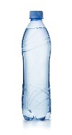 | 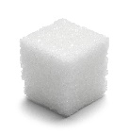 | 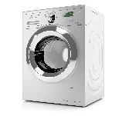
 | drinks bottle | sugar cube | washing machine
Approx. volume

2. Complete the following sentences; (1 mark)
To convert a volume in cm³ into a volume in dm³, divide by
To convert a volume in cm³ into a volume in m³, divide by

3. a. A balloon of helium has a volume of 1600 cm³. What is its volume in units of dm³?
b. The technician has prepared 550 cm³ of HCl(aq). What is its volume in units of m³?
c. An experimental method requires 1.35 dm³ of NaOH(aq). What volume is this in cm³?
d. A swimming pool has a volume of 375 m³. What volume is this in cm³?
e. A 12 g cylinder of CO₂ contains 6.54 dm³ of gas. What volume of gas is this in units of m³?
(5 marks)

4. Which cylinder of propane gas is the best value for money? (3 marks)
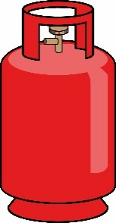
a. b. c.
2.13 × 10⁶ cm³
of propane
for £15.49
2700 dm³
of propane
for £21.25
7 m³
of propane
for £28.75

Practical Skills
Laboratory equipment
Practical work is a key aspect in the work of a chemist.
To help you plan effective practical work it is important that you are familiar with the common laboratory equipment available to you.
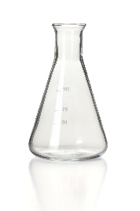
1. For each of the pieces of glassware shown in the images below, state their name and give a possible volume(s).
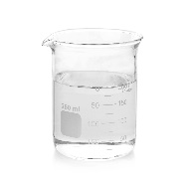
a. Name: b. Name:

Possible volume(s): Possible volume(s):

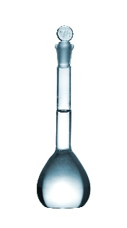
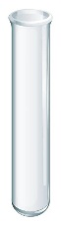
c. Name: d. Name:

Possible volume(s): Possible volume(s):

e. Name: f. Name:

Possible volume(s): Possible volume(s):

(6 marks)

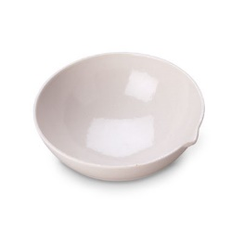
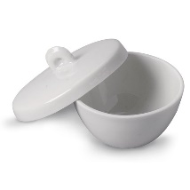
2. Name the common laboratory equipment in the images below. (4 marks)
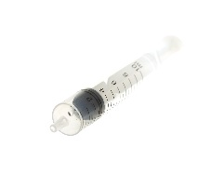
a. b. c.

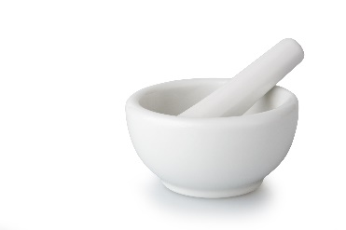
d.

Recording results
1. A student is looking at endothermic processes. He adds 2.0 g of ammonium nitrate to 50 cm³ of water and measures the temperature change. He repeats the experiment three times.
His results are shown in the table below.

 | Temperature at start | Temperature at end | Temperature change
Run 1 | 21.0 | –1.1 | 22.1
Run 2 | 20 | –2 | 22
Run 3 | 20.2 | 2 | 18.2
Mean |  |  | 22.05

Annotate the table to suggest five ways in which the table layout and the recording and analysis of his results could be improved. (5 marks)

2. For each of the experiments described below, design a table to record the results.
Experiment 1: Simon is investigating mass changes during chemical reactions. He investigates the change in mass when magnesium ribbon is oxidised to form magnesium oxide:
magnesium + oxygen → magnesium oxide
He records the mass of an empty crucible. He places a 10 cm strip of magnesium ribbon in the crucible and records the new mass of the crucible. He heats the crucible strongly until all the magnesium ribbon has reacted to form magnesium oxide. He allows the crucible to cool before recording the mass of the crucible and magnesium oxide.
Experiment 2: Nadiya is investigating how the rate of a reaction is affected by concentration. She investigates the reaction between magnesium ribbon and hydrochloric acid.
magnesium + hydrochloric acid → magnesium chloride + hydrogen
She places 25 cm³ of hydrochloric acid with a concentration of 0.5 mol dm^{–3} into a conical flask and fits a gas syringe. She adds a 3.0 cm strip of magnesium ribbon and measures the volume of hydrogen gas produced every 20 s for 3 minutes.
She repeats the experiment with hydrochloric acid with concentrations of 1.0 mol dm^{–3} and then 1.5 mol dm^{–3}.
(5 marks)

Drawing scatter graphs

When you want to find a correlation between two variables it is helpful to draw a scatter graph.
Key points to remember when drawing scatter graphs include:
- The independent variable (the variable that is changed) goes on the x-axis and the dependent variable (the variable you measured) goes on the y-axis.
- The plotted points must cover more than half the graph paper.
- The axes scales don’t need to start at zero.
- A straight line or smooth curve of best fit is drawn through the points to show any correlation.

Karina is investigating the relationship between the volume of a gas and its temperature. She injects 0.2 cm³ of liquid pentane (b.p. 36.1 °C) into a gas syringe submerged in a water bath at 40 °C. After 5 minutes she measures the volume of gas in the syringe. She repeats the experiment three times with the water bath at 40 °C.
She then repeats the experiment for temperatures of 50, 60, 70 and 80 °C.
Her results are shown in the table below:
Temperature / °C | Volume of gas / cm³
 | Run 1 | Run 2 | Run 3 | Mean
40 | 40.8 | 43.1 | 42.7 | 42.2
50 | 46.1 | 46.2 | 46.9 | 46.4
60 | 54.7 | 48.1 | 48.3 | 48.2
70 | 49.1 | 49.6 | 49.5 | 49.4
80 | 51.0 | 47.3 | 51.0 | 51.0

1. Plot a scatter graph of the volume of the gas against the temperature. (6 marks)
2. Add error bars to show the range of readings used to calculate the mean volume of the gas at each temperature. (2 marks)
3. Draw in a line of best fit. (1 mark)
4. Describe the correlation observed. (1 mark)

